**Todrique Hamilton**

Computer History

Motherboard

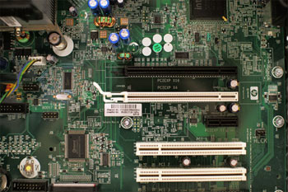

The **motherboard** is the computer's **main circuit board**. It's a thin plate that holds the CPU, memory, connectors for the hard drive and optical drives, expansion cards to control the video and audio, and connections to your computer's ports (such as USB ports). The motherboard connects directly or indirectly to every part of the computer.

CPU/Processor

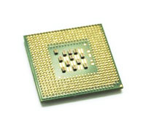

The central processing unit (CPU), also called a processor, is located inside the computer case on the motherboard. It is sometimes called the brain of the computer, and its job is to carry out commands. Whenever you press a key, click the mouse, or start an application, you're sending instructions to the CPU.

RAM (Random access memory)

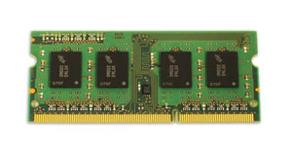

RAM is your system's short-term memory. Whenever your computer performs calculations, it temporarily stores the data in the RAM until it is needed.

Hard Drive

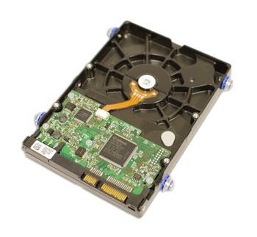

The hard drive is where your software, documents, and other files are stored. The hard drive is long-term storage, which means the data is still saved even if you turn the computer off or unplug it.

Power Supply Unit

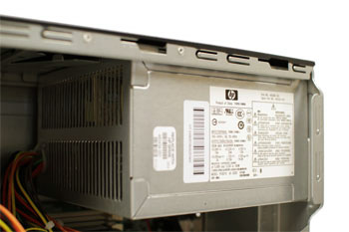

The power supply unit in a computer **converts the power** from the wall outlet to the type of power needed by the computer. It sends power through cables to the motherboard and other components.

Expansion Card

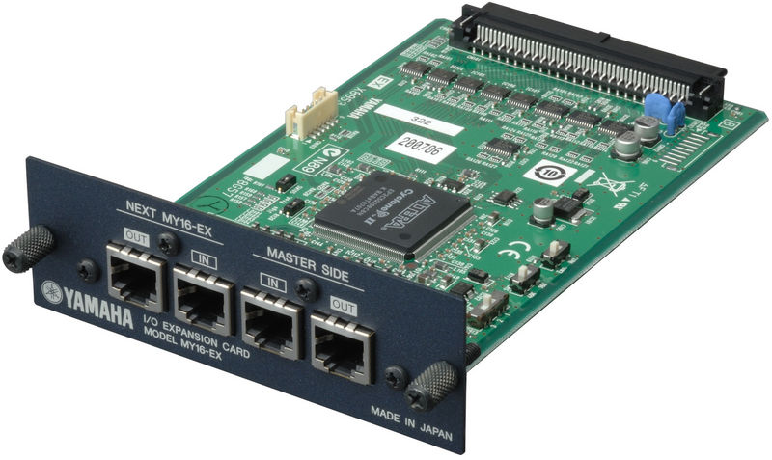

Most computers have **expansion slots** on the motherboard that allow you to add various types of **expansion cards**. These are sometimes called **PCI (peripheral component interconnect) cards**.

Video Card

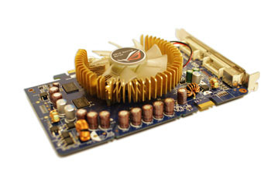

The **video card** is responsible for **what you see** on the monitor.

Network Card

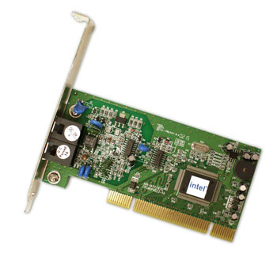

The **network card** allows your computer to communicate over a network and access the Internet.

Blue booth Card (Or adopter)

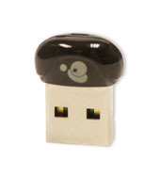

Bluetooth is a technology for wireless communication over short distances.

