ATAC DiffEnrich Analysis
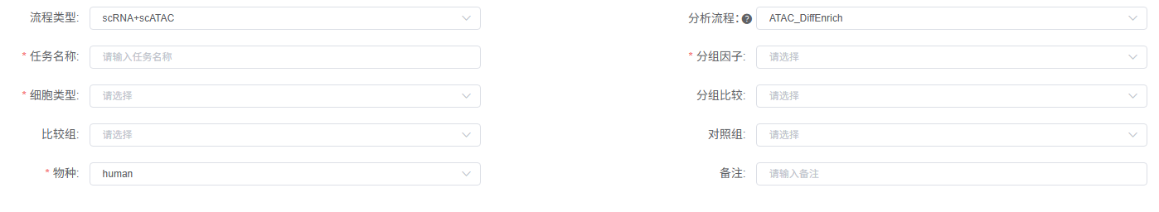
To find differentially accessible regions between clusters of cells, we perform a differential accessibility (DA) test by the R package presto (version. 1.0.0)^{[1]} which has implemented an extremely fast Wilcoxon rank sum test. Additionally, ClusterProfiler (version 4.10.1)^{[2]} is utilized to conduct GO and KEGG functional enrichment analysis on genes adjacent to the differential peaks identified for each cell type (or cluster), with the top 20 most significant terms displayed via bar plots and bubble plots for pathway visualization.

[1] Korsunsky I, Nathan A, Millard N, Raychaudhuri S. Presto scales Wilcoxon and auROC analyses to millions of observations. BioRxiv. 2019 May 29:653253.
[2] Yu G, Wang LG, Han Y, He QY. clusterProfiler: an R package for comparing biological themes among gene clusters. OMICS. 2012;16(5):284-287. doi:10.1089/omi.2011.0118

