BCR Analysis
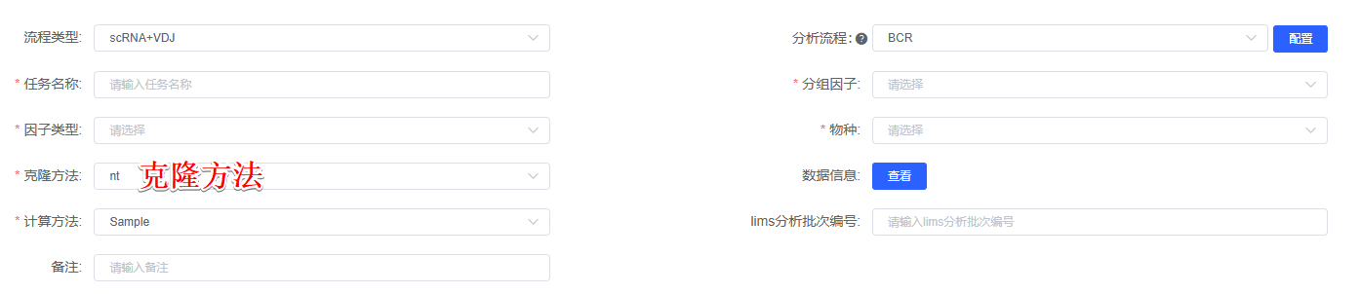
Using the scRepertoire(version 1.8.0)^{[1]} package, sample-specific consensus annotation files were consolidated into a list of BCR sequencing results using combineBCR function, and then integrated with the Seurat object using the combineExpression function. Clonotypes were called based on the CDR3 nucleotide sequence or amino acid sequence(克隆方法). The following diversity and clonality analysis were analyzed following the official tutorial of scRepertoire package. For analysis of V and J gene usage, heatmap visualization was generated using the CalcSegmentUsage function of VDJtools(version 1.1.4)^{[2]}, Circos plots was generated using the PlotFancyVJUsage function of VDJtools. Sample clonal diversity (Shannon and chao1 index) was analyzed using R-packet immunarch(version 0.9.0)^{[3]}. Somatic hypermutation frequencies for individual sequences was calculated using the observedMutations function of Shazam(version 1.0.2)^{[4]}.

[1] Borcherding, N., Bormann, N. L. & Kraus, G. scRepertoire: an R-based toolkit for single-cell immune receptor analysis. F1000Res 9, 47 (2020).
[2] Shugay, M. et al. VDJtools: unifying post-analysis of T cell receptor repertoires. PLoS Comput. Biol. 11, e1004503 (2015).
[3] Samokhina, M. et al. immunomind/immunarch: Immunarch 0.9.0. Zenodo https://doi.org/10.5281/zenodo.7446955 (2022).
[4] Gupta, N. T. et al. Change-O: a toolkit for analyzing large-scale B cell immunoglobulin repertoire sequencing data. Bioinformatics 31, 3356–3358 (2015).

