STAR-Fusion Analysis
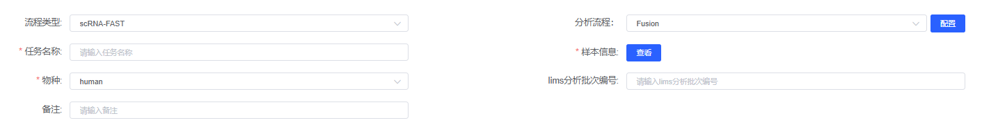
STAR-Fusion(Version 1.13.0)^{[1][2]} was used to identify candidate fusion transcripts supported by Illumina reads. The pipeline mapped sequencing reads to annotated exons while systematically filtering artifacts, including exclusion of alignments in similar regions and removal of duplicate reads. We applied such selection criteria, retaining only fusion events supported by ≥10 junction reads and detected in ≥2 cells based on barcode matching. The fusion cell percent was calculated as the number of cells with detected fusion divided by the total number of cells.

[1] Haas, B.J., Dobin, A., Li, B. et al. Accuracy assessment of fusion transcript detection via read-mapping and de novo fusion transcript assembly-based methods. Genome Biol 20, 213 (2019). https://doi.org/10.1186/s13059-019-1842-9
[2] Haas B., Dobin A., Stransky N., et al. STAR-Fusion: Fast and Accurate Fusion Transcript Detection from RNA-Seq[J]. 2017.DOI:10.1101/120295.

