COMMOT Analysis
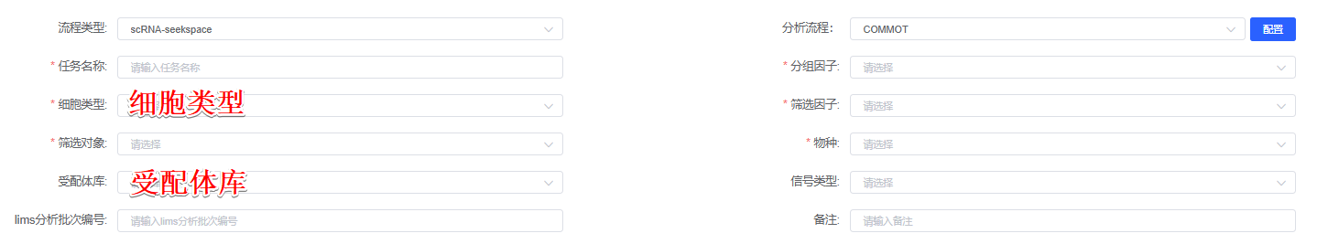
Cell-cell interactions were analyzed using COMMOT python packages (version 0.0.3)^{[1]}, a tool that enables comprehensive modeling of both direct and indirect interactions between different cell types while incorporating the spatial organization of cells within tissues. For this analysis, 细胞类型 were excluded to focus on the TME. Additionally, genes expressed in more than 0.5% of all cells were first filtered. This gene list was further refined by extracting known ligand receptor pairs from the 受配体库 database. Only ligand-receptor pairs co-occurring within a distance of 500 µm were considered for subsequent analysis. For the identified ligand-receptor pairs and their associated pathways, signal strength and vectors were calculated based on the distance between sending and receiving cells as well as gene expression intensity.

[1] Cang, Z., Zhao, Y., Almet, A.A. et al. Screening cell–cell communication in spatial transcriptomics via collective optimal transport. Nat Methods 20, 218–228 (2023). https://doi.org/10.1038/s41592-022-01728-4

