DiffEnrich analysis
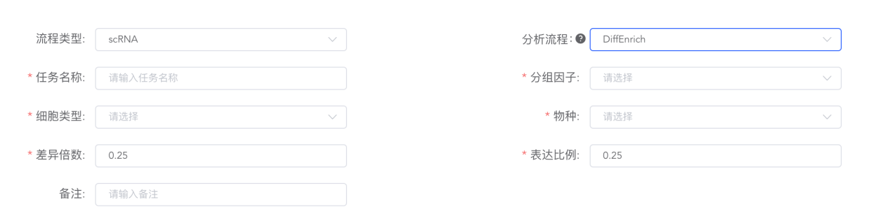
Performs differential analysis between a specific cell type (or cluster) and all other cells, mapping these differentially expressed genes (DEGs) to known biological pathways or functional modules to identify significantly enriched pathways. Using the FindAllMarkers() function from Seurat (Version 4.0.0) ^{[1]}, it calculates DEGs for the selected 细胞类型 and visualizes the expression patterns of the top 9 DEGs through violin plots and feature plots. Additionally, ClusterProfiler (Version 3.18.1)^{[2]} is utilized to conduct GO/KEGG functional enrichment analysis on all DEGs identified for each cell type (or cluster), with the top 20 most significant terms displayed via bar plots and bubble plots for pathway visualization.

[1] Hao Y, Hao S, Andersen-Nissen E, et al. Integrated analysis of multimodal single-cell data. Cell. 2021;184(13):3573-3587.e29. doi:10.1016/j.cell.2021.04.048
[2] Yu G, Wang LG, Han Y, He QY. clusterProfiler: an R package for comparing biological themes among gene clusters. OMICS. 2012;16(5):284-287. doi:10.1089/omi.2011.0118

