GeneActivity Analysis
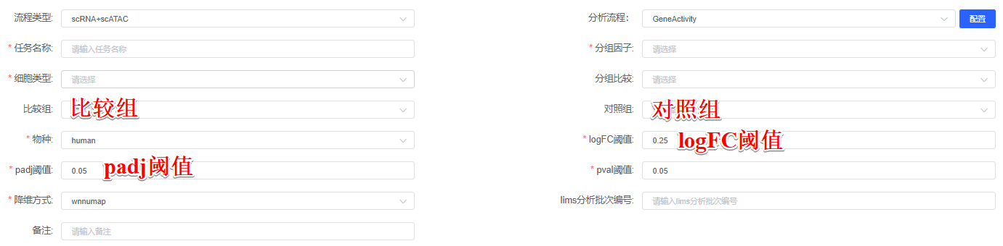
Gene activity scores were computed from scATAC-seq data using the GeneActivity function in Signac (version 1.14.0)^{[1]}, which quantifies chromatin accessibility in gene bodies and their 2 kb upstream promoter regions. The gene activity score matrix (genes × cells) was created as a new assay in Seurat, normalized​by total counts per cell, scaled to the median counts, and log-transformed. Cluster-specific chromatin accessibility patterns were identified through differential gene activity analysis using the FindAllMarkers function in Seurat, which applies a Wilcoxon rank-sum test. For comparative analyses between 比较组 vs 对照组, differential gene activity was evaluated with the FindMarkers function, using consistent statistical thresholds (adjusted p < padj阈值, log2 fold-change > logFC阈值).
[1] Stuart, T. , Srivastava, A. , Madad, S. , Lareau, C. A. , & Satija, R. . (2022). Single-cell chromatin state analysis with signac (vol 18, pg 1333, 2021). Nature methods(2), 19. https://doi.org/10.1038/s41592-021-01282-5

