TCR Analysis
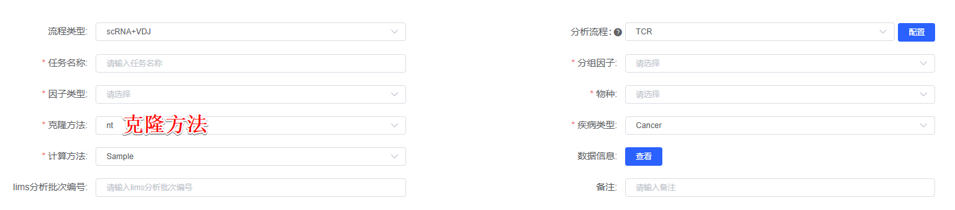
Using the scRepertoire(version 1.8.0)^{[1]} package, sample-specific consensus annotation files were consolidated into a list of TCR sequencing results using combineTCR function, and then integrated with the Seurat object using the combineExpression function. Clonotypes were called based on the CDR3 nucleotide sequence or amino acid sequence(克隆方法). The following diversity and clonality analysis were analyzed following the official tutorial of scRepertoire package. For analysis of V and J gene usage, heatmap visualization was generated using the CalcSegmentUsage function of VDJtools(version 1.1.4)^{[2]}, Circos plots was generated using the PlotFancyVJUsage function of VDJtools. Sample clonal diversity (Shannon and chao1 index) was analyzed using R-packet immunarch(version 0.9.0)^{[3]}. T cell epitope annotation uses the McPAS-TCR database, and the CDR3 sequence of detected T cells is queried in the database to obtain the corresponding antigen information. Cell diffusion diagram of T cells was generated using the R package Destiny(version 3.12.0)^{[4]}.

[1] Borcherding, N., Bormann, N. L. & Kraus, G. scRepertoire: an R-based toolkit for single-cell immune receptor analysis. F1000Res 9, 47 (2020).
[2] Shugay, M. et al. VDJtools: unifying post-analysis of T cell receptor repertoires. PLoS Comput. Biol. 11, e1004503 (2015).
[3] Samokhina, M. et al. immunomind/immunarch: Immunarch 0.9.0. Zenodo https://doi.org/10.5281/zenodo.7446955 (2022).
[4] Angerer P, et al. destiny: diffusion maps for large-scale single-cell data in R. Bioinformatics. 2016;32(8):1241–1243.

