Cellphonedb Spatial Analysis
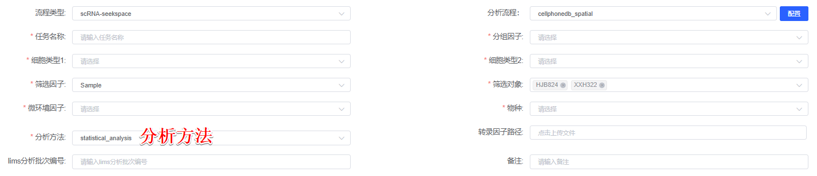
CellPhoneDB Python package (version 5.0.1)^{[1]}, a repository of ligand-receptor interactions, was employed to identify enriched interactions between various cell types in spatial transcriptomics data. CellPhoneDB was used to analyze the interaction strengths, which were defined as the means of the average expression level of ligand and receptor in the corresponding cluster cells. To narrow down the most relevant interactions, we looked for specific interactions classified by ligand/receptor expression in more than 10% of cells within a cell type, and at least one gene-cell type pair must be supported by the provided cell type DEG file. Analysis was conducted using default parameters with the “cellphonedb method 分析方法” command. By calculating the proportion of the means that were higher than the actual mean, a P value for the likelihood of the cell type specificity of the corresponding receptor–ligand complex was obtained. We then selected interactions that were biologically relevant.

[1] Troul'e, Kevin et al. “CellPhoneDB v5: inferring cell-cell communication from single-cell multiomics data.” (2023).

