group_diffenrich analysis
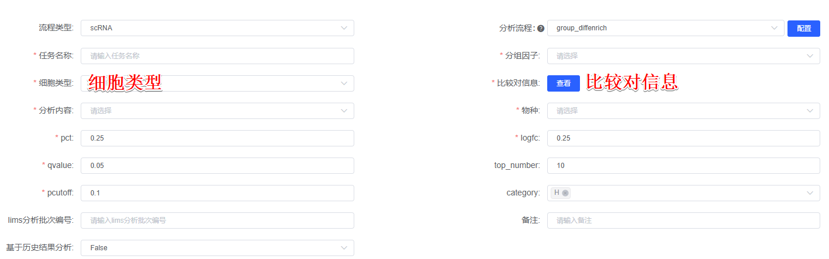
Perform differential analysis between experimental conditions (or groups) within the same cell type (or cluster), mapping these differentially expressed genes to known biological pathways or functional modules to determine significantly enriched pathways. Calculate the differentially expressed genes (DEGs) between 比较对信息 of selected 细胞类型 using the FindMarker() function in Seurat (Version 4.4.0)^{[1]}. Visualization tools such as dot plots, violin plots, heatmaps, and volcano plots are employed to display expression patterns of the top 5 DEGs. Additionally, In addition, GO, KEGG, Reactome, GSEA, etc. can be used to analyze significant all/up/down-regulated DEGs. The top 15 most significant terms are illustrated using bar plots, bubble plots, circle plots, and chord diagrams for pathway enrichment results.

[1] Hao Y, Hao S, Andersen-Nissen E, et al. Integrated analysis of multimodal single-cell data. Cell. 2021;184(13):3573-3587.e29. doi:10.1016/j.cell.2021.04.048

