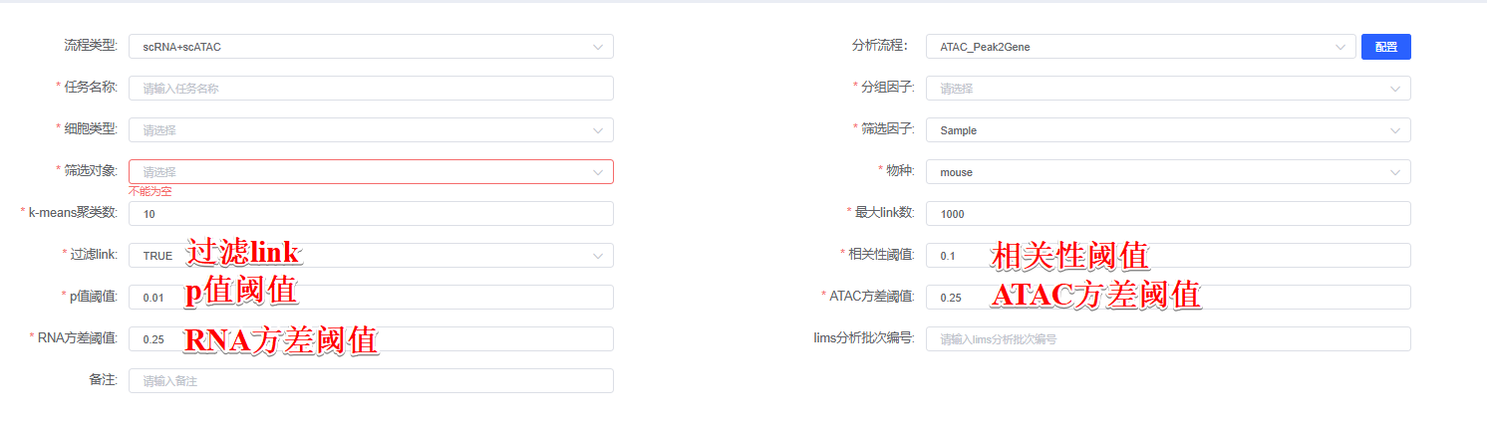
For each gene, we find the set of peaks that may regulate the gene by computing the correlation between gene expression and accessibility at nearby peaks using the Signac (version 1.14.0)^{[1]} function LinkPeaks^{[2]} with a p-value cutoff of p值阈值 and absolute correlation cutoff of 相关性阈值. (Additionally, we calculated the variance quantiles for both ATAC peaks and RNA genes across all samples, and only retained peak-gene links where the associated peak exhibited a variance quantile above ATAC方差阈值 and the gene showed a variance quantile above RNA方差阈值.)

[1] Stuart T, Srivastava A, Madad S, Lareau CA, Satija R. Single-cell chromatin state analysis with Signac. Nature methods. 2021 Nov;18(11):1333-41.
[2] S. Ma, B. Zhang, L. M. LaFave, A. S. Earl, Z. Chiang, Y. Hu, J. Ding, A. Brack, V. K. Kartha, T. Tay, T. Law, C. Lareau, Y. C. Hsu, A. Regev, J. D. Buenrostro, Chromatin potential identified by shared single-cell profiling of RNA and chromatin. Cell 183, 1103–1116.e20 (2020).

