CellChat Spatial Analysis
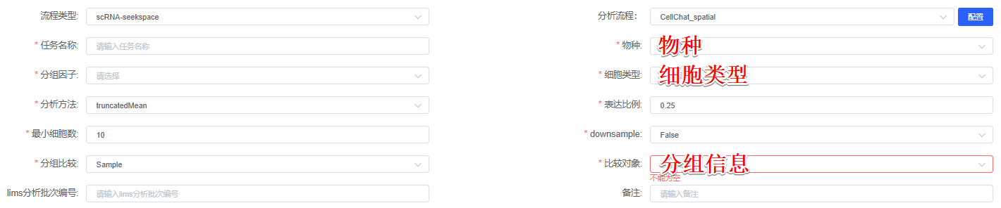
The CellChat R packages (version 2.1.2)^{[1]} was used to evaluate the cell interaction based on known ligand-receptor pairs. The normalized counts of 细胞类型 were loaded into CellChat, and the data were pre-processed using the identifyOverExpressedGenes, identifyOverExpressedInteractions, and projectData functions based on the “CellChatDB.物种” database. The core functions of CellChat, namely computeCommunProb was applied in a sequential manner to infer significant ligand-receptor pairs. Spatial constraints were incorporated into our cell-cell communication analysis by enabling distance filtering (distance.use = TRUE) and setting an interaction range of 250 μm (interaction.range = 250), thereby restricting our consideration to physically proximal cellular interactions within this biologically relevant distance threshold. We systematically compared cell-cell communication strength between 组1 and 组2….

[1] Jin, S., Guerrero-Juarez, C.F., Zhang, L. et al. Inference and analysis of cell-cell communication using CellChat. Nat Commun 12, 1088 (2021). https://doi.org/10.1038/s41467-021-21246-9

