GSVA Analysis
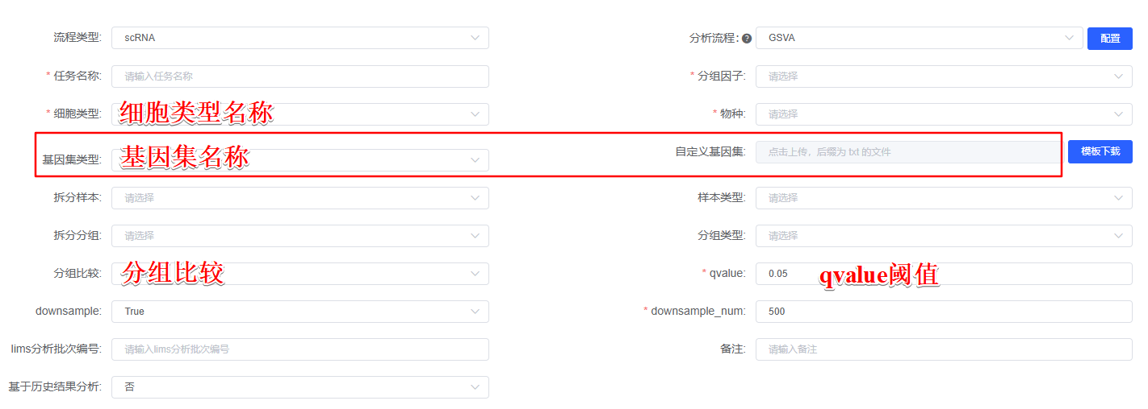
The gene set variation analysis (GSVA, version 1.48.0)^{[1]} was used to analyze gene set enrichment patterns in 细胞类型名称or基因集名称the hallmark pathways or canonical pathways collected in the Molecular Signatures Database (MSigDB, version 7.5.1)^{[2]} or 自定义基因集. We calculated the enrichment scores using the default parameters of the GSVA algorithm, which employs a non-parametric kernel estimation of the cumulative density function of gene expression values.

如有分组比较
Differential enrichment analysis was performed by limma (version 3.54.2)^{[3]} between 分组比较中的两个组名 to identify significantly altered pathways (q < qvalue阈值).

[1] Hänzelmann S, Castelo R, Guinney J (2013). “GSVA: gene set variation analysis for microarray and RNA-Seq data.” BMC Bioinformatics, 14, 7. doi:10.1186/1471-2105-14-7, https://doi.org/10.1186/1471-2105-14-7.
[2] Liberzon A, Birger C, Thorvaldsdóttir H, Ghandi M, Mesirov JP, Tamayo P. The Molecular Signatures Database (MSigDB) hallmark gene set collection. Cell Syst. 2015 Dec 23;1(6):417-425. doi: 10.1016/j.cels.2015.12.004. PMID: 26771021; PMCID: PMC4707969.
[3] Ritchie ME, Phipson B, Wu D, Hu Y, Law CW, Shi W, Smyth GK (2015). “limma powers differential expression analyses for RNA-sequencing and microarray studies.” Nucleic Acids Research, 43(7), e47. doi:10.1093/nar/gkv007.

