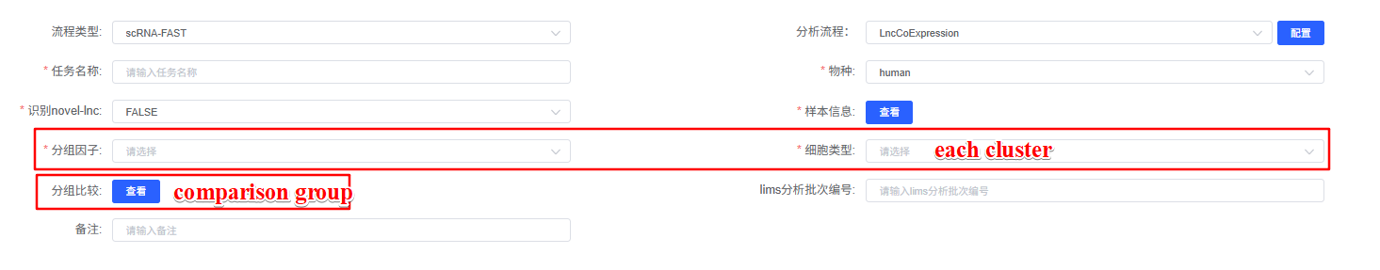
LncCoExpression^{[1]} is a computational module used to analyze co-expression relationships between lncRNAs and protein-coding RNAs. For each cluster or comparison group, we first identified differentially expressed genes (DEGs), retaining only those with avg_log2FC ≥ 0.25 and p_val_adj < 0.05 for co-expression network construction. The GrnBoost2 algorithm from the pySCENIC^{[2]} (Version 0.12.1) package was used to build the gene co-expression network. To focus on lncRNA-associated interactions, we retained only edges connected to at least one lncRNA and selected the top 0.5% of edges by weight. Network communities were identified using the Louvain algorithm, with modules containing ≥7 edges being retained. Functional enrichment analysis was performed using the clusterProfiler^{[3]} (Version 4.12.6) package.

- Santus, L., Sopena-Rios, M., García-Pérez, R. et al. Single-cell profiling of lncRNA expression during Ebola virus infection in rhesus macaques. Nat Commun 14, 3866 (2023). https://doi.org/10.1038/s41467-023-39627-7
- Sande, B. V. D. , Flerin, C. , Davie, K. , Waegeneer, M. D. , Hulselmans, G. , & Aibar, S. , et al. A scalable scenic workflow for single-cell gene regulatory network analysis. Nature Protocols
- T Wu#, E Hu#, S Xu, M Chen, P Guo, Z Dai, T Feng, L Zhou, W Tang, L Zhan, X Fu, S Liu, X Bo*, G Yu*. clusterProfiler 4.0: A universal enrichment tool for interpreting omics data. The Innovation. 2021, 2(3):100141. doi: 10.1016/j.xinn.2021.100141

