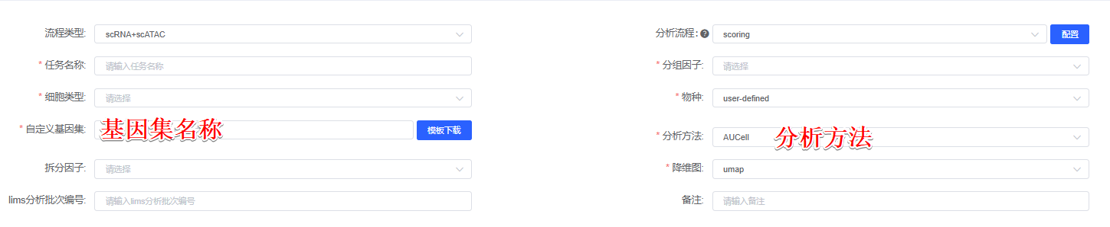
分析方法：AUCell
To evaluate the 基因集名称 gene set activities in different cell clusters or sample types, we employed the 分析方法 scoring algorithm from the R package irGSEA (version 3.2.4)^{[1]}, AUCell^{[2]} evaluates whether a set of genes shows a significant enrichment at the top of a ranked gene list by calculating the Area Under the Curve (AUC) for each cell, assessing the proportion of genes in the gene set that are highly expressed in each cell.

分析方法：UCell
To evaluate the 基因集名称 gene set activities in different cell clusters or sample types, we employed the 分析方法 scoring algorithm from the R package irGSEA (version 3.2.4)^{[1]}, Ucell^{[3]} uses a Mann-Whitney U statistic to calculate enrichment scores for gene signatures in single-cell data, providing a rank-based, annotation-free method that is fast and requires minimal preprocessing.

分析方法：singscore
To evaluate the 基因集名称 gene set activities in different cell clusters or sample types, we employed the 分析方法 scoring algorithm from the R package irGSEA (version 3.2.4)^{[1]}, singscore^{[4][5]} scores individual samples independently without training or fitting parameters to the data, making it particularly suitable for small sample numbers and heterogeneous data.

分析方法：AddModuleScore
To evaluate the 基因集名称 gene set activities in different cell clusters or sample types, we employed the 分析方法 scoring algorithm from the R package irGSEA (version 3.2.4)^{[1]}, AddModuleScore^{[6]} calculates the average expression of a gene set in each cell, subtracted by the background expression level, providing a normalized enrichment score that accounts for gene expression variability.

[1] Fan C, Chen F, Chen Y, Huang L, Wang M, Liu Y, Wang Y, Guo H, Zheng N, Liu Y, Wang H. irGSEA: the integration of single-cell rank-based gene set enrichment analysis. Briefings in Bioinformatics. 2024 Jul;25(4):bbae243.
[2] Aibar S, Bravo Gonzalez-Blas C, Moerman T, Huynh-Thu V, Imrichova H, Hulselmans G, Rambow F, Marine J, Geurts P, Aerts J, van den Oord J, Kalender Atak Z, Wouters J, Aerts S (2017). “SCENIC: Single-Cell Regulatory Network Inference And Clustering.” Nature Methods, 14, 1083-1086. doi:10.1038/nmeth.4463
[3] Andreatta M, Carmona SJ (2021). “UCell: Robust and scalable single-cell gene signature scoring.” Comput Struct Biotechnol J., 19, 3796-3798. doi:10.1016/j.csbj.2021.06.043.
[4] Foroutan M, Bhuva D, Lyu R, Horan K, Cursons J, Davis M (2018). “Single sample scoring of molecular phenotypes.” BMC bioinformatics, 19(1), 404. doi:10.1186/s12859-018-2435-4.
[5] Bhuva D, Cursons J, Davis M (2020). “Stable gene expression for normalisation and single-sample scoring.” Nucleic Acids Research, 48(19), e113. doi:10.1093/nar/gkaa802.
[6] Tirosh I, Izar B, Prakadan SM, Wadsworth MH 2nd, Treacy D, Trombetta JJ, Rotem A, Rodman C, Lian C, Murphy G, Fallahi-Sichani M, Dutton-Regester K, Lin JR, Cohen O, Shah P, Lu D, Genshaft AS, Hughes TK, Ziegler CG, Kazer SW, Gaillard A, Kolb KE, Villani AC, Johannessen CM, Andreev AY, Van Allen EM, Bertagnolli M, Sorger PK, Sullivan RJ, Flaherty KT, Frederick DT, Jané-Valbuena J, Yoon CH, Rozenblatt-Rosen O, Shalek AK, Regev A, Garraway LA. Dissecting the multicellular ecosystem of metastatic melanoma by single-cell RNA-seq. Science. 2016 Apr 8;352(6282):189-96. doi: 10.1126/science.aad0501.

