hdWGCNA Analysis
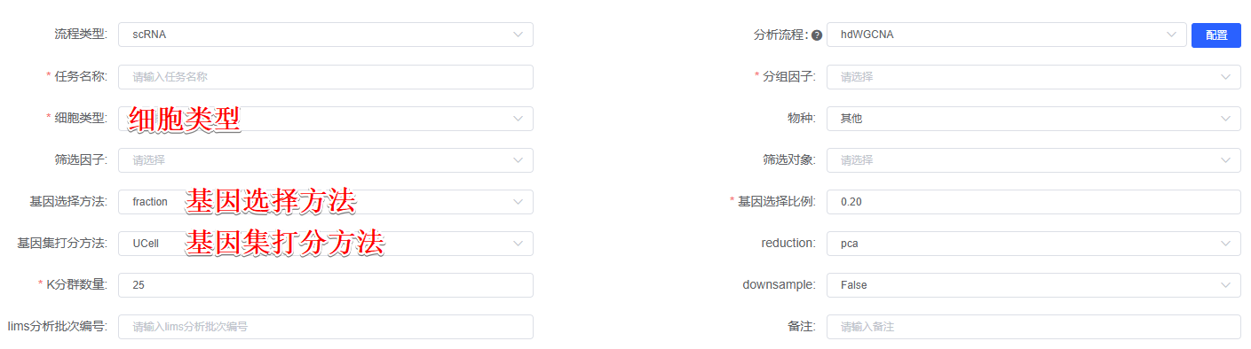
The hdWGCNA (version 0.4.0)^{[1]} method was employed to construct a cell-type-specific co-expression network, followed by the identification of gene modules and co-expressed genes within the network. Hierarchical clustering and dynamic cutting tree functions were utilized for module identification, with different branches representing distinct gene modules. Hub genes were selected based on their gene significance (GS) and membership degree (MM) in the module. The analysis process begins with preprocessing the gene expression data, during which细胞类型 are selected . Next, genes are filtered using基因选择方法to enhance the reliability of downstream analyses. Following this, a gene co-expression network is constructed. Then, modules or clusters of highly correlated genes are identified, and module signature genes are calculated using either the基因集打分方法algorithm. Finally, module preservation analyses are performed to assess the robustness of the identified modules.

[1] Morabito, S., Reese, F., Rahimzadeh, N., Miyoshi, E., & Swarup, V. (2023). hdWGCNA identifies co-expression networks in high-dimensional transcriptomics data. Cell reports methods, 3(6),100498.https://doi.org/10.1016/j.crmeth.2023.100498

