CellphoneDB Analysis
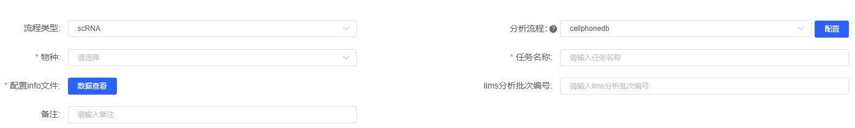
CellPhoneDB (version 5.0.1)^{[1]}, a comprehensive database and analysis tool for cell-cell communication analysis, was employed to investigate intercellular interactions in single-cell transcriptomics data. The analysis was performed using a custom pipeline that integrated cell type information, sample metadata, and species-specific annotations. The interaction strength was calculated as the mean of the average expression values of ligand-receptor pairs in the corresponding interacting cell types. The analysis pipeline considered only interactions where ligand/receptor genes were expressed in more than 10% of cells within each specific cell type. Statistical significance was assessed through a permutation test (1,000 times), where cell type labels were randomly shuffled to generate a null distribution. Ligand-receptor pairs with P-values < 0.05 were considered significant interactions. Cell type-specific ligand-receptor interactions were determined based on the specific expression of the ligand by one cell type and the corresponding receptor by another cell type.

[1] Efremova M, Vento-Tormo M, Teichmann S A, et al. CellPhoneDB: inferring cell–cell communication from combined expression of multi-subunit ligand–receptor complexes[J]. Nature protocols, 2020, 15(4): 1484-1506.

