CellChat Analysis
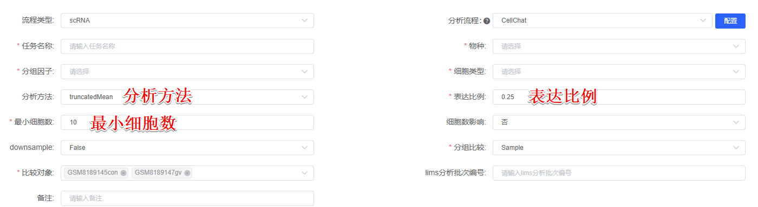
To investigate intercellular communication networks, we performed CellChat analysis (version 2.1.0)^{[1]} using the CellChatDB v2 database, which contains approximately 3,300 validated molecular interactions, including secreted autocrine/paracrine signaling (40%), extracellular matrix (ECM)-receptor interactions (17%), cell-cell contact interactions (13%), and non-protein interactions (30%). For each condition, we first filtered out cell types containing fewer than 最小细胞数 cells to ensure robust analysis. The analysis was performed using normalized expression data from single-cell RNA sequencing. We employed the 分析方法 method for calculating interaction strength, which produces fewer but stronger interactions, with a trim parameter of 表达比例 to account for lowly expressed genes. The interaction strength was calculated based on the expression values of ligands and receptors, following the law of mass action to derive the degree of cooperativity. We analyzed all major signaling pathways, including secreted signaling, cell-cell contact, and ECM-receptor interactions. For each cell type pair, we identified the top 20 ligand-receptor pairs based on their P-values and interaction strength values. These pairs were then mapped to their respective signaling pathways to understand their roles in mediating intercellular communication.

[1] Jin S, Guerrero-Juarez CF, Zhang L, Chang I, Ramos R, Kuan C-H, et al. Inference and analysis of cell-cell communication using CellChat. Nat Commun. 2021;12:1088

