NicheNet Analysis
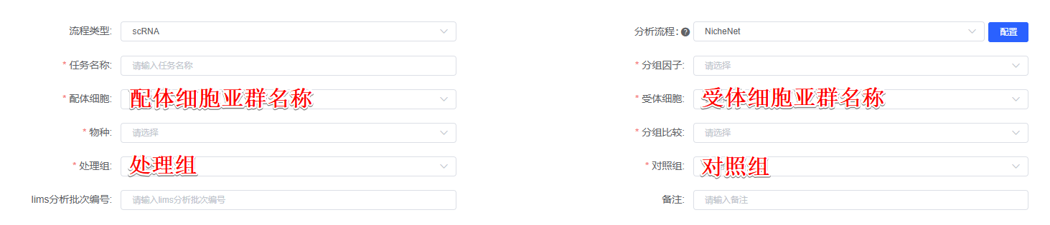
NicheNet (Version 2.0.4)^{[1]} was used to identify potential ligands that drive the phenotype of 受体细胞亚群名称. The top 30 differentially expressed genes were ordered using log2FC between 处理组 and 对照组 were treated as potential ligands or targets. Sender cells from 配体细胞亚群名称 and target cells from 受体细胞亚群名称 were included to construct the expressed ligand-receptor interactions and calculate the ligand activity. We used the active_ligand_target_links function to compute the potential intensity of regulation between the ligand and target.

[1] Browaeys, R., Saelens, W., and Saeys, Y. (2020). NicheNet: modeling intercellular communication by linking ligands to target genes. Nat. Methods 17, 159–162. https://doi.org/10.1038/s41592-019-0667-5.

