CopyKAT Analysis
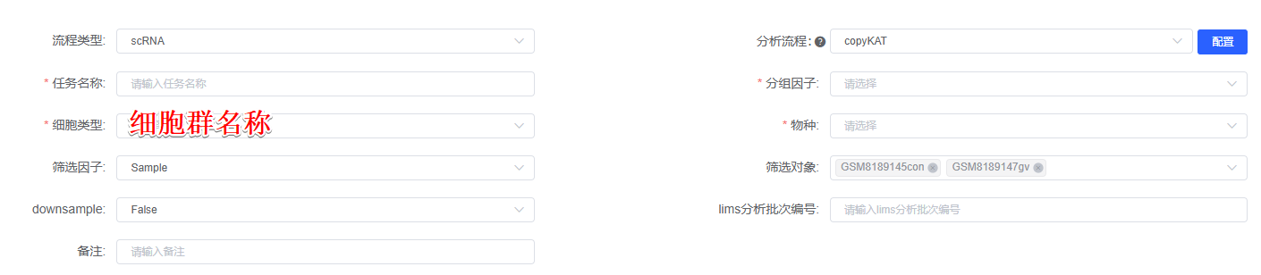
CopyKAT (Version 1.1.0)^{[1]} combines Bayesian methods and hierarchical clustering to calculate the genomic copy number distribution of individual cells in 细胞群名称. Based on the copy number results, normal and tumour cells are inferred. Tumour cells are further extracted for copy number inference, resulting in subpopulations with subclonal differences.

[1] Gao, R., Bai, S., Henderson, Y. C., Lin, Y., Schalck, A., Yan, Y., Kumar, T., Hu, M., Sei, E., Davis, A., Wang, F., Shaitelman, S. F., Wang, J. R., Chen, K., Moulder, S., Lai, S. Y., & Navin, N. E. (2021). Delineating copy number and clonal substructure in human tumors from single-cell transcriptomes. Nature biotechnology, 39(5), 599–608. https://doi.org/10.1038/s41587-020-00795-2

