Monocle2 Analysis
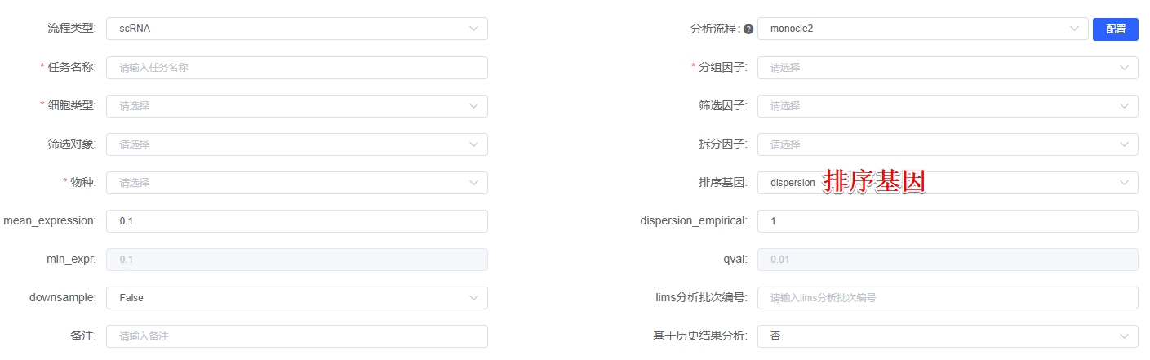
Monocle2 package (version 2.3.6)^{[1]} was used to determine the potential lineage differentiation. The importCDS function in Monocle was used to convert the original count in the Seurat object into CellDataSet, then Genes used for pseudotime ordering were selected using dispersionTable Function or differentialGeneTest Function (排序基因). DDRTree method was utilized for dimension reduction and cell ordering along the pseudotime trajectory. No root state is specified and ordering was done in an unsupervised manner. Branch analysis was performed with BEAM function. The signicantly changed genes in the branch point were clustered using plot_genes_branched_pseudotime Functions according to the distinct patterns of gene expression change.
[1] Trapnell, Cole et al. “The dynamics and regulators of cell fate decisions are revealed by pseudotemporal ordering of single cells.” Nature biotechnology vol. 32,4 (2014): 381-386. doi:10.1038/nbt.2859

