Monocle3 Analysis
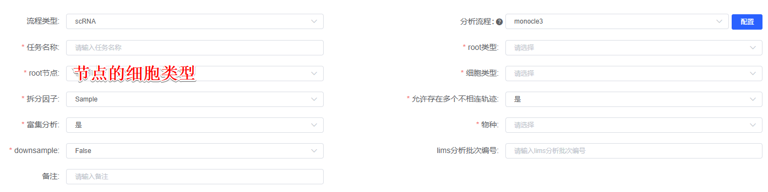
Monocle3(version 1.0.0)^{[1]} primarily performs pseudotime analysis to resolve cellular changes during biological processes such as development or disease, enabling trajectory analysis for selected cell populations. It helps uncover developmental trajectories and transcriptional dynamics by constructing cell trajectory maps based on gene expression patterns in single-cell data, identifying critical transcriptional states and transition points. Select root节点的细胞类型 as the roo node to generate a pseudotime distribution plot derived from UMAP dimensionality reduction. Monocle3 further conducts pseudotime-based expression correlation analysis, displaying trajectory differentiation results for the top 10 genes. Additionally, it groups genes into distinct modules using the Louvain algorithm and performs GO/KEGG functional enrichment analysis on these modules to highlight key biological pathways.

[1] Trapnell C, Cacchiarelli D, Grimsby J, et al. The dynamics and regulators of cell fate decisions are revealed by pseudotemporal ordering of single cells. Nat Biotechnol. 2014;32(4):381-386. doi:10.1038/nbt.2859

