SCENIC Analysis
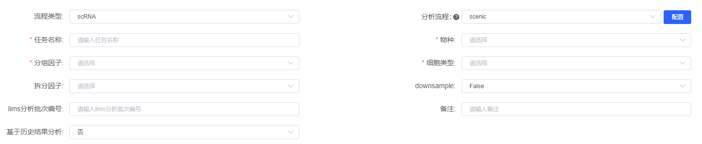
Single-cell gene regulatory network (GRN) reconstruction and regulon analysis were performed using ​​pySCENIC (version 0.12.1)^{[1][2]}​​. First, GRNBoost (gradient boosting) was applied to infer TF-target co-expression modules. Subsequently, direct TF-DNA binding was validated using RcisTarget by scanning cis-regulatory motifs. Finally, regulon activity was quantified per cell via AUCell, which ranks gene expression to compute AUC scores. Cell type-specific regulons were identified using regulon specificity scores (RSS) — quantifying the enrichment of regulon activity within a specific cell cluster — and Z-scores, which standardize the deviation of a regulon’s mean activity in a cell group relative to the global population (|Z| > 2.0, FDR < 0.05).

- Aibar S, Carmen Bravo González-Blas, Moerman T, et al. SCENIC: single-cell regulatory network inference and clustering[J]. Nature Methods [2025-04-18]. https://doi.org/10.1038/nmeth.4463
[2] Kumar, N., et al. "Correction to: Inference of Gene Regulatory Network from Single-Cell Transcriptomic Data Using pySCENIC." Methods in molecular biology (Clifton, N.J.) 2328(2021):C1. https://doi.org/10.1007/978-1-0716-1534-8_10

