Single-cell RNA sequencing data processing and analysis

Data Preprocessing and Quality Control
Raw single-cell sequencing data was processed using SeekSoulTools to generate gene-cell expression matrices. Then analyses were performed using Seurat (4.1.1). Stringent quality control parameters were applied to eliminate low-quality cells based on the following criteria: number of detected genes (nFeature_RNA) within [feature.range最小值, feature.range最大值], total UMI counts (nCount_RNA) within [umi.range最小值, umi.range最大值], and specific gene set（比如线粒体基因集） expression proportion below xx% （range过滤方法） or thresholds using Median Absolute Deviation (MAD) method（MAD过滤方法）.
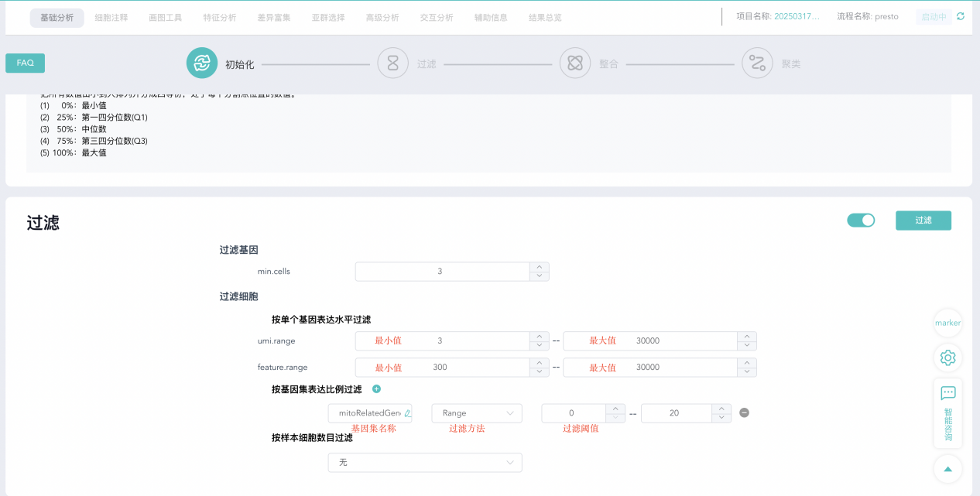

Data normalization and integration
After quality control and filtering, library-size normalization to each cell was performed by NormalizeData. Highly variable genes were identified using FindVariableFeatures (method: "vst", number of features: 2000). Data was then scaled using the ScaleData. Removed batch effects across multiple samples, we implemented Canonical Correlation Analysis (CCA)（根据分析参数选择一种，具体的写作内容如下）:
(1) Canonical Correlation Analysis (CCA): Anchor cells between samples were identified using FindIntegrationAnchors based on shared genes. Expression matrices were then integrated using IntegrateData for batch correction.
(2) Harmony: This method achieves global alignment while preserving local structure, offering high computational efficiency and scalability for large datasets.
(3) Merge: Using Seurat's merge function for combining multiple samples, suitable for cases with minimal batch effects.
(4) Reciprocal PCA (RPCA): Mapping anchors between samples were identified using FindTransferAnchors (reduction method: "rpca"), followed by IntegrateData to project all data into a shared low-dimensional space.
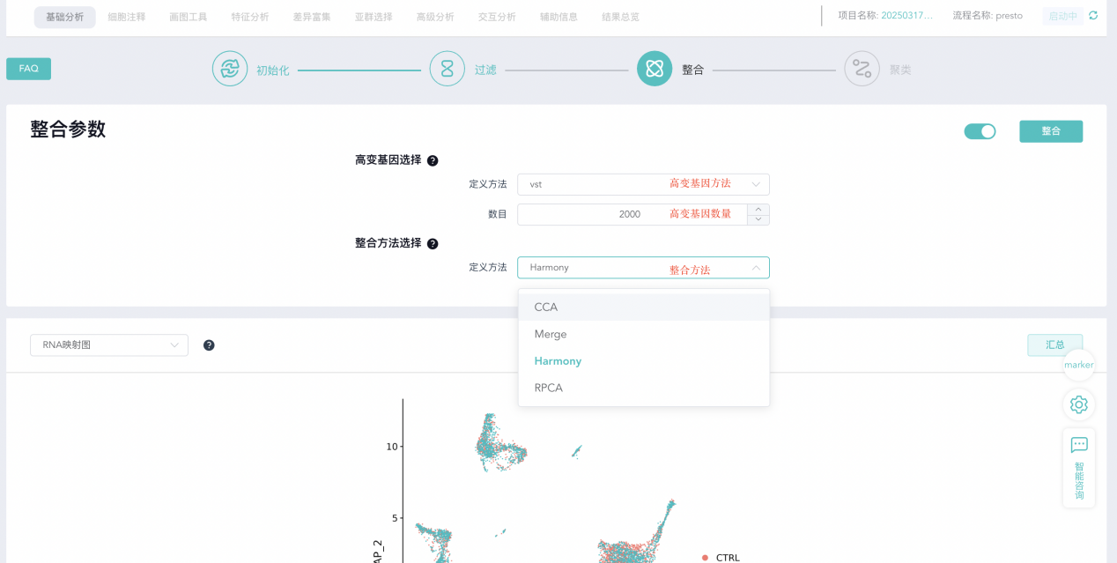

Dimensionality reduction and clustering
The first XX（主成分数量） principal components (PCs) were utilized for downstream analysis. A K-nearest neighbor (KNN) graph was constructed using FindNeighbors, followed by cell clustering using FindClusters with the Louvain algorithm at a resolution of XX（分辨率参数）.
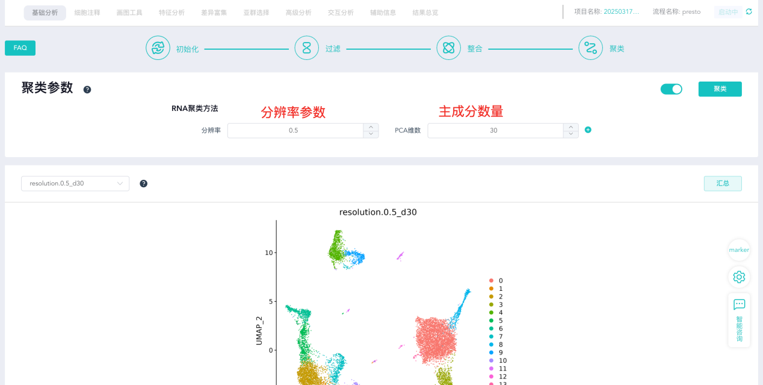

Cell type annotation
Cell types were identified using an integrated approach combining SingleR and artificial intelligence (AI). The top 20 differentially expressed genes from each cell cluster were extracted using presto analysis to construct cluster feature vectors. Large Language Models (LLMs) were employed to analyze differential gene patterns and infer cell types and subtypes, incorporating collected marker lists. And cell type assignments were manually verified and corrected based on the expression specificity of canonical markers, for example, T cell: CD3D, CD3E, CD3G; B cell: CD19, MS4A1; Plasma cell: JCHAIN, IGKC; epithelial: KRT20, EPCAM and soon on. And the subcluster of T cell, Epithelial amd Macrophase were further identified as above method.

Data visualization
Interactive data visualization was implemented using ggplot2 and plotly packages.
- Dimension reduction plots (DimPlot) for clustering and cell type distribution
- Feature plots (FeaturePlot) for individual gene expression patterns
- Heatmaps (DoHeatmap) for gene expression patterns across cell types
- Dot plots (DotPlot) for integrated visualization of gene expression intensity and cell proportions
- Violin plots (VlnPlot) for comparing gene expression levels between cell groups, with statistical significance assessed using t.test or wilcox.test functions
- Stacked bar plots and pie charts for visualizing cell type proportions across different groups

Signature score calculation
Gene set scoring was performed using the AddModuleScore function to quantify the collective expression of defined gene lists（基因集）.
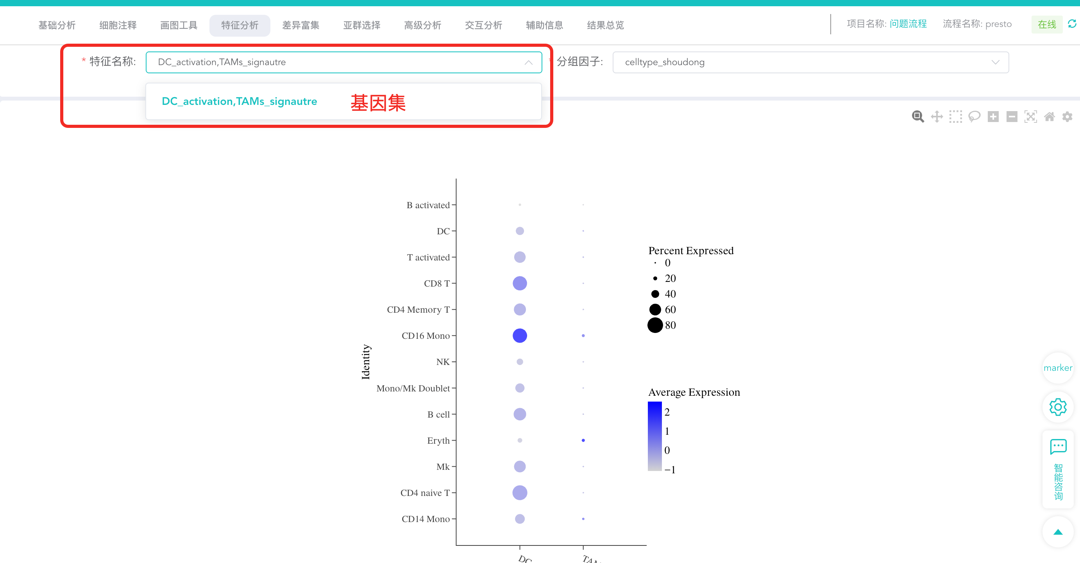

Differential expression analysis
Differential expression analysis was performed using Seurat's FindMarkers function or Presto method, employing Wilcoxon rank-sum tests with Bonferroni correction for multiple testing. Differentially expressed genes were filtered using the following criteria: adjusted p-value < 0.05, minimum log fold change > 0.25, and expression in at least 10% of cells.
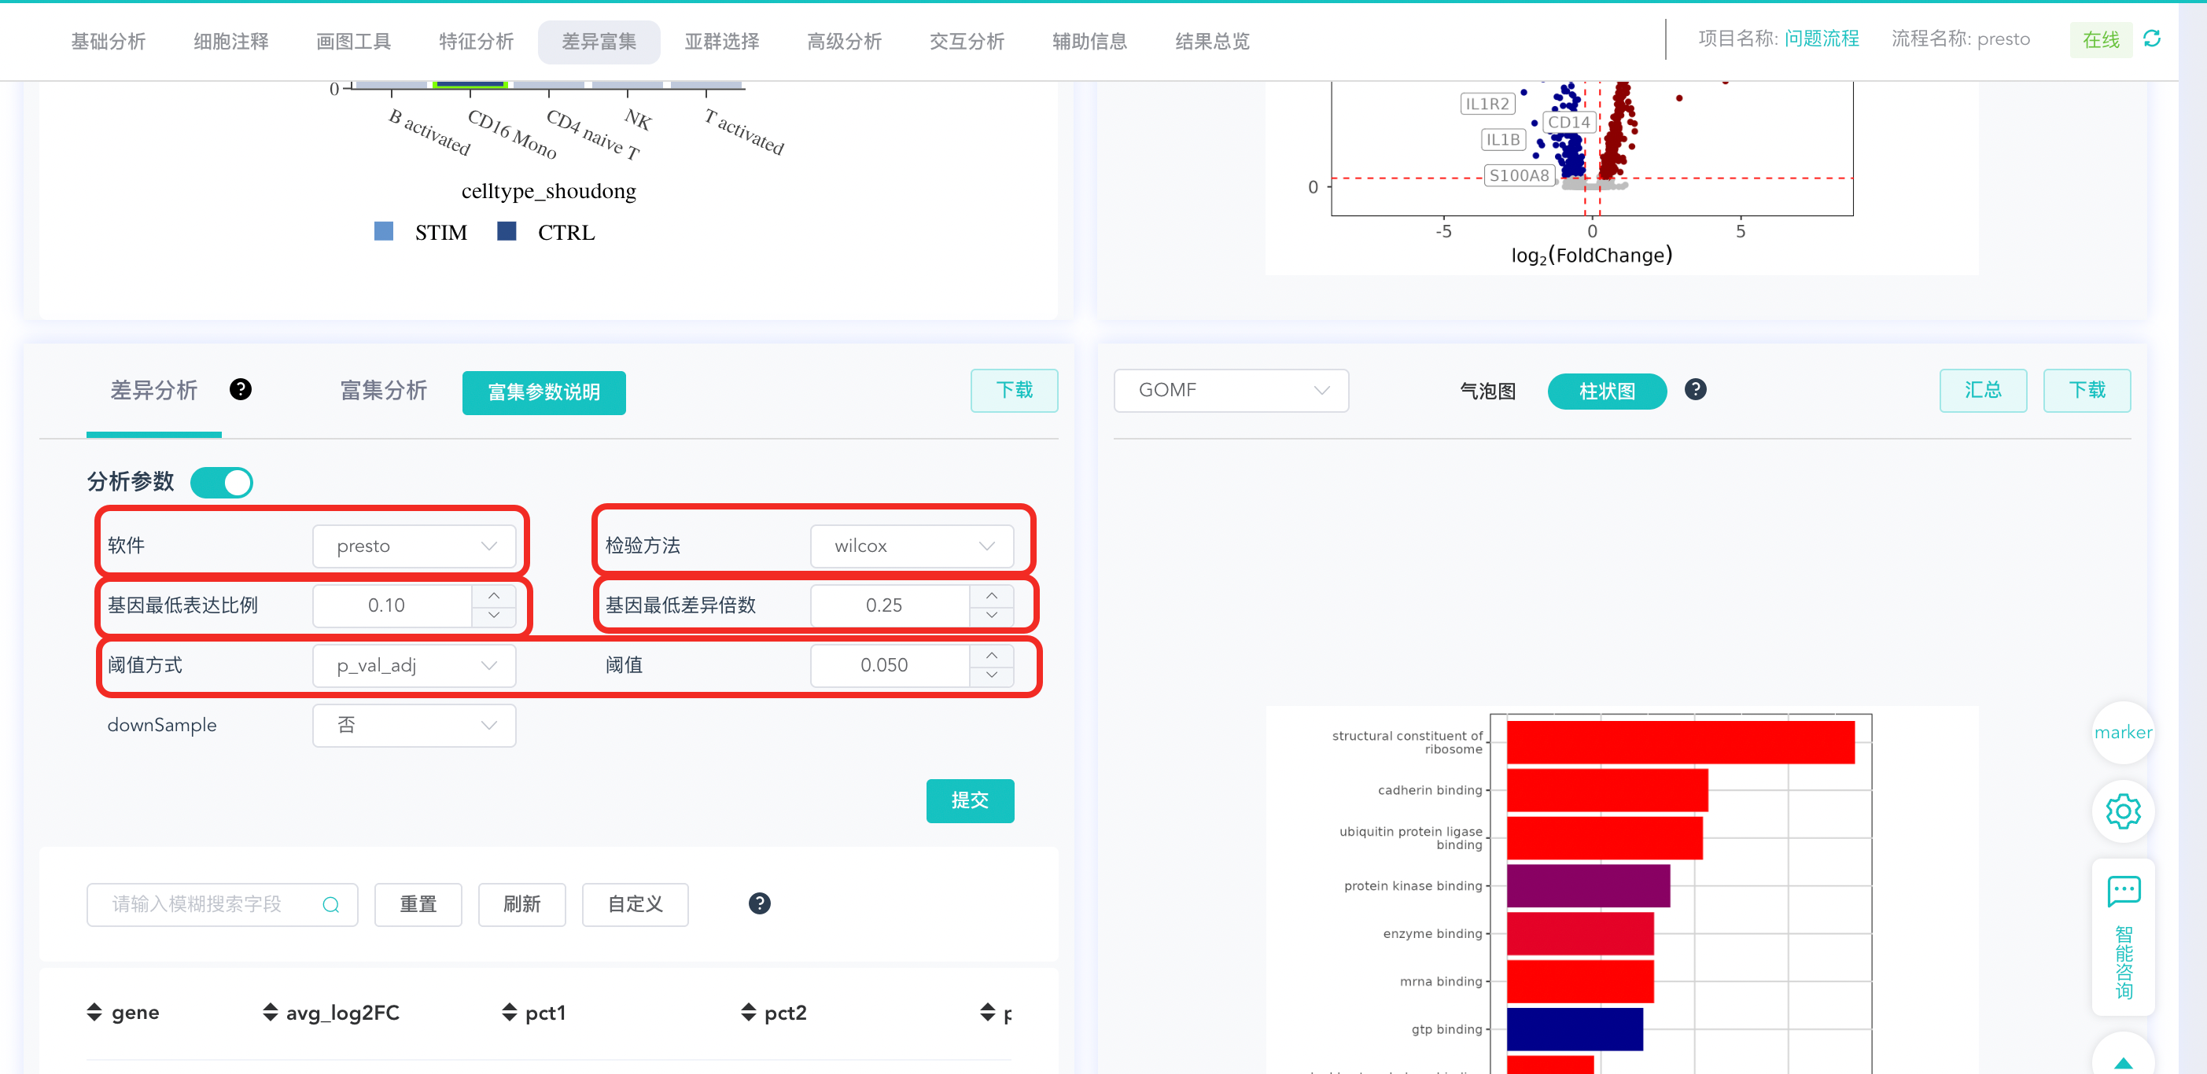

Functional enrichment analysis
Differentially expressed genes were subjected to functional enrichment analysis using clusterProfiler (version 4.2.0). This included Gene Ontology (GO), Kyoto Encyclopedia of Genes and Genomes (KEGG), and Reactome pathway. GO include biological processes (BP), molecular functions (MF), and cellular components (CC). Statistical significance was determined at an adjusted p-value < 0.05.
