CIS 248 – Advanced Application Development
Information System Report: Deliverable 2
Nova Denton-Parry, Zach Kahler, Jeremy Kirkpatrick, & Bruce Schulz

Sprint 1 Backlog
Story ID | User Story
US-01 | As a sensory-sensitive user, I want to create an account and log in so that my wardrobe and comfort data are tied to my personal profile.
US-02 | As a caregiver, I want to create dependent profiles linked to my account so that I can manage wardrobe and outfits for the person I support.
US-03 | As a user, I want to add clothing items to my wardrobe with sensory tags (texture, pressure, warmth level) and photos so that the app knows what I own and how each item feels
US-04 | As a user, I want to view my wardrobe catalog and filter by category, fabric, or sensory tag so that I can quickly find relevant clothing items.
US-05 | As a user, I want the app to fetch real-time weather data for my location so that outfit suggestions are appropriate for today's conditions
US-06 | As a user, I want to log my daily outfit by selecting items from my wardrobe so that the app can track what I wear.
US-07 | As a user, I want to rate my post-wear comfort (overall 1–5, plus optional texture/pressure/temperature sub-scores) so that the app learns which items are most comfortable for me.
US-08 | As a user, I want to receive smart outfit suggestions ranked by weather match and my historical comfort scores so that I can dress comfortably every day.
US-09 | As a user, I want to view my outfit history and comfort trend charts over time so that I can identify patterns and improve my clothing choices.
US-10 | As a user, I want to receive push notification reminders in the morning (log outfit) and evening (rate comfort) so that I stay consistent with tracking
US-11 | As a user, I want my data encrypted and backed up to the cloud so that I don't lose my history if I change devices.
US-12 | As a new user, I want a guided onboarding flow that collects my sensory preferences and helps me add my first clothing item so that the app is useful from day one.
US-13 | As a user, I want the app to protect my data with authentication guards so that unauthenticated users cannot access private screens
US-14 | As a caregiver, I want to switch between dependent profiles within the app so that I can manage multiple people's wardrobes without logging out
US-15 | As an admin, I want to manage user accounts (enable/disable) and system configuration so that I can maintain the platform

Burndown Chart
Link to Trello Board with Burndown Chart ‘Power-Up’: https://trello.com/b/89unOKqu/sensorywardrobe
Screencap of Burndown Chart: 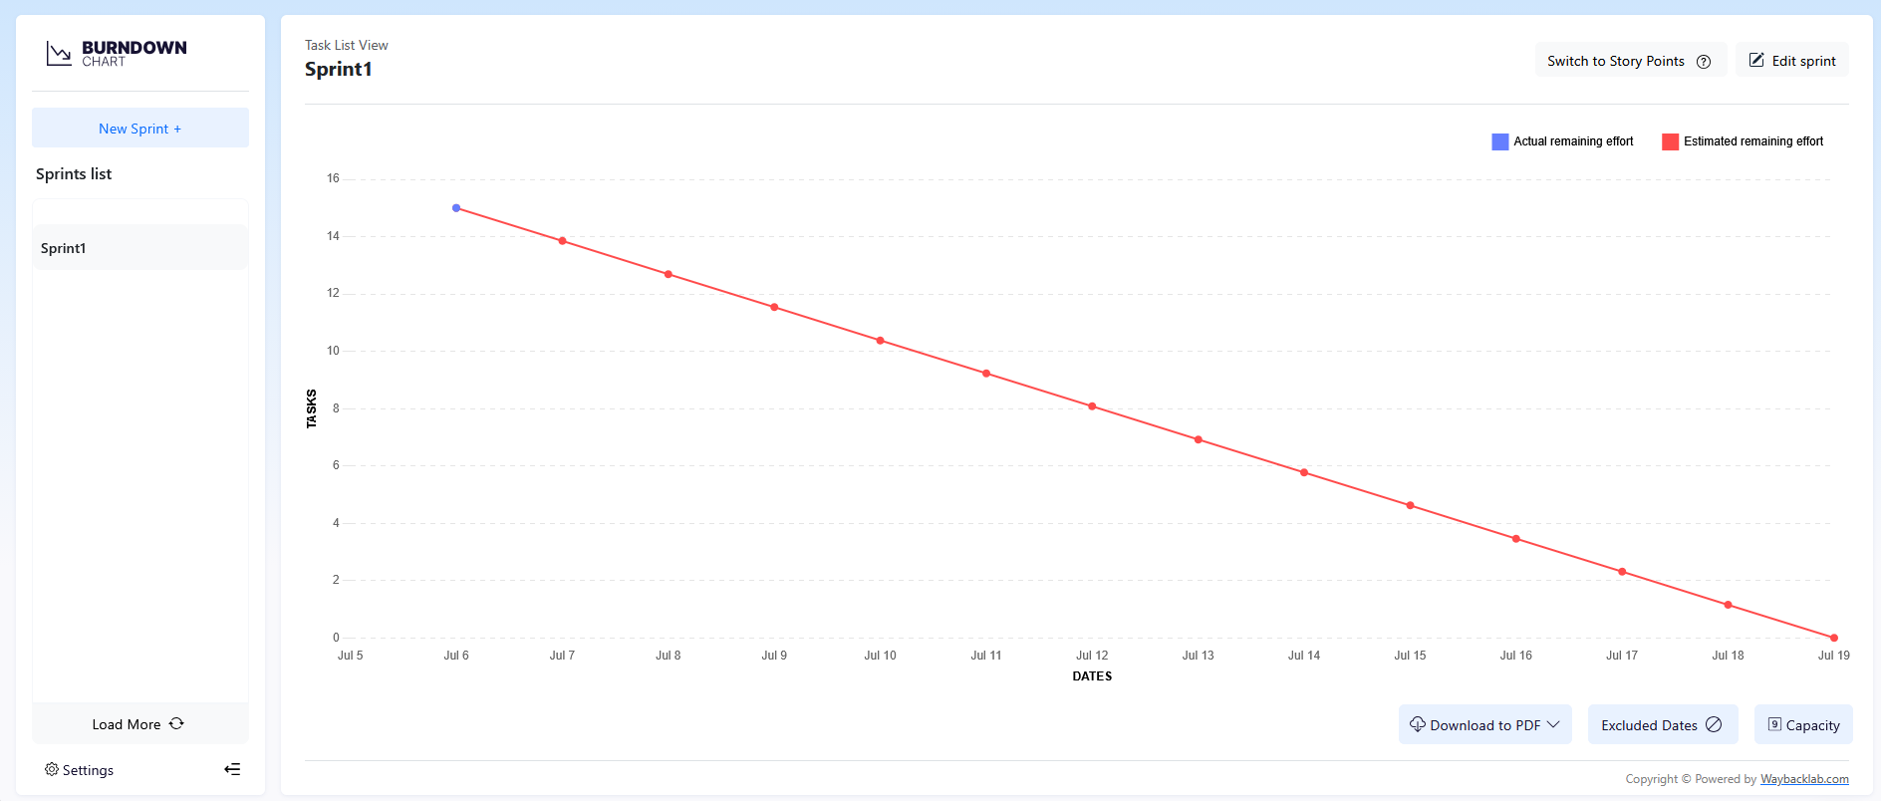

Wireframes:
Navigate the wireframes on the site for (potentially) easier viewing: https://app.visily.ai/projects/cf22e3fb-5161-4e5e-a460-a91921622774/boards/2658575

Home Screen Wireframe
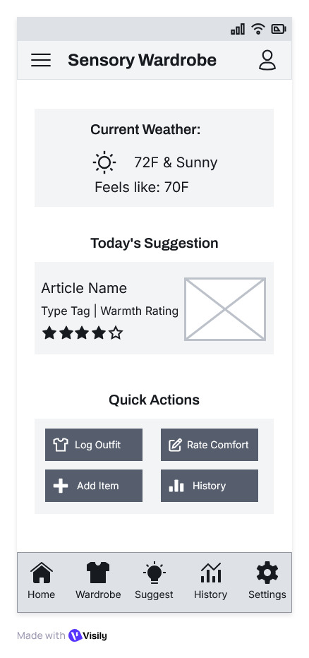

Add Clothing Item Screen Wireframe
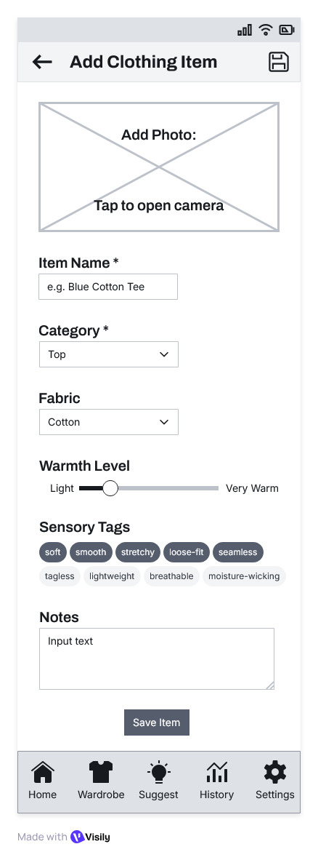

Log Outfit Screen Wireframe
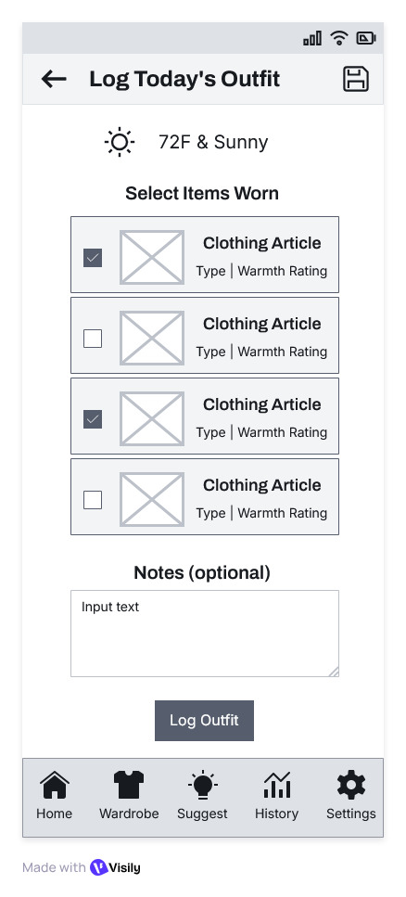

Log Outfit’s Comfort Screen Wireframe
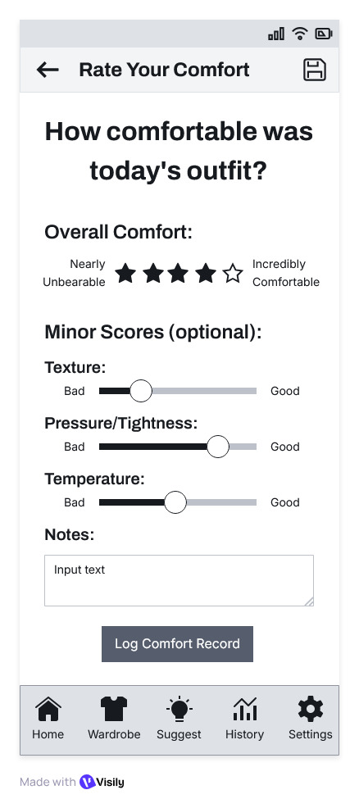
Outfit Suggestions Screen Wireframe
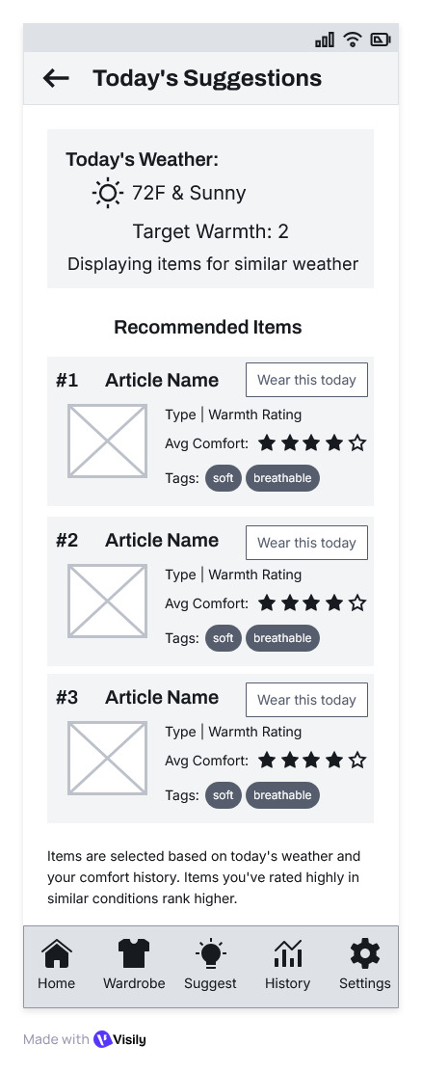

Outfit/Comfort History Screen Wireframe
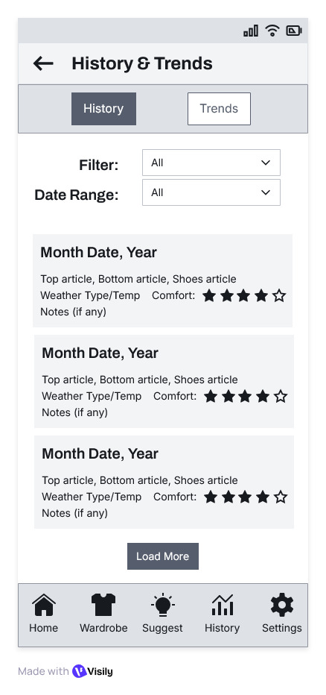
Outfit/Comfort Trends Screen Wireframe
