**Supplemental Table 1. List of linker reactions.**

Osmotic coefficient refers to whether or not the linker reaction contributes to osmolarity. a, Apoplast; gc, Guard cell; me, Mesophyll cell; p, Plastid; v, Vacuole; c, Cytosol.

|  |  |  |  |
| --- | --- | --- | --- |
| Osmotic Coefficient | Cell | Compartment | Metabolites |
| 0 | a | NA | Cl, Fructose, Glucose, K, Malate, Nitrate, Sucrose, aMalate |
| gc | p | Starch |
| me | p | Starch |
| v | 4_amino_butyrate, Arg, Asn, Citrate, Cys, Gln, Glt, Gly, His, Ile, Leu, Lys, L_alpha_alanine, L_aspartate, Malate, Met, Phe, Pro, Ser, Sucrose, Thr, Trp, Tyr, Val, aCitrate, aMalate, bHis |
| 1 | gc | c | Citrate, Cl, Fructose, Glucose, K, Malate, Nitrate, Sucrose |
| v | 4_amino_butyrate, Arg, Asn, Citrate, Cys, Cl, Fructose, Glucose, Gln, Glt, Gly, His, Ile, K, Leu, Lys, L_alpha_alanine, L_aspartate, Malate, Met, Nitrate, Phe, Pro, Ser, Sucrose, Thr, Trp, Tyr, Val, aCitrate, aMalate, bHis |

**Supplemental Figure 1. Transfer metabolites and ions**

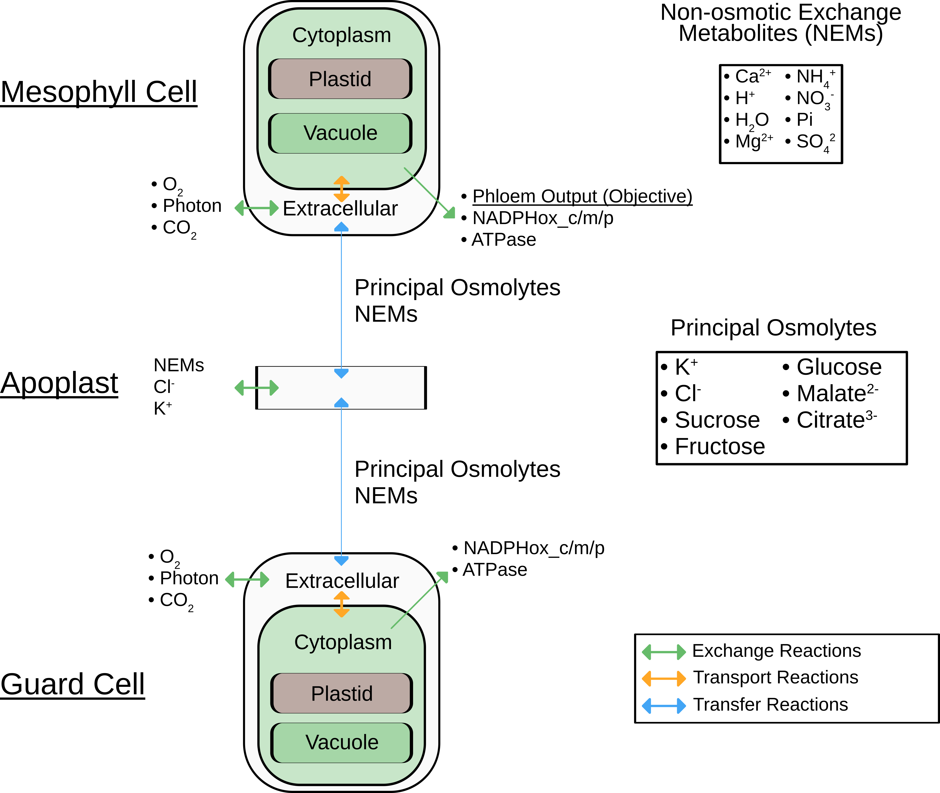

**Supplemental Figure 2. Transporters and channels in guard cell model**

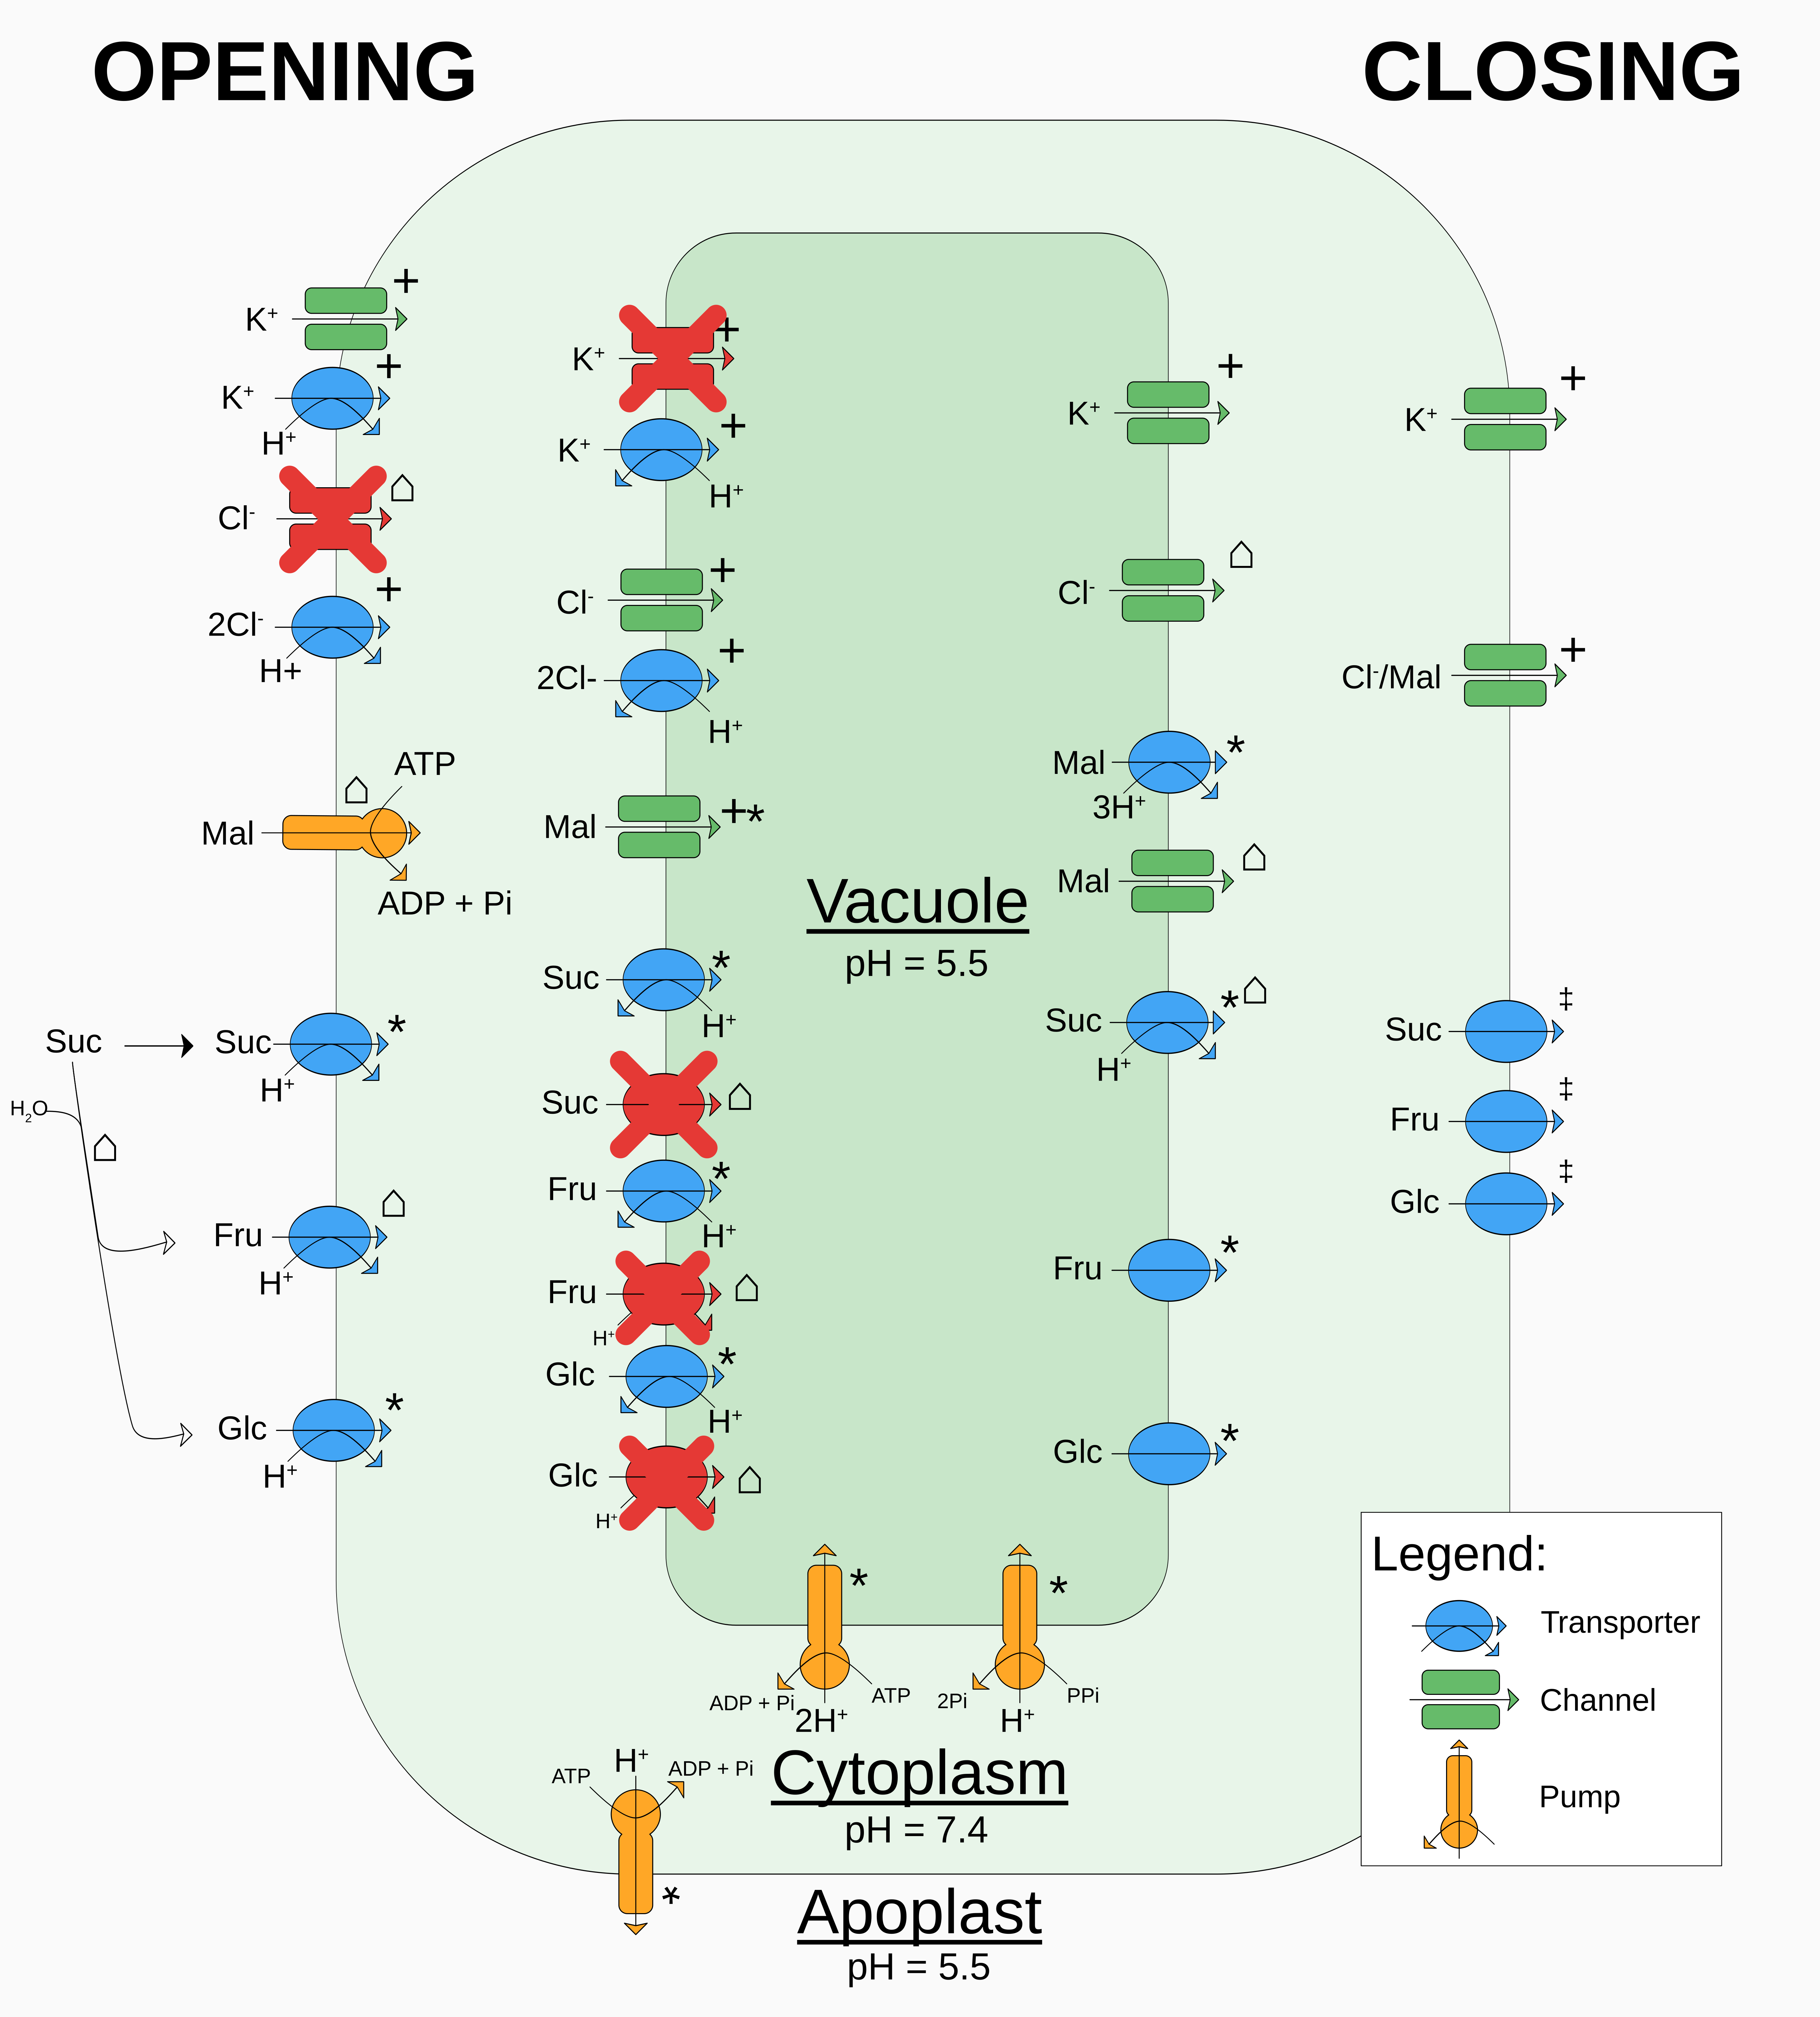

**Supplemental Table 2. Parameter bounds for parameter scan**

|  |  |  |  |  |  |
| --- | --- | --- | --- | --- | --- |
| **Parameter** | **Lower** | **Upper** | **Units** | **Source Lower** | **Source Upper** |
| *P*abs | 0.81 | 0.99 | Dimensionless | 90% of [(Zhu et al., 2010)](https://paperpile.com/c/IW5K2R/2INz) | 110% of [(Zhu et al., 2010)](https://paperpile.com/c/IW5K2R/2INz) |
| *T*l | 1.7 x 10-4 | 2.4 x 10-4 | m | [(Wuyts et al., 2010)](https://paperpile.com/c/IW5K2R/kShU) | [(Ramonell et al., 2001)](https://paperpile.com/c/IW5K2R/N1UR) |
| *A*l | 1 | 1 | m2 | Fixed | Fixed |
| *V*gc | 4.75 x 10-13 | 4.1 x 10-12 | dm3 | [(Jezek and Blatt, 2017)](https://paperpile.com/c/IW5K2R/oLKz) | [(Hills et al., 2012)](https://paperpile.com/c/IW5K2R/vJTh) |
| *F*q*F*m | 0.79 | 0.9 | Dimensionless | [(Lawson et al., 2003)](https://paperpile.com/c/IW5K2R/TvnR) | [(Lawson et al., 2003)](https://paperpile.com/c/IW5K2R/TvnR) |
| *R*ch | 0.035 | 0.183 | Dimensionless | [(Fujiwara et al., 2019)](https://paperpile.com/c/IW5K2R/V65d) | [(Fujiwara et al., 2019)](https://paperpile.com/c/IW5K2R/V65d) |
| Lair | 0.185 | 0.37 | Dimensionless | [(Ramonell et al., 2001)](https://paperpile.com/c/IW5K2R/N1UR) | [(Earles et al., 2018)](https://paperpile.com/c/IW5K2R/UvsX) |
| *L*epidermis | 0.1 | 0.24 | Dimensionless | [(Willmer and Fricker, 1996)](https://paperpile.com/c/IW5K2R/tBoo) | [(Ramonell et al., 2001)](https://paperpile.com/c/IW5K2R/N1UR) |
| *Vac*frac | 0.751 | 0.9 | Dimensionless | [(Wang et al., 2017)](https://paperpile.com/c/IW5K2R/tZOU) | [(Andrés et al., 2014)](https://paperpile.com/c/IW5K2R/tuWT) |
| *T* | 283.15 | 298.15 | K | 10C | 25C |
| *R* | 0.08205 | 0.08205 | dm3·atm·K−1·mol−1 | Tiesinga et al. (2019) | Tiesinga et al. (2019) |
| *N*gcs | 1.72 x 108 | 11.6 x 108 | m-2 | [(Willmer and Fricker, 1996)](https://paperpile.com/c/IW5K2R/tBoo) | [(Papanatsiou et al., 2016)](https://paperpile.com/c/IW5K2R/JWv0) |
| *n* | 1.5 | 2.5 | atm | Wang et al. (2012) | [(Wang et al., 2017)](https://paperpile.com/c/IW5K2R/tZOU) |
| *m* | 0.8 | 1 | atm·µm-1 | [(Wang et al., 2017)](https://paperpile.com/c/IW5K2R/tZOU) | Wang et al. (2012) |
| *r* | 5 x 10-14 | 8 x 10-14 | dm3·µm-1 | [(Wang et al., 2017)](https://paperpile.com/c/IW5K2R/tZOU) | Wang et al. (2012) |
| *s* | 1 x 10-13 | 3 x 10-13 | dm3 | Wang et al. (2012) | [(Wang et al., 2017)](https://paperpile.com/c/IW5K2R/tZOU) |
| *C*apo | 0.0230 | 37.3 | mol·dm-3 | [(Wang et al., 2017)](https://paperpile.com/c/IW5K2R/tZOU) | [(Roelfsema and Hedrich, 2002)](https://paperpile.com/c/IW5K2R/nId8) |
| *A*closed | 1 | 4 | µm | [(Jezek and Blatt, 2017)](https://paperpile.com/c/IW5K2R/oLKz) | [(Wang et al., 2017)](https://paperpile.com/c/IW5K2R/tZOU) |
| *A*open | 2.75 | 12 | µm | [(Horrer et al., 2016)](https://paperpile.com/c/IW5K2R/IqY5) | [(Wang et al., 2017)](https://paperpile.com/c/IW5K2R/tZOU) |
| ATPase | 0 | 17 | fmol·GC-1·h-1 | 0 | [(Flütsch et al., 2020b)](https://paperpile.com/c/IW5K2R/nMcE) |