Instructions
This program has three purposes:
- Organised storage of map log information
- Optimal route calculation input as waypoints on the map log
- Flight path logging
Copy the executable into the working directory of Evochron. This is usually c:\swg3d\EvochronMercenary.

Evochron Log File
If it doesn't exist already, create a new text file in the same directory called savedatasettings.txt
Open this text file and set the contents to 5000
This will make Evochron output game data every 5 seconds (this can be changed by adjusting the number above. Please be aware that reducing this number too low may affect game performance)

Configuring the Program
Launch the map log program. For the time being, you are only interested in the bottom two text boxes
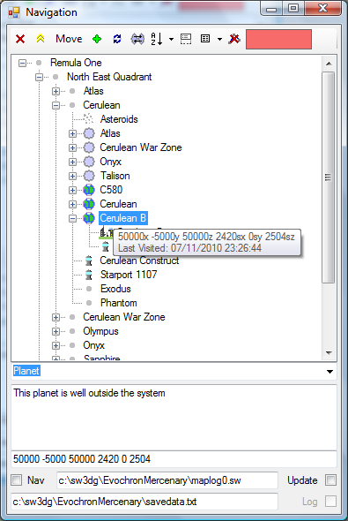Illustration 1: Main Screen
The upper of the two textboxes must point to the Map Log file. This file contains the map log entries that you record in-game. This should be called something like maplog0.sw.
The Nav and Update checkboxes will become active once the file is specified.
Nav – Check this box to turn on the data logger. This will watch the nav log file and add any entries you make in-game to the system.
To keep the map log tidy, you can optionally check the Update tick box. This will delete entries in the map log once they have been added to the system. If you plan on using this, back up your original map log file first!
The lower text box is used to link the the game log file. This is usually called savedata.txt. This allows the program to identify the current location of the pilot when performing route calculation. The Log check box continually outputs your current position to logdata.txt if checked. This can then be used to plot your flight path.
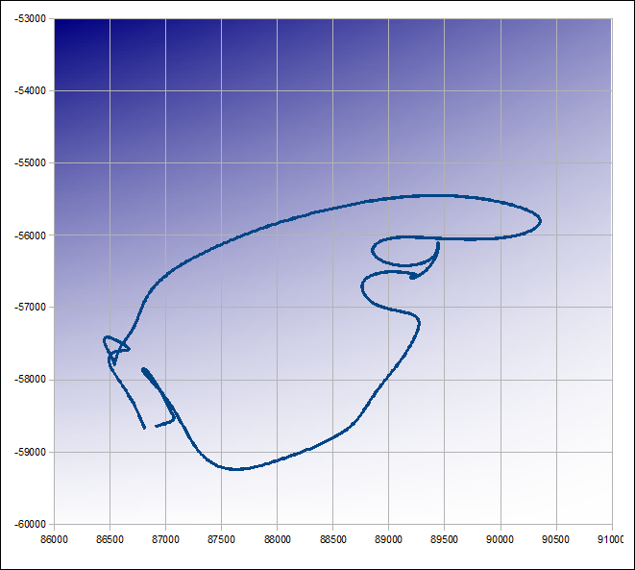Illustration 2: Example Flight Path using OpenOffice

Controls

Toolbar
- Deletes the currently selected node
- Promotes the currently selected node to top level
Move – Moves the selected node to become the child of another. Select the node you wish to move, click this button then click the node you wish to move it to
- Duplicate the selected node and add it as a child
- Refresh the tree view
- Attempts to link jump nodes – See below on managing the jumpgate network
- Toggle the lower panel on or off
- Use this to select the default location for new entries imported from the map log
Top Level – Any new entries will be added to the top level
Selected Node – Any new entries will be added as children of the selected node
- Delete waypoints. If Update is selected, clear waypoints from map log
- Type into the search box to find an entry on the log system. This also doubles up as an indicator to show how close you are to the nearest unvisited object. Hover the mouse cursor over to see what the object is. If this is of no interest, double click the search box and the next closest unvisited item will be displayed (this may take a second or two).
The colour of this box will vary from Blue (cold) to Red (hot). The indicator scale is between 0 and 30 sectors.

Tree View
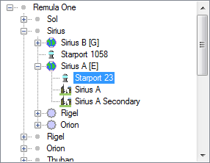Illustration 3: Tree View
The tree is the display area for the navigation database. Information can be arranged in a structured way to improve ease of navigation.
Each entry will have an icon depending on the type of object.
A node can be renamed by clicking the text area and changing its text.
While flying around in evochron, this system will attempt to monitor your position and remember when you visit stations, planets or any other item recorded in this program. Hover the mouse over an entry to see when you last visited an object.
Note, visiting an object will also indicate that all parent objects above it were visited at the same time.

Object Type
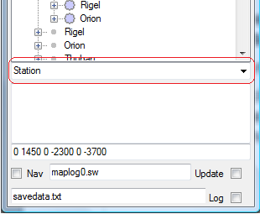Illustration 4: Object Type
Once an object is extracted from the map log, the program will not know what type of object it is. Select the object type from this drop down list.

Comments
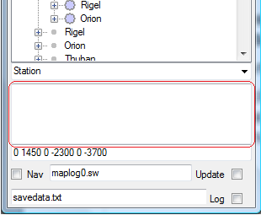Illustration 5: Comments
The large text box below the Object Type combo box is used for putting a description. One exception to this is Jump objects. The text in the comments must be the destination co-ordinates of the jump. See below for further information.

Co-ordinates
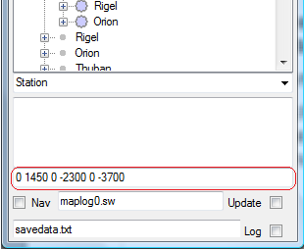Illustration 6: Co-ordinates
This box shows the co-ordinates of the currently selected node. This information is read only.

Logging Data
Once the input files have been specified, the program is ready for use.
- Back up the maplog file
- Launch the data logger and tick the Nav button
- Optionally, click the Update button to empty the map log after reading
- Launch Evochron Mercenary and start flying
- Log places of interest on the Nav log
- Alt+Tab back to the nav log
- The new entry should be in the program ready to organise

The Jump Network
Jump gate information is used to calculate the optimum route between your current location and your arrival point.
The game log and navigation log files must be correctly specified in order to use the route plotter.
Double click an entry and it will plot the best calculated route into the in-game navigation log. It will use known jump points entered into the system Note that both sides of a jump gate are included as waypoints so ignore the arrival jump points.
When recording jump gates, you also need to specify the jump location. There are two ways this can be done:

Manual
- Select the jump gate you wish to configure. Click the clone button to add a sub entry to the jump gate.
- Click this new entry and change the object type to Jump
- Click the destination entry and copy the text in the co-ordinates box
- Click back to the new Jump entry you have just created
- Paste the co-ordinates in the comments box
- Alternatively, you can enter the co-ordinates manually in the format X Y Z SX SY SZ
(Seperate each entry with a space)
- Repeat for the other direction if this is for jumpgates

Automatic
- If you format your jump gate information correctly, the system can calculate all links for you.
- When recording a jump gate, set the type to Jump Gate (you do not need to create a Jump object as this is done automatically)
- Ensure the name of the jump gate matches the name of the system you wish it to jump to
- Ensure the direct parent of the jump gate is a system
- Click the link jumpgates button to attempt to link all recorded jumpgates
- If successful, the system will create a Jump event for your new jumpgate and any other gates which have not been linked yet.

