Rocket Odyssey

Use-Case Model

Version 1.0

Revision History

|  |  |  |  |
| --- | --- | --- | --- |
| **Date** | **Version** | **Description** | **Author** |
| 16/03/2020 | 1.0 | Initial revision | Tofan Emil-Mihai |

Table of Contents

1. Use-Cases Identification 4

2. UML Use-Case Diagrams 4

Use-Case Model

# Use-Cases Identification

**Use case: Administrator’s use case for the application**

**Level: summary level**

**Primary actor: Administrator**

**Main success scenario: The Administrator’s main job represent operations on the database. He will be able to delete users from the database, delete the leaderboard containing the highest scores from the players or delete a specific user’s score history. Besides the database operations, the administrator will be notified everytime a user has provided feedback about the application.e following format:**

**Extensions: If any of the above described operations fail or if the administrator is notified by a user of an existent problem, the administrator will be able to start a series of tests to make sure the application’s normal workflow will be restored.**

**Use case: User’s use case for the application**

**Level: user-goal level**

**Primary actor: User**

**Main success scenario: The User’s job is to play and enjoy the game. Out of all the possibilities that the program has to offer, a user will be able to start a new instance of the game, review his or her history of the highest score obtained during previous instances or view the leaderboard to see where he or she stands compared to other players.e following format:**

**Extensions: If any of the above described operations fail, the user will be able to provide feedback to the administrator**

# UML Use-Case Diagrams

**UML Use-Case Diagram for the User Actor :**

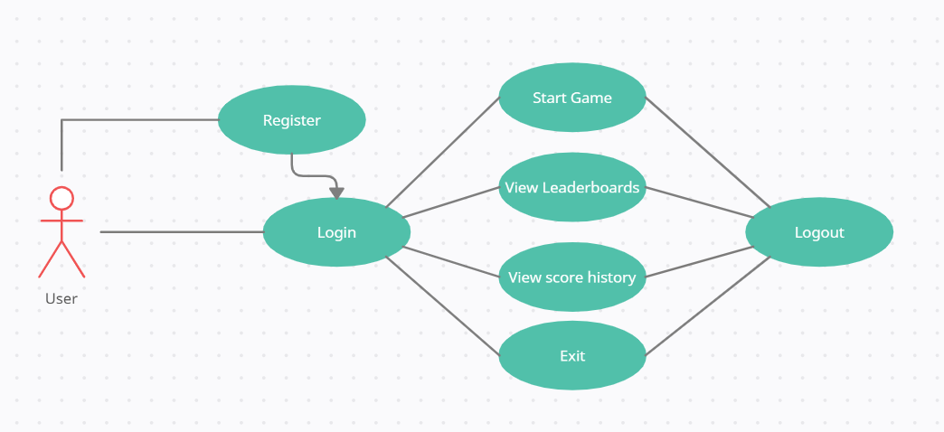

**UML Use-Case Diagram for the Administrator Actor :**

