Topic: Optimized Flood Emergency Evacuation and Relief Distribution System for Urban Areas

Problem Description
Even after the government’s countless attempts and efforts, flooding reamins to be a recurring and serious problem in many of urban areas of Bangladesh, especially large metropolitan areas like Dhaka and Chattogram. This year during the July flash floods in Chattogram, more than 866,000 people were affected, among which 43 were killed. During heavy rainfall or river overflow, roads become submerged, bridges may become unusable, electricity and communication systems may fail, and people may need to be moved quickly from dangerous zones to safer shelters. At the same time, emergency authorities must deliver food, drinking water, medicine, and rescue equipment using a limited number of vehicles.
The proposed problem is to design an algorithmic decision-support system that helps city authorities plan evacuation routes and relief distribution during an active flood. The system receives information about the road network, flooded locations, available shelters, relief warehouses, vehicle capacities, and population distribution. Based on this information, it must identify reachable areas, compute safe routes, prioritize affected zones, assign people to shelters, and select relief items for transportation under limited carrying capacity.
The problem is not simply finding one shortest path. Flood conditions change over time, some roads become unavailable, shelters have limited capacities, and different zones may have different urgency levels. Therefore, the solution requires combining multiple algorithmic techniques from graph theory, sorting, divide and conquer, computational geometry, and dynamic programming.

Given Information
- A city road network represented as a graph G(V, E), where intersections or important places are vertices and roads are edges.
- Road weights representing travel time, distance, water level risk, or road safety.
- A set of flooded points reported by sensors, emergency calls, or field workers.
- A set of affected zones with population size, severity level, and required evacuation priority.
- A set of shelters with locations and maximum capacity.
- A set of relief warehouses containing food, water, medicine, blankets, and other supplies.
- A limited number of relief vehicles, each with a fixed carrying capacity.

Objectives
- Identify which affected areas are reachable through the remaining usable road network.
- Find safe and efficient evacuation routes from affected areas to shelters.
- Prioritize highly affected zones so that rescue and relief operations are not delayed.
- Assign people to shelters while considering shelter capacity and route safety.
- Select relief items for each vehicle so that the most important supplies are delivered within capacity limits.
- Design a low-cost temporary connection network among shelters, warehouses, and control centers if communication or supply links need to be restored.
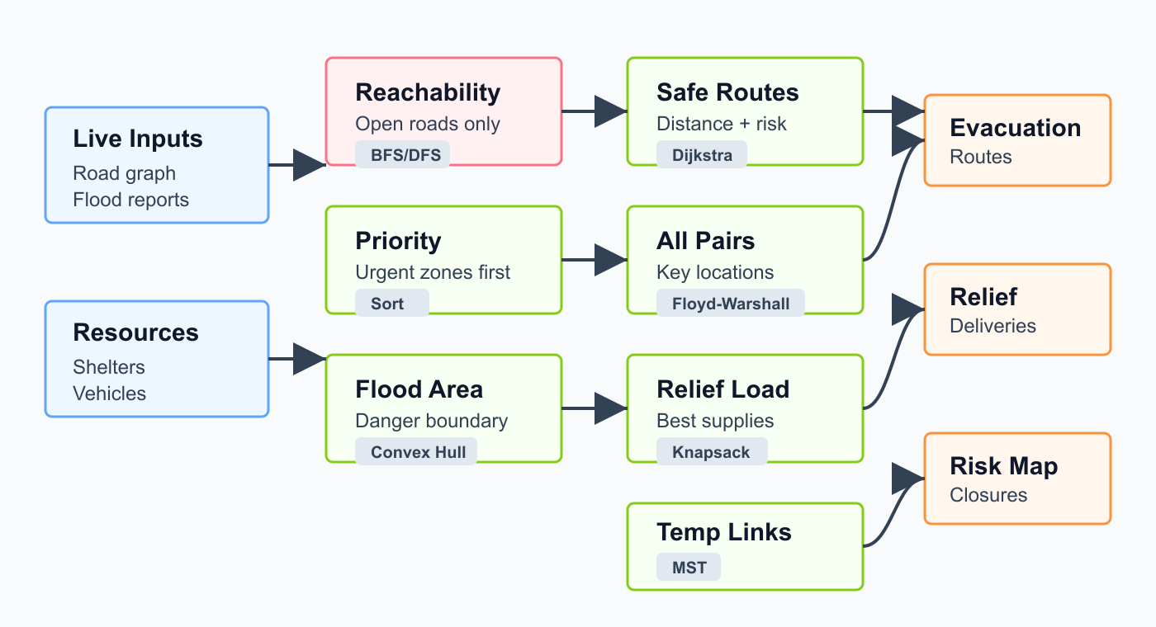Figure 1: proposed pipeline connecting the real world flood-related problems to algorithms

Algorithmic Components
Breadth-First Search (BFS) and Depth-First Search (DFS): BFS or DFS can be used to check whether an affected area is reachable from rescue stations or shelters after flooded roads are removed from the graph. These algorithms can also identify disconnected components in the city network, helping authorities detect isolated zones that may require boats, helicopters, or special rescue teams. Thus, graph traversal algorithms are of paramount importance during emergencies like this where the flood patterns are unpredictable and we need to calculate aavailability of routes on demand.
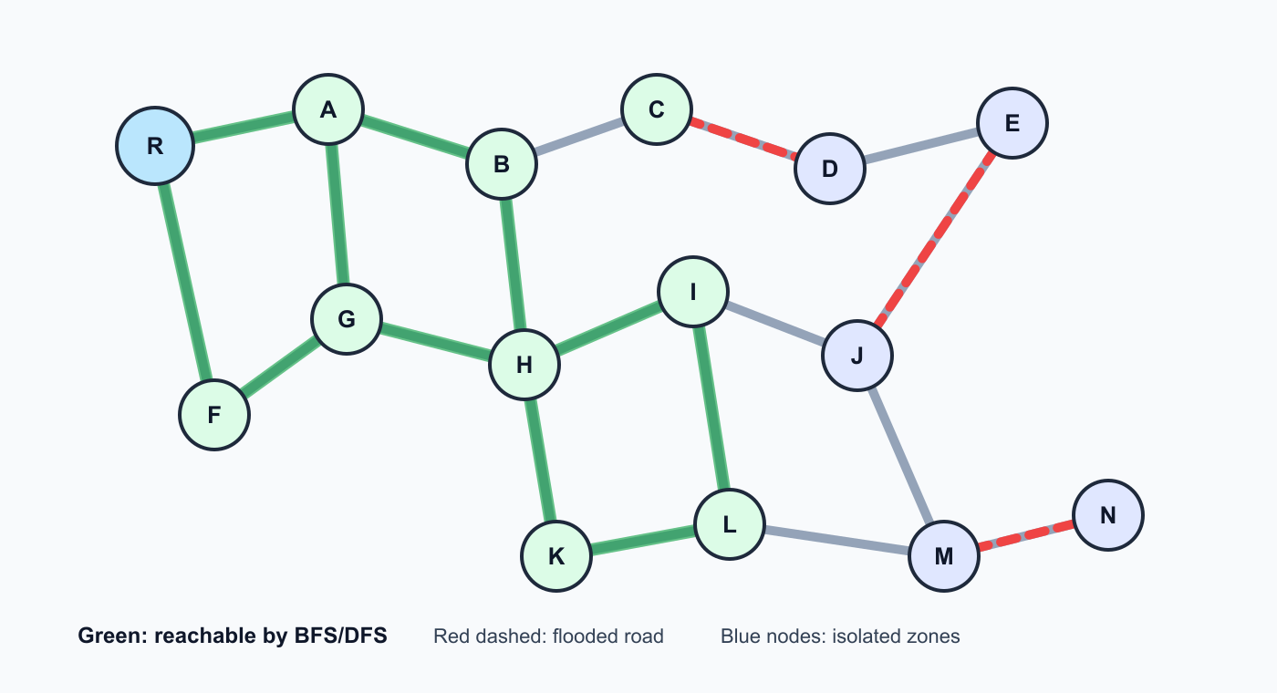Figure 2: connectivity of regions

Dijkstra's Algorithm: Dijkstra's algorithm can be used to find the shortest or fastest safe route from an affected zone to a shelter when all road weights are non-negative. The edge weight may represent travel time, distance, or a combined cost based on both distance and flood risk. Since there are not expected to be any negative weighted edge, rescue or relief teams can use Dijkstra’s Algorithm to quickly map out the best possible path from a relief centre or fire station to a flood-affected area requiring emergency aid.
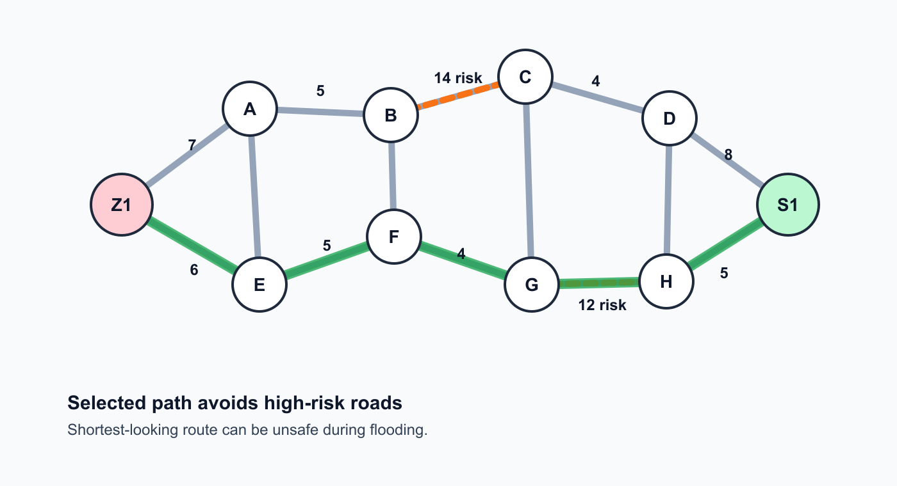Figure 3: best possible route from a srouce to a destination
Floyd-Warshall Algorithm: Floyd-Warshall can compute shortest paths between all important locations, such as shelters, warehouses, hospitals, and rescue stations. This is useful when authorities repeatedly need distance or travel-time information between many pairs of locations.
Prim's or Kruskal's Minimum Spanning Tree Algorithm: If temporary communication lines, supply routes, or emergency service connections must be established among shelters and warehouses, MST algorithms can help choose a minimum-cost set of links that keeps all key locations connected.
Merge Sort, Quick Sort, or Radix Sort: Sorting algorithms can rank affected zones by severity score, population size, estimated waiting time, or risk level. This helps emergency managers decide which areas ld receive rescue teams or relief supplies first.

Convex Hull: Convex hull can be applied to reported flood points to estimate the outer boundary of the flooded region. This boundary helps visualize the danger area and can support decisions about road closures and evacuation zones.
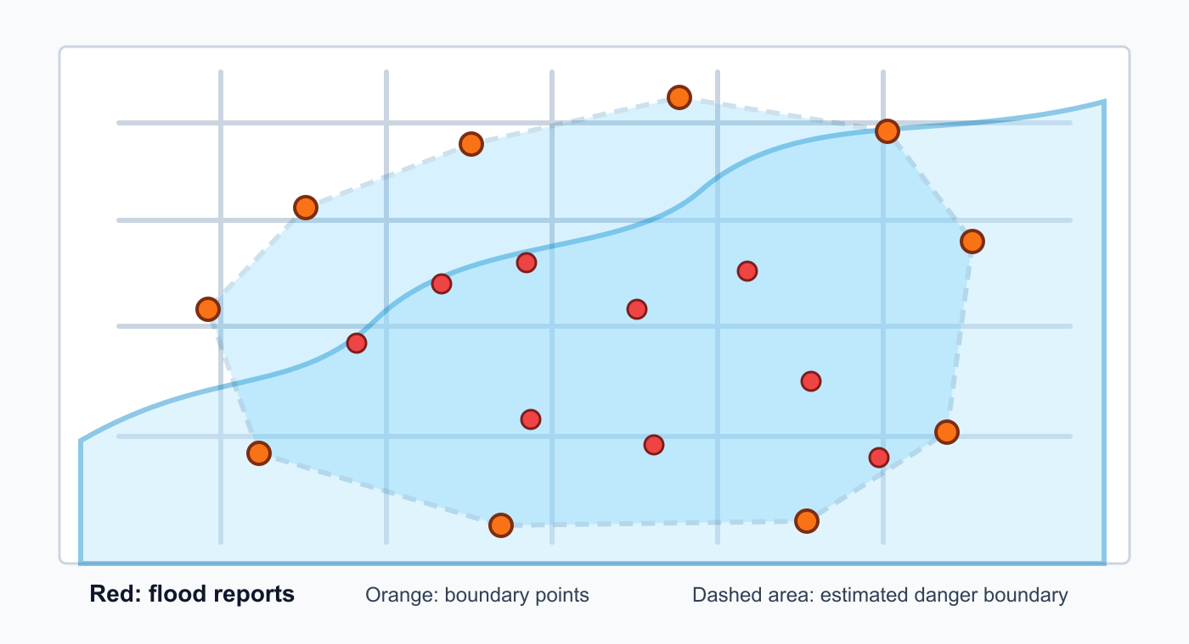Figure 4: convex hull to map out the flood

Dynamic Programming - 0/1 Knapsack: The importance of relief items are often binary, meaning that they need to be either carried as a whole, bearing their entire weight or not carried at all. Thus the concept of the 0/1 Knapsack Problem comes in handy to calculate the best combination of relief items to be carried in a finite capacity. Relief vehicles have limited capacity, while each relief item has a weight and importance value. The 0/1 knapsack algorithm can select the best combination of supplies, such as medicine, food, and water, so that the total value is maximized without exceeding vehicle capacity.

Complex Engineering Problem Criterias Met:
CEP Criterion | Criterion Name | Justification
P1 | Depth of Knowledge | The problem requires in-depth understanding of graph modeling, shortest path algorithms, graph traversal, minimum spanning tree, sorting, convex hull, and dynamic programming. It cannot be solved by a routine formula or a single textbook procedure.
P2 | Conflicting Requirements | The system must balance shortest travel time, safest routes, shelter capacity, vehicle capacity, urgency of victims, and limited resources. A route that is shortest may not be safest, and a shelter that is nearest may already be full.
P3 | Depth of Analysis | There is no obvious single solution because evacuation planning, relief distribution, road availability, and shelter assignment influence each other. The problem requires abstraction, modeling, and integration of several algorithmic sub-problems.
P4 | Familiarity | Real-time flood evacuation and relief distribution is beyond standard classroom examples. It involves uncertain road conditions, changing flood boundaries, and emergency decisions under pressure.
P6 | Stakeholder Involvement | The problem involves citizens, rescue teams, shelter managers, hospitals, traffic authorities, city administrators, and relief organizations. These stakeholders may have different and sometimes conflicting priorities.
P7 | Interdependence | The problem contains many connected sub-problems: road reachability, route optimization, flood boundary estimation, relief item selection, shelter assignment, and emergency network design. A decision in one part affects the constraints and results of other parts.

Conclusion
The optimized flood emergency evacuation and relief distribution system is a real-world engineering problem that strongly depends on algorithms studied in CSE 4403. It uses graph traversal to identify reachable areas, shortest path algorithms for safe routing, sorting for prioritization, convex hull for flood boundary estimation, MST for low-cost emergency network planning, and dynamic programming for relief item selection. Because the problem involves conflicting objectives, multiple stakeholders, and several interdependent components, it qualifies as a Complex Engineering Problem.

Youtube Link to Presentation:
https://youtu.be/Pzme0o9nkPY

