Movie Scout Lab Report
Project: Movie Browser with JavaFX, DAO Classes, and MariaDB
Database: vpl_lab
Module: Lab9 / DatabaseServerProject

1. Problem Statement
The lab task was to prepare a movie browsing application and explain the database schema, DAO classes, Java classes, database queries, dynamically added UI components, FXML files, application screenshots, and database schema evidence.
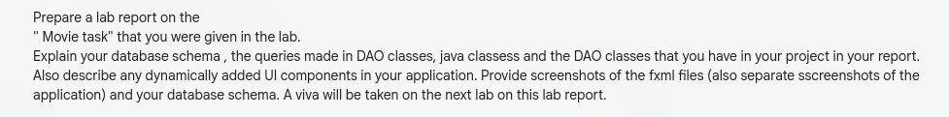
Figure 1: Given lab report requirements.

2. Project Overview
Movie Scout is a JavaFX desktop application that displays a collection of movies from a MariaDB database. The application supports browsing all movies, searching by movie title, filtering by genre, viewing movie details, and adding or removing movies from a Watch Later list.
Part
DatabaseServerProject
src/application

3. Database Schema
The database contains two tables: movies and watch_later. The movies table stores all movie information. The watch_later table stores selected movie IDs and references movies.id.
Relationship: movies.id 1 --- 0..1 watch_later.movie_id. The foreign key uses ON DELETE CASCADE, so deleting a movie also deletes its Watch Later row.
movies column
id
title
genres
cast_members
duration_minutes
imdb_rating
summary
poster_url
watch_later column
movie_id
created_at
CREATE TABLE IF NOT EXISTS movies (
id INT AUTO_INCREMENT PRIMARY KEY,
title VARCHAR(160) NOT NULL UNIQUE,
genres VARCHAR(180) NOT NULL,
cast_members VARCHAR(260) NOT NULL,
duration_minutes INT NOT NULL,
imdb_rating DECIMAL(3,1) NOT NULL,
summary TEXT NOT NULL,
poster_url VARCHAR(500) NOT NULL
);
CREATE TABLE IF NOT EXISTS watch_later (
movie_id INT PRIMARY KEY,
created_at TIMESTAMP DEFAULT CURRENT_TIMESTAMP,
CONSTRAINT fk_watch_later_movie
FOREIGN KEY (movie_id) REFERENCES movies(id)
ON DELETE CASCADE
);

4. Database Evidence
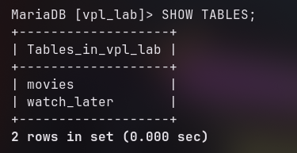
Figure 2: MariaDB output showing the movies and watch_later tables.
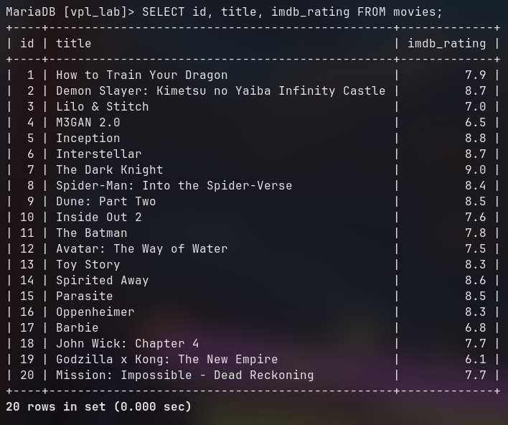
Figure 3: Movie records stored in the movies table.
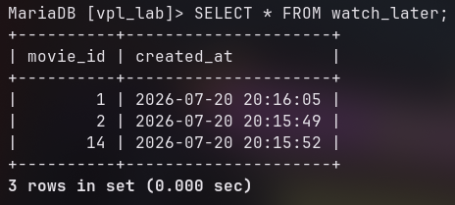
Figure 4: Records stored in the watch_later table.

5. DAO Classes and Queries

5.1 DBConnection
DBConnection centralizes JDBC connection creation. Both the database server module and the JavaFX client use JDBC to connect to the local MariaDB server.
public static Connection getConnection() throws SQLException {
return DriverManager.getConnection(URL, USER, PASSWORD);
}

5.2 MovieSeedDAO
MovieSeedDAO prepares the database for the client application. It creates the database, creates tables, inserts seed data, and counts movies after setup.
public void initializeDatabase() throws SQLException {
createDatabase();
createTables();
seedMovies();
}
The seed query uses INSERT IGNORE. This prevents duplicate records because title is unique in the movies table.
INSERT IGNORE INTO movies
(title, genres, cast_members, duration_minutes, imdb_rating, summary, poster_url)
VALUES (?, ?, ?, ?, ?, ?, ?)

5.3 MovieDAO
MovieDAO reads movie data from the database. It contains methods for counting movies, searching movies, loading genres, and finding a movie by ID.
Counting movies:
SELECT COUNT(*) AS movie_count FROM movies
Searching and filtering movies:
SELECT m.id, m.title, m.genres, m.cast_members, m.duration_minutes,
m.imdb_rating, m.summary, m.poster_url,
CASE WHEN wl.movie_id IS NULL THEN FALSE ELSE TRUE END AS watch_later
FROM movies m
LEFT JOIN watch_later wl ON wl.movie_id = m.id
WHERE LOWER(m.title) LIKE LOWER(?)
ORDER BY m.imdb_rating DESC, m.title
The LEFT JOIN allows the application to show whether each movie is already in Watch Later. The LIKE condition supports title search. Genre and Watch Later filters append extra WHERE conditions.
Loading genres:
SELECT genres FROM movies ORDER BY genres
The DAO splits comma-separated genres in Java, removes duplicates, and fills the genre combo box.
Finding a movie by ID:
WHERE m.id = ?
This prepared statement is used when a movie card is clicked and the detail dialog opens.

5.4 WatchLaterDAO
WatchLaterDAO manages insert and delete operations for the Watch Later list.
INSERT IGNORE INTO watch_later (movie_id) VALUES (?)
This query adds a movie to Watch Later. INSERT IGNORE avoids duplicate insert errors because movie_id is the primary key.
DELETE FROM watch_later WHERE movie_id = ?
This query removes a movie from Watch Later.

6. Java Classes
Class
Main
MovieScoutApplication
Movie
MovieDAO
WatchLaterDAO
DatabaseServerApplication
MovieSeedDAO

7. Dynamic UI Components
The FXML file defines the main layout containers, search field, genre combo box, status label, and empty movie grid. The movie cards are generated dynamically in Java after records are loaded from the database.
movieGrid.getChildren().setAll(
movies.stream().map(this::createMovieCard).toList()
);
Each movie card is created by createMovieCard(Movie movie). The method creates a poster, title label, year label, genre chips, rating row, and click handler.
VBox card = new VBox(10, posterPane, body, ratingRow);
card.getStyleClass().add("movie-card");
card.setOnMouseClicked(event -> showDetails(movie.getId()));
Genre chips are dynamic because the code splits each movie genre string and creates a new Label for each genre.
for (String genre : movie.getGenres().split(",")) {
Label chip = new Label(genre.trim());
chip.getStyleClass().add("genre-chip");
chips.getChildren().add(chip);
}

8. FXML Files

8.1 movie-browser-view.fxml
This FXML file defines the main browser screen: top bar, theme button, navigation buttons, search field, genre combo box, movie grid, and status bar.
<TextField fx:id="searchField" promptText="Search movie..." />
<ComboBox fx:id="genreBox" promptText="All Genres" />
<FlowPane fx:id="movieGrid" hgap="18.0" vgap="22.0" />
<Label fx:id="statusLabel" text="Ready" />

8.2 movie-detail-view.fxml
This FXML file defines the movie detail dialog layout. Java fills the controls after a movie card is clicked.
<StackPane fx:id="posterSlot" prefHeight="320.0" prefWidth="220.0" />
<Label fx:id="detailTitle" wrapText="true" />
<Label fx:id="detailMeta" />
<Label fx:id="detailGenres" wrapText="true" />
<Button fx:id="detailWatchLaterButton" text="Add to Watch Later" />

9. Application Screenshots
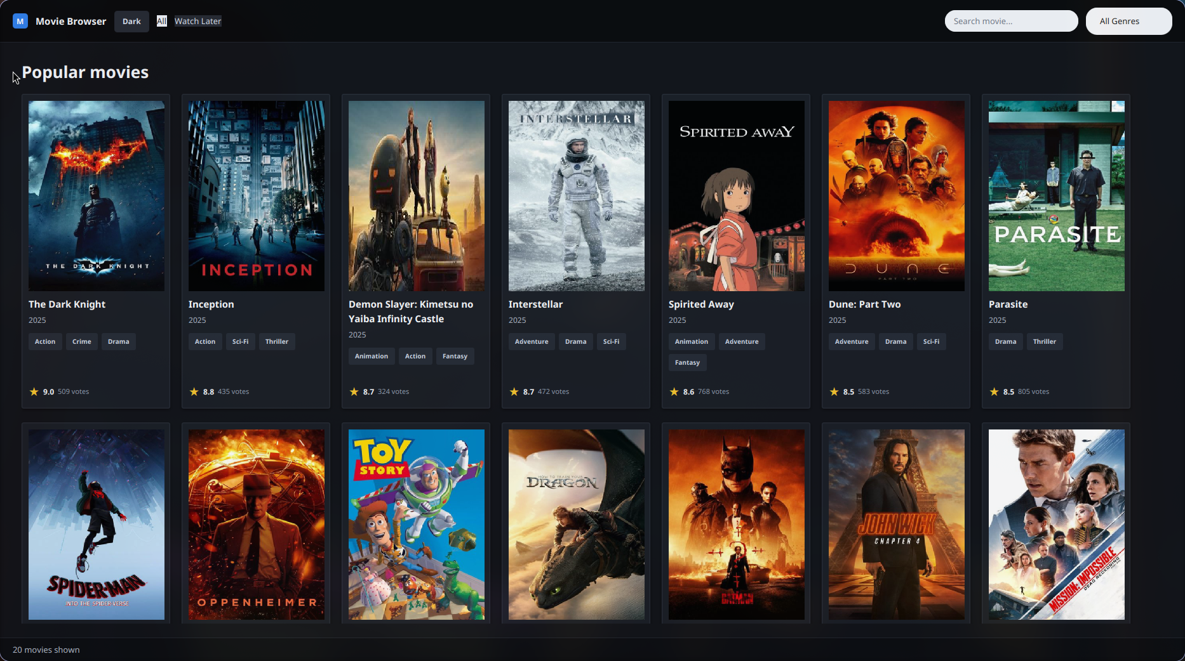
Figure 5: Home screen showing all popular movies loaded from the database.
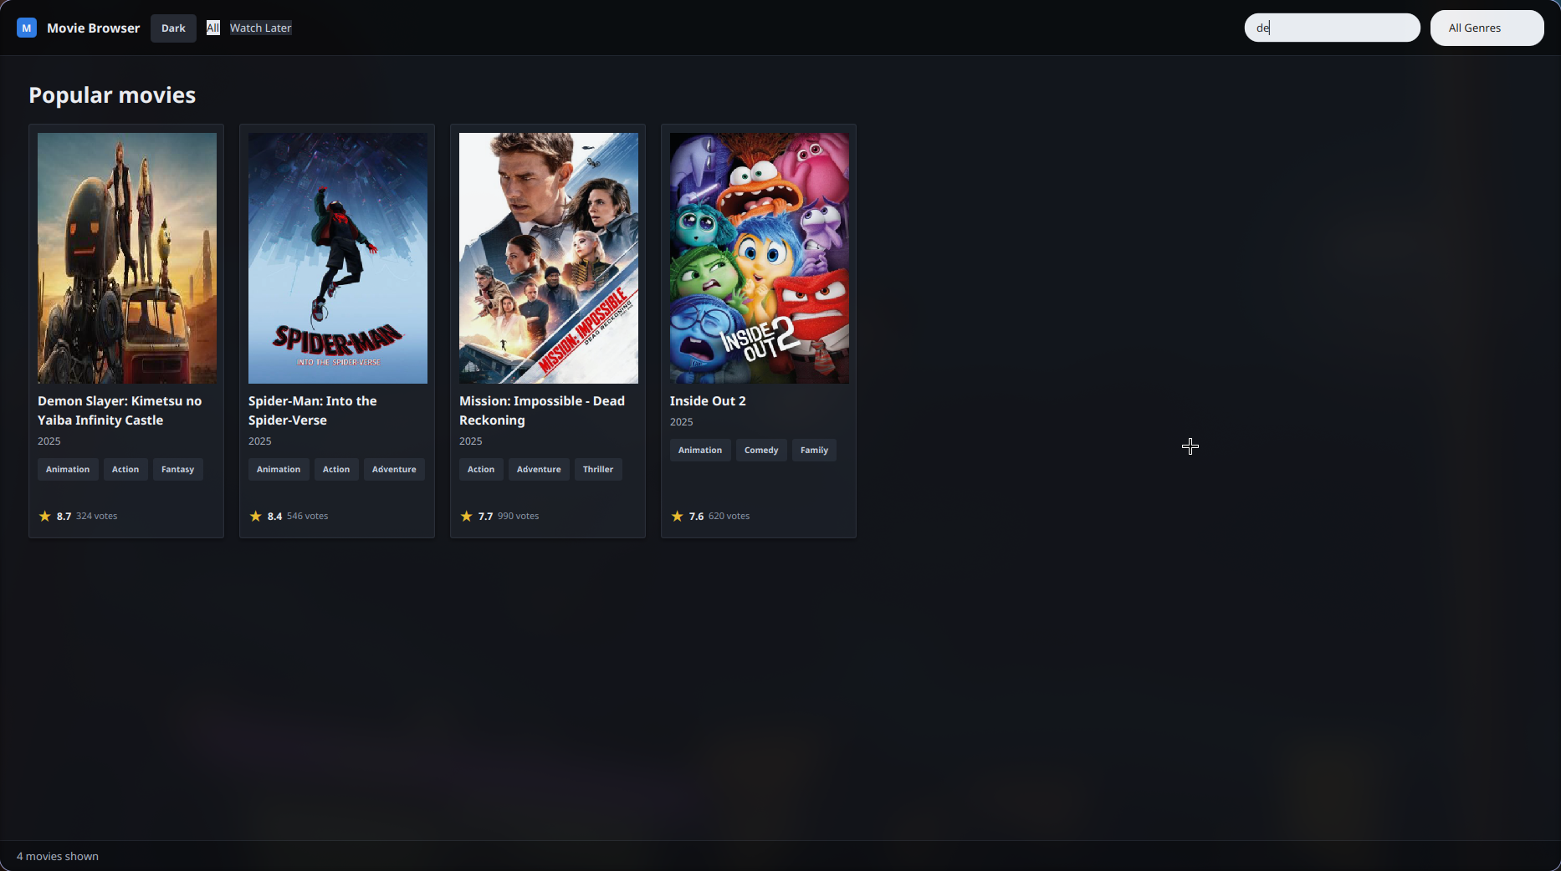
Figure 6: Search feature filtering movies by title text.
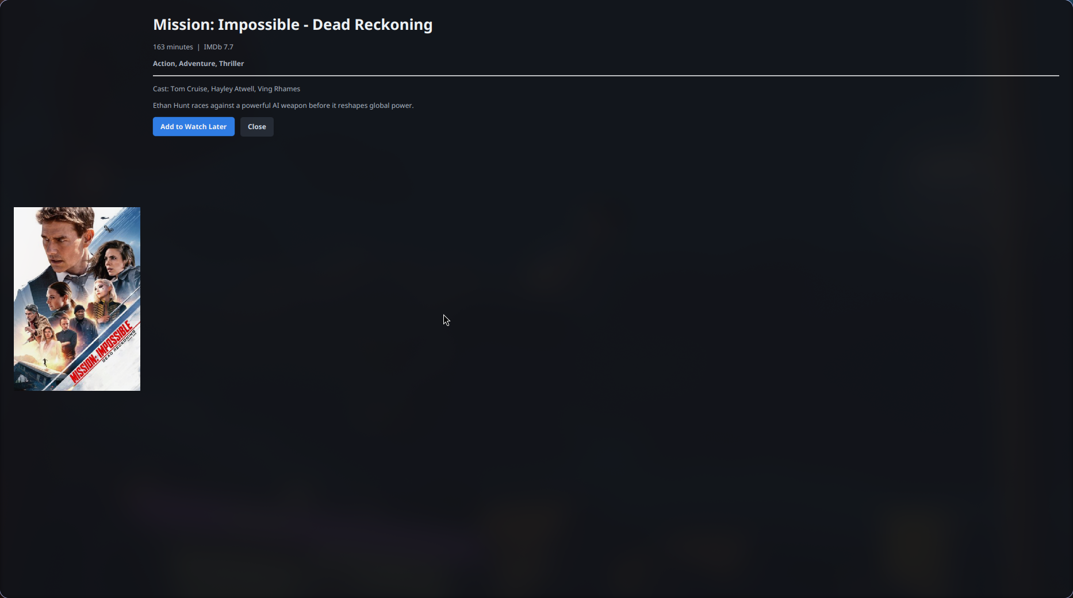
Figure 7: Movie detail dialog with poster, metadata, cast, summary, and Watch Later button.
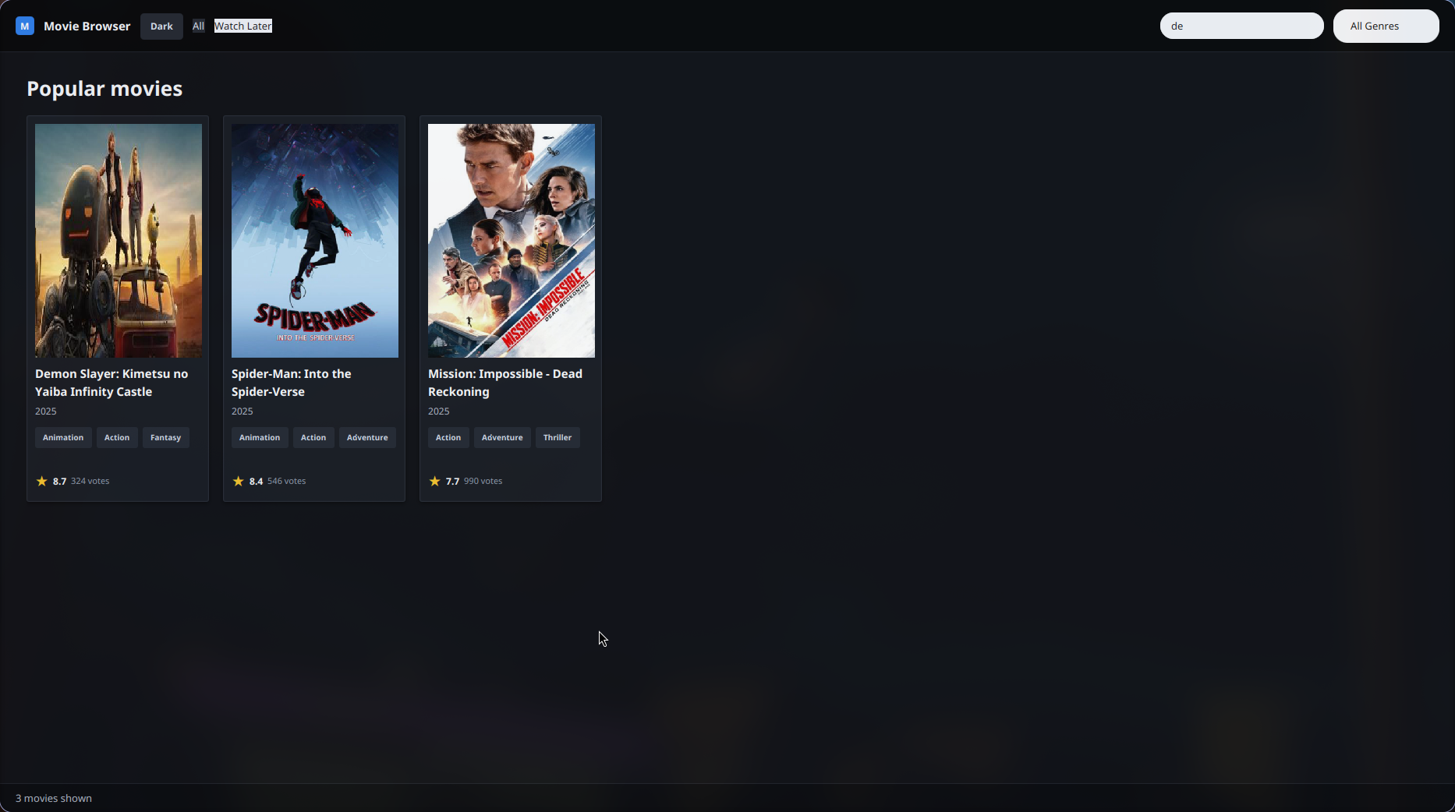
Figure 8: Watch Later view showing movies saved in the watch_later table.

10. Conclusion
The project satisfies the movie browsing task by combining a JavaFX user interface with a MariaDB database backend. The database server module initializes the schema and seed data, while the client uses DAO classes to run prepared SQL queries. The application dynamically generates movie cards, supports live search and filtering, displays detailed movie information, and persists Watch Later selections in the database.

