1. Vim in 100 secs
https://www.youtube.com/watch?v=-txKSRn0qeA
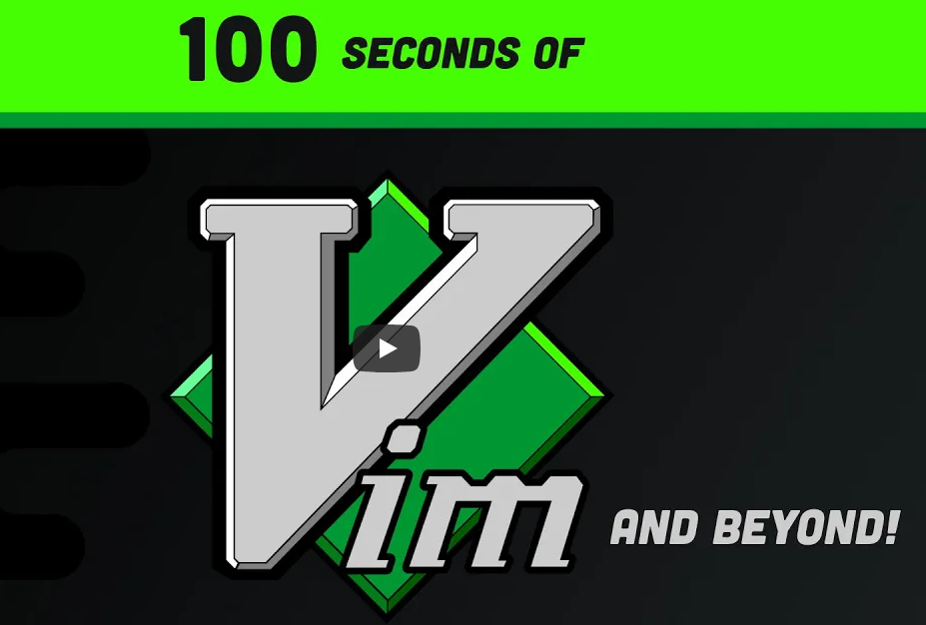

2. Vim tutorial
https://www.youtube.com/watch?v=IiwGbcd8S7I
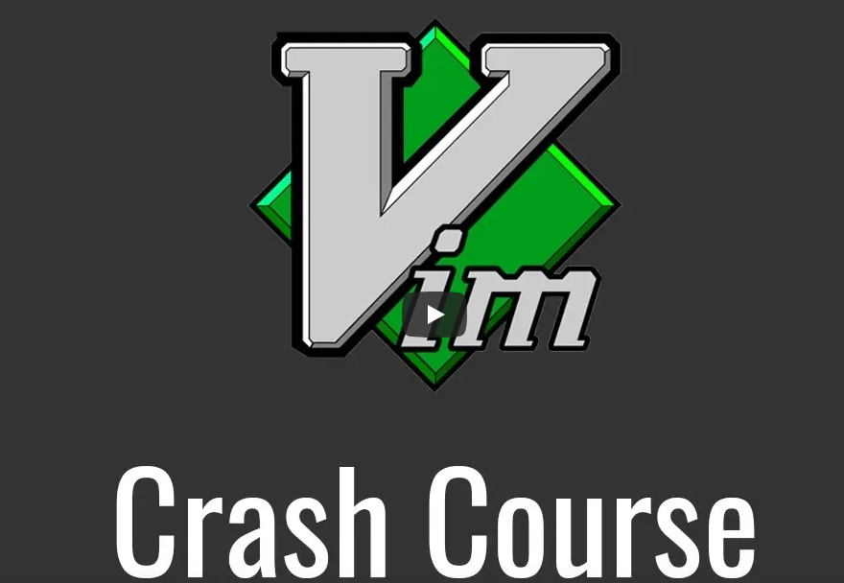

3. Vim (Secrets)
