Cache Coherence Examples
You can have multiple copies of any one instruction operand in a shared memory multiprocessor with a separate cache memory for each processor. In main memory and in each cache memory simultaneously. If one copy of an operand is changed, other copies of the operand must also be changed. Cache coherence inconsistency arises if it is not changed.[1]
There are three levels of cache coherence problem [1]:
- Every writing operation looks instantaneous.
- For every separate operand, all processors see the same values.
- Different processors may see an operation and assume different values for variables. This situation is called non-coherent behavior.
Because there are multiple levels in a memory hierarchy, some of these levels are private to other processors (for example cpu’s caches are private to each other). Hence some levels may contain copies of a value that are inconsistent with other copies of the value.[2]
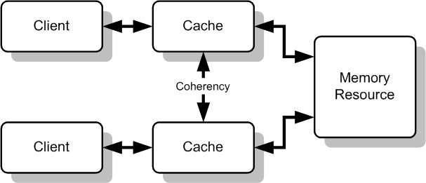
Figure 1- Multiple memory caches acting like a shared resource [2]
Cache coherence appears in stale web caches and un-updated code repositories as well as in computer architecture as you can see in Figure. [3]
Let’s say I have a computer. In this computer there is a microprocessor. In this microprocessor there are 3 parallel working cpu’s and each cpu has its own cache(small memory). These cpu’s sharing a shared bus and a shared memory as you can see in Figure 1.
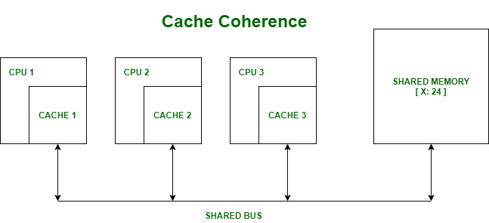
Figure 2-Cache Coherence Example 1 [1]
Let say in our shared memory, there is a variable named X and it is equal to 24. [1]
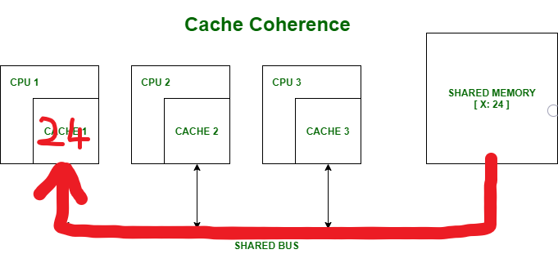
Figure 3-Cache Coherence Example 1
At Figure 3 processor 1 reads variable x and obtains 24 from the memory and caches it. [1]
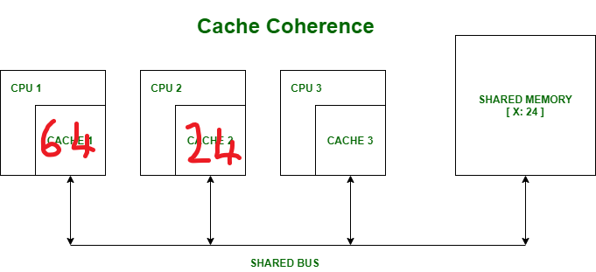
Figure 4- Cache Coherence Example 1
At Figure 4, processor 2 reads x as 24 and obtains it from memory then caches it in its cache. [1]
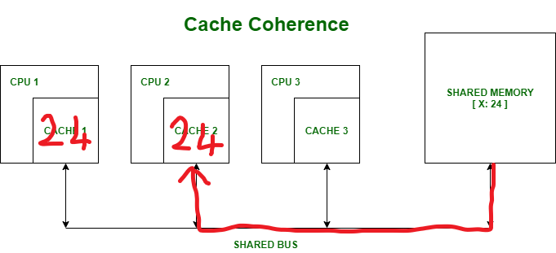
Figure 5-Cache Coherence Example 1
At Figure 5 processor 1 writes 64 to variable x instead of previous value 24. Its locally cached copy is updated. [1]
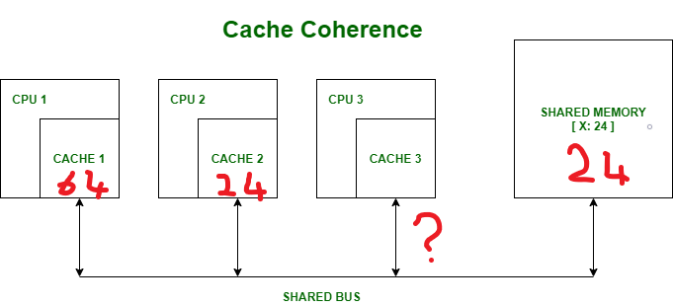
Figure 6- Cache Coherence Example 1
At Figure 6 processor 3 reads variable x. What value should it get? Shared memory and processor 2 thinks the value of the variable x is 24 and processor 1 thinks it is 64. This is a data inconsistency and the cache coherence problem.[1]
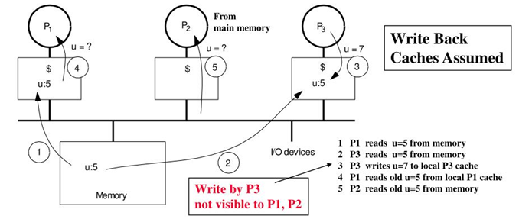
Figure 7- Cache Coherence Example 2 [4]
As you can see in Figure 7, processors see different values for variable u after event 3. A value that has been modified in the cache could not have been written back to memory with a write back cache. Processes can see a previous value when accessing main memory. It is unacceptable because it leads to the wrong execution of the program.[4]

Summary
This problem is most apparent when individual processors maintain a cached copy of a unique shared-memory location and change that copy. It might occur in computer architecture and web applications when multiple levels in a memory hierarchy are private to other levels. Because of that, some levels may contain copies of a value that are inconsistent with other copies of the value.

References
[1]cu16bsc3173(24-08-2020).Cache coherence:
https://www.geeksforgeeks.org/cache-coherence/
[2]Wikipedia contributors(23-11-2020)Cache coherence:
https://en.wikipedia.org/wiki/Cache_coherence
[3]Wood,Hill,Sorin.(2011).A primer on memory consistency and cache coherence:
https://course.ece.cmu.edu/~ece847c/S15/lib/exe/fetch.php?media=part2_2_sorin12.pdf
[4]Shaaban(spring 2009)EECC756:
https://image3.slideserve.com/6553848/cache-coherence-problem-example-l.jpg

