CUKUROVA UNIVERSITY

Coloring Algorithms



Selahattin Bozan
2015556010

Orhan Çelik
2015556014

İksen Ekmekçi
2017556024

CONTENTS

1.ABSTRACT .…………………….............................................2

2.COLORING ALGORITHMS .......................................................3

3. COLORING ALGORITHM:GREEDY ..........................................5

4. PSEUDO CODE ..........................................................................5

5. IMPLEMENTING ALGORITHM WITH USING C++ ....................6

6.CONCLUSION...............................................................................8

7.REFERENCES...............................................................................9

1.Abstract

The graph coloring problem is a practical method of representing many real world problems including time scheduling, frequency assignment, register allocation, and circuit board testing. In this project we implement Greedy Coloring Algorithm to find a solution for the graph coloring problem.

2.COLORING ALGORITHMS

There are many Coloring Algorithms but we will only work on Greedy in this section. The greedy coloring for a given vertex ordering can be computed by an algorithm that runs in linear time.

3. COLORING ALGORITHMS:GREEDY

Showing step by step how the algorithm.

Example 1
Assing colour to first vertex
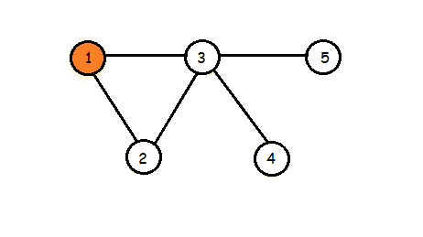

Traverse every vertex and assing color by checking
Colors assinned to it’s adjacent vertices
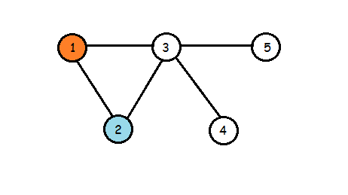

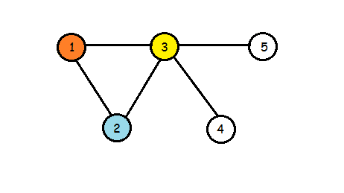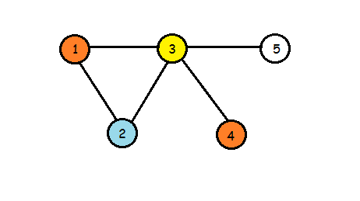
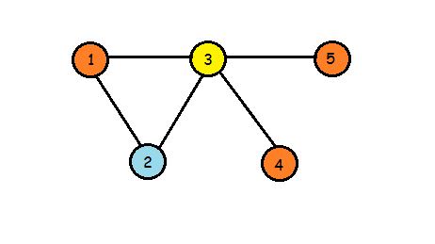

Example 2

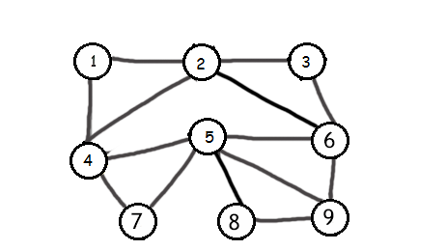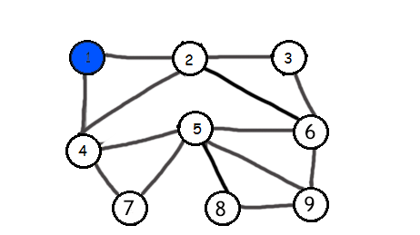

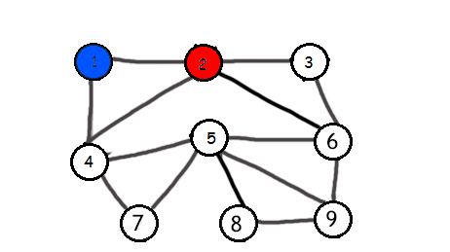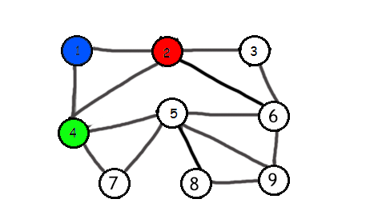
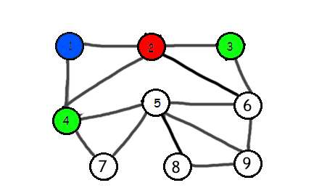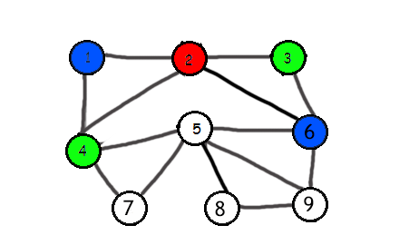

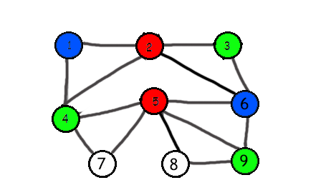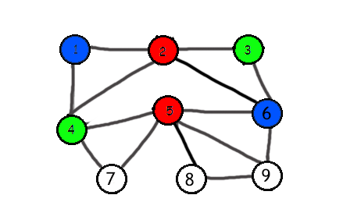
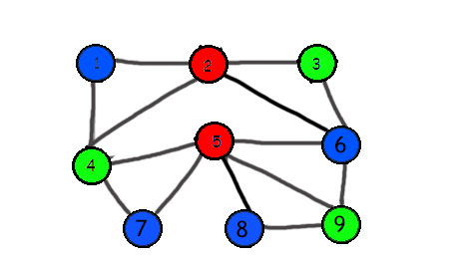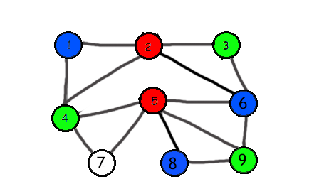

4. PSEUDE CODE

set Greedy (Set Candidate){
solution= new Set( );
while (Candidate.isNotEmpty()) {
next = Candidate.select(); //use selection criteria,
//remove from Candidate and return value
if (solution.isFeasible( next)) //constraints satisfied
solution.union( next);
if (solution.solves()) return solution}
//No more candidates and no solution
return null
}

Pseudo code for greedy cont.

select() chooses a candidate based on a local selection criteria, removes it from Candidate, and returns its value.

isFeasible() checks whether adding the selected value to the current solution can result in a feasible solution (no constraints are violated).

solves() checks whether the problem is solved.

5.IMPLEMENTING ALGORITHM WITH USING C++

// A C++ program to implement greedy coloring algorithm
#include <iostream>
#include <list>
using namespace std;

// A class for an undirected graph
class Graph
{
int VER; // number of vertices
list<int> *adj; // A dynamic array of adjacency lists
public:
// Constructor destructor
Graph(int VER) { this->VER = VER; adj = new list<int>[VER]; }
~Graph() { delete [] adj; }

// function to add an edge
void addEdge(int v, int w);

// Prints greedy coloring algo
void greedyColoring();
};

void Graph::addEdge(int v, int w)
{
adj[v].push_back(w);
adj[w].push_back(v); //undirected graph
}

// Assigns colors (starting from 0) to all vertices and prints
// the assignment of colors
void Graph::greedyColoring()
{
int result[VER];

// first color to first vertex
result[0] = 0;

for (int u = 1; u < VER; u++)
result[u] = -1; // no color is assigned to u

/* A temporary array to store the available colors. True
value of available[cr] means that the color cr is
assigned to one of its adjacent vertices*/

bool available[VER];
for (int cr = 0; cr < VER; cr++)
available[cr] = false;

// Assign colors to remaining V-1 V:verticies
for (int u = 1; u < VER; u++)
{
/* Process all adjacent vertices and flag their colors
as unavailable*/

list<int>::iterator i;
for (i = adj[u].begin(); i != adj[u].end(); ++i)
if (result[*i] != -1)
available[result[*i]] = true;

// Find the first available color
int cr;
for (cr = 0; cr < VER; cr++)
if (available[cr] == false)
break;

result[u] = cr; // Assign the found color

// Reset the values back to false for the next iteration
for (i = adj[u].begin(); i != adj[u].end(); ++i)
if (result[*i] != -1)
available[result[*i]] = false;
}

// print
for (int u = 0; u < VER; u++)
cout << "Vertex " << u << " ---> Color "
<< result[u] << endl;
}

int main()
{
Graph g1(5);
g1.addEdge(0, 1);
g1.addEdge(0, 3);
g1.addEdge(1, 4);
g1.addEdge(1, 2);
g1.addEdge(2, 4);
g1.addEdge(3, 2);
cout << "Coloring of graph 1 \n";
g1.greedyColoring();//Running the greedy coloring algorithm for graph above

Graph g2(5);
g2.addEdge(0, 1);
g2.addEdge(0, 2);
g2.addEdge(1, 2);
g2.addEdge(1, 3);
g2.addEdge(2, 4);
g2.addEdge(4, 2);
cout << "\nColoring of graph 2 \n";
g2.greedyColoring();//Running the greedy coloring algorithm for graph above

return 0;
}
Output:
Coloring of graph 1
Vertex 0 ---> Color 0
Vertex 1 ---> Color 1
Vertex 2 ---> Color 0
Vertex 3 ---> Color 1
Vertex 4 ---> Color 2

Coloring of graph 2
Vertex 0 ---> Color 0
Vertex 1 ---> Color 1
Vertex 2 ---> Color 2
Vertex 3 ---> Color 0
Vertex 4 ---> Color 0

6.CONCLUSION

The project aims at finding an optimized solution to the graph coloring problem with using Greedy Algorithm. Greedy graph coloring is widely used. Unfortunately,
there is no efficient algorithm available for coloring a graph with minimum number of colors as the problem is a known NP Complete problem. There are approximate algorithms to solve the problem though. Following is the basic Greedy Algorithm to assign colors. It doesn’t guarantee to use minimum colors, but it guarantees an upper bound on the number of colors. The basic algorithm never uses more than d+1 colors where d is the maximum degree of a vertex in the given graph.

7.REFERENCES
- https://iq.opengenus.org/graph-colouring-greedy-algorithm/
- https://en.wikipedia.org/wiki/Greedy_coloring
- https://www.geeksforgeeks.org/graph-coloring-set-2-greedy-algorithm/
- https://www.cs.cornell.edu/courses/cs3110/2012sp/recitations/rec21-graphs/rec21.html
- https://www.geeksforgeeks.org/graph-coloring-set-2-greedy-algorithm/

