


ÇUKUROVA UNIVERSITY

ENGINEERING FACULTY
DEPARTMENT OF COMPUTER ENGINEERING

ALGORITHMS

The Reducability of 3SAT to KNAPSACK PROBLEM

Assistant Professor Fatih Abut

CAHİT BARKIN ÖZER
2018556059

EFE İNCEFİKİR
2018556453

ÖMER AKGÜL
2019556460

12.12.2020
ADANA
The Reducability of 3SAT to Knapsack Problem

Abstract 3

1. Introduction 3
a. History of knapsack problem 3
b. Explanation of the problem 3
2. Concrete examples to satisfy the knapsack problem 4
a. Recursion method 4
b. Dynamic programming method 5
c. Memorization Method 6
d. Comparison of the methods 7
3. Rreducibility of 3sat to knapsack 7
a. 3sat explanation 7
b. Reducibility operation of 3sat to knapsack 7
Summary and Conclusion 9
References 10

Abstract

The Knapsack problem is an old and one of the most common algorithm problems with several variants. At the end of this paper, we will have an overall understanding of Knapsack's history, explanation, versions and solution methods. We would also clarify the 3SAT reducibility of the problem and solve two examples. We will end with the summary and the conclusion.

- Introduction

- History of knapsack
The Knapsack Problem is a well-researched problem throughout the history, some works at dates as early as 1897. The name of the problem is first seen in the works of Tobias Dantzig, a mathematician. It is a reference to the problem of packing the most useful items to a luggage.
The Knapsack problem is a popular problem that most researchers deal. A study at the Stony Brook University Algorithm Repository in 1999 says that the knapsack problem was the 19th most common among other problems. [1]
One example for an early application of knapsack algorithms is in making and grading tests which takers of the test have the choice of which question they answer. It is a simple process for small examples. For example, a test taker must answer all the questions to achieve the highest possible score of 100 in a 12-question test, each worth 10 points. However, it is more difficult to provide options in tests where the score values are heterogeneously distributed. On April 1, 1973, Martin Feuerman and Harvey Weiss proposed a system where test takers were given a heterogeneous test with a score of 125. They wanted students to answer the questions the best they can. A knapsack problem would then get a subset of problems that points added up to 100 and take the one which gives the student best possible score out of them. [2]
b. Explanation of the problem
The Knapsack Problem is a problem that is well integrated to our day to day lives. Think of this instance for example: You are going to a small road trip with your friends. You do not want to carry the burden of luggage, so you decide to take only a backpack with you. But there are lots of things you want to carry with you too. Maybe you want to finish that book you are almost at the end of, maybe you want to take pictures of the landscapes you are about the visit, or you want to draw those landscapes to see what your interpretation of them will look like. You must make compromises if you want the convenience just carrying a backpack. To make the most out of the space of your backpack, you must give values to your items, and divide them to the space they are occupying. If you take the items with most value. after that equation, you will carry the maximum amount of value your backpack can carry. This is how the Knapsack Problem works. It is a problem to find the most value for our limited space, so its primary duty is optimization. The Knapsack Problem can be found in domains such as mathematics, complexity theory, cryptography, combinatorics, computer science, etc.
The “knapsack problem,” pushes the limits of computing. And this problem is not just a thought experiment, it is a lot more. “A lot of problems we face in life, be it business, finance, including logistics, container ship loading, aircraft loading — these are all knapsack problems. From a practical perspective, the knapsack problem is ubiquitous in everyday life.” - Carsten Murawski, professor at the University of Melbourne in Australia.[3]
Once most researchers used the Knapsack problem’s complexity to create security systems, but now these systems can be cracked easy because of how well The Knapsack problem has been studied. The knapsack problem is a “NP” problem, which is an acronym for “nondeterministic polynomial time.” The name references how a computer goes through numerous steps for the sake of arriving at a solution. Size of the inputs increments the number considerably. [3]
2.Concrete examples to satisfy the knapsack problem
For this section, we will focus only on solving binary (0-1) knapsack problems. Some of those algorithms are brute force (Recursion), dynamic programming, memory functions (memorization method), branch and bound, greedy, and genetic algorithms. Three of these will be mentioned and compared.[5]
  - Recursion Method
Main idea of this method is going over all the combinations of items. It is a direct way to satisfy the problem.
A function, which gives the maximum value of items combined defined first. It can be called as maxSack(Item ,capacity). This function returns the maximum value we get whether with or without the Item passed through. We have a list of items’ weight on weight[] array.
To solve the problem, the maxSack function is called with 0th item. The function then calls itself with the new capacity and 2nd. This goes on until we pass through all the subsets. When the recursion ends, it returns the best solution.
Here is the pseudo code explaining the process [6]:
optknapsack(k, w)
//basecase
if (w ≤ 0)
return 0
if (k ≤ 0)
return 0
//choice 1: take item k from the knapsack
if (weight[k] ≤ w)
with = value[k] + optknapsack(k − 1, w − weight[k])
else
with = 0
//choice 2: do not take item k from the knapsack
without = optknapsack(k − 1, w)
//the optimal solution is the best of the two
return max(with, without)
The complexity of this method can be calculated as follows,
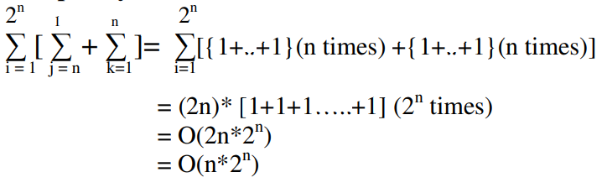
Figure 1 Calculation Of Complexity [2]
As you can see at the Figure 1, Brute Force algorithm’s complexity is O(n2^n).
  - Dynamic Programming
The idea behind dynamic programming is dividing the problem into smaller parts. To achieve this, an iterative way is followed. A table is supposed to be formed first. Then it’s filled the same way as recursion method executed. As we have a combination table, it is no longer needed to calculate each subtree. Now we only need to calculate each combination once. [4]
Here is the pseudo code explaining the process [6]:

create T[0..n][0..W] and initialize all entries to 0
for (k = 1; k < n; k + +)
for (w = 1; w < W; w + +)
if (w[k] ≤ w)
with = v[k] + T[k-1][w-w[k]]
else with=0
without = T[k-1][w]
T[k][w] = max(with, without)
return T[n][W]
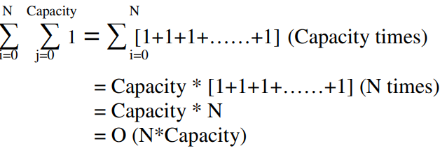
Figure 2 Calculation Of Complexity [5]
As you can see at the Figure 2, the complexity of the Dynamic Programming algorithm is O(N*Capacity)[5].
  - Memorization Method
If we think about the dynamic programming method, only improvement achieved is not calculating the same combination twice. So, if in the recursion method, we don’t calculate already calculated numbers, we reduce the complexity. To do this we need to memorize all combinations. There is a table defined to do this and in each subtree this table is checked. The complexity of this method can be calculated the same as dynamic programming. It’s calculated in Figure 2.
Here is the pseudo code explaining the process [6]:
optknapsackDP(k, w)
//basecase
if (w ≤ 0) return 0
if (k ≤ 0) return 0
if (T[k][w] 6= 0) return T[k][w] //if solution already computed, return it
if (w[k] ≤ w) //choice 1: take item k in the backpack (if possible)
with = v[k] + optknapsackDP(k − 1, w − w[k])
else with=0
without = optknapsackDP(k − 1, w) //choice 2: do not take item k in the backpack
T[k][w] = max(with, without) //store solution in the table
return T[k][w]
  - Comparison of the Methods
All the methods mentioned are based on the same logic. They first handle the problem as combination of smaller problems. Then solve those smaller problems. First method developed goes through all the subsets recursively. It does not look if the subset is calculated before. As a result, the complexity of the recursion method is exponentially increasing. But the dynamic programming method is calculating only the new subsets as it forms a table of solutions. Complexity of that is simpler than recursion method but uses more memory. The memorization method’s complexity is same as dynamic programming but uses less memory as it is not memorizing repetitive solutions.

3.Reducability of 3SAT to Knapsack
- 3sat Explanation:
SAT(Boolean Satisfiability) is the problem that can be summarized as ensuring the truth of equations in boolean algebra. SAT is structurally an NP-Complete class problem. 3SAT is a SAT problem but the clauses are limited to at most three literals. 3SAT and Knapsack are both NP problems. [7]
3SAT={<∅>|∅,3CNF- then formula is satisfiable}. CNF-formula (Conjunctive normal form): It is a Boolean formula consisting of several clauses connected by ∧ (and) symbols (e.g ((~x3 ∨ x2 ∨ ~x1) ∧ (x1 ∨ x2 ∨ ~x2))). It contains at least one sentence with result of 1 for a sentence to meet the CNF formula. Few literals connected with the ∨ (or) symbols are called clauses (e.g (x1 ∨ x2 ∨ ~x2)). A boolean variable or its complement is called literal (e.g x, ~x).[7]
- Reducibility operation of 3sat to knapsack:
Reduction: If the problem A can be simplified to the problem B, the solution to the problem B can then be used to solve the problem A. Let us say we have a 3SAT expression that indicated by F. We have to create a list L of items and budget b that shows our capacity. Let us also say our 3SAT expression F has c number of clauses and v number of variables. List L would have 3c+2v number of base-32 integers each has length of c+v. We chose Base32 to better represent a real-world example. [8]
Example: (x ∨ y ∨ z) ∧ (~x ∨ ~y ∨ ~z). C=2 and v=3 for this problem. Let say arbitrarily x, y, z are variables 1,2, 3. X can start with 001 (y:010, z:100) or 100 (y:010, z:001). The last 2 digit shows the value it has in each clause. For this case in first clause x is positive (1) and for the second case x is negative (0). Because of this x: 00101 and ~x : 00110. And the rest of the variables are y: 01010, ~y: 01001, z: 10010, ~z: 10001. First clause: 00005, 00006, 00007 and second clause: 00050, 00060, 00070 [8]
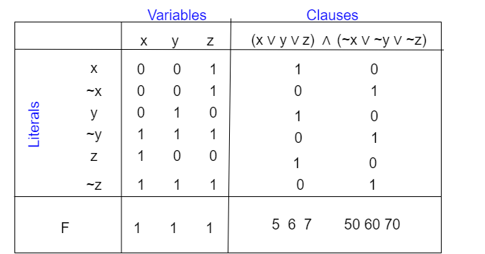
Figure 3- Picturization of the values [9]
If you look at the Figure 3 above, you can understand the values better. Our formula of Budget b = 8(1+32+32²+…+32^{c-1}) + 32^{c}(1+32+32²+…+32^{v-1}). That means for the position of each clause is 8 and for the position of each variable is 1 . There is no chance to be carries between positions because base-32 is large enough. For this example, the sum of digits in the position for a variable is 2 for all integers. It is 1+1+1+5+6+7 = 21 for the first clause. 1’s are for the three literals of the clause; 5, 6, and 7 are for the integers of that clause. [8]
Next step is fullfiling the budget digit by digit. Accordingly, it must contain precisely all of the integers for z and ~x if a set of integers are equal to the budget. At least one integer from literals must be 1 for each clause, so we can choose 5, 6 or 7 from that position. [8]
Each integer can be crated from 3SAT instance F in a time-proportional manner to its length. So, reduction’s complexity is O(n²). Take an arbitrary assignment A if F is satisfiable. Choose an integer for the literals that A makes true. You will find out that the chosen integers are between 1 and 3 in the digit for each clause. Choose one of the integers 5, 6 or 7 to make a total of 8 for each clause.The sum of the selected integers exactly equals the budget. We must also show that the sum of the integers equals the budget b and satisfies F. For each digit of the variable x, either an integer for x or a digit for x is chosen, but both of them cannot occur.[8]
Let us say the truth assignment A makes this literal true. The sum of 8 will only be met if there is at least one 1 among the digits. It defines a valid assignment precisely for one of each pair of literal weight included in the subset since digits of F are 1. As a result, F is satisfied because the assignment of A makes each clause true. [8]

Example: Reduce 3SAT (x ∨ y ∨ z) (¬x ∨ y ∨ ¬z) (¬x ∨ ¬y ∨ z) to Knapsack base-2 [9]
Let us say, Knapsack = { (w1, w2, …, wn, S) | The sum of subsets of wi equals to S }. Where v is the number of variables and c is the number of clauses, build a knapsack instance with 2(v+c) number of wi 's, each with (v+c) number of decimal digits. V digits marks which variable contains it for the 2v literal weights. C digits indicates which clauses contains it. Two slack weights marks that clause for each clause.[9]
For each element, we will have two new elements simulating whether the item is used single time or not even used at all. For i (every element) we get two new weights w0i=(2^(n+1)+2^i)nB and w1i=(2^(n+1)+2^i)nB+wi. The new weight bound W’ equals to W′=(n^(2n+1)+2^n+⋯+2^i)nB+w. While the values of the elements are the same as their weight, the target value is equal to W’.
If the formula is satisfiable, taking into account the true literals in that assignment, choose the literal weight. If k literals in a clause are given by that assignment, pick (3 - k) weights for that clause. Total will be equal to S. Let us suppose our knapsack instance has a solution. There is no carry in sum because the columns are less than or equal to 5 per column (remember the weights are decimal). Since v digits of S are equal to 1, an assignment is defined by one of any literal pairs of weights in the subset. Since S's c (number of sentences) digits are 3 but each contributes no more than 2 slack weights , at least one of the literal weights chosen must be 1 in that clause such the assignment satisfies the formula.[9]
Summary
The Knapsack Problem is a well-researched problem throughout the history, some works at dates as early as 1897. We can summarize Knapsack problem as; we select items with the maximum value per unit weight as our weight capacity allows us to select. There are different versions and programming methods of Knapsack problem. Knapsack and 3SAT problems both are NP(it takes polynomial time to solve) problems hence they can convert to each other for the sake of finding an easier solution to one of the problems. We need to construct a list L and a budget b (we use a formula for b). We choose our literals with respect to variables and clauses, sum their integer values and check if fit into budget. Reduction’s complexity is O(n²) because each integer can be created from 3SAT instance in a time-proportional manner to its length.
Conclusion
NP problems are in our life and it is so important for us to find a way to convert them to each other to have better understanding on them and maybe find a easier p problem version for that exact np problem. These reductions may resolve some new NP problems we will encounter in the future so being able to reduct is highly important.
REFERNCES

1. The knapsack problem
[1] Wikipedia contributors. (2020,december,2). Knapsack Problem :
[https://en.wikipedia.org/wiki/Knapsack_problem]
[2] Feuerman and Weiss- A Mathematical Programming Model for Test Construction and Scoring
[3] Landau. (2020,march,9). How mathematical conundrum called Knapsack is all around us:
[https://www.smithsonianmag.com/science-nature/why-knapsack-problem-all-around-us-180974333/]

2. Concrete examples to satisfy the knapsack problem
[4] Lagoudakis, M. The 0–1 Knapsack Problem an Introductory Survey. Retrieved from [https://citeseerx.ist.psu.edu/viewdoc/download?doi=10.1.1.47.4378&rep=rep1&type=pdf]
[5] Hristakeva, M., & Shrestha, D. Different Approaches to Solve the 0/1 Knapsack Problem. [https://www.micsymposium.org/mics_2005/papers/paper102.pdf]
[6] Toma, L., & Majercik, S. Dynamic Programming: 0-1 Knapsack. Retrieved from [https://www.bowdoin.edu/~smajerci/teaching/cs2200/2020spring/Lectures/knapsack.pdf]

3. Rreducibility of 3sat to knapsack
[7] Wikipedia contributors. (2020, december,3). Boolean satisfiability problem :
[https://en.wikipedia.org/wiki/Boolean_satisfiability_problem]
[8] Ullman. (2010,spring). More NP Complete Problems:
[http://infolab.stanford.edu/~ullman/ialc/spr10/slides/pnp3.pdf]

[9] Gharan (2020, spring) CSE421 Algorithms NP-Completeness:
[https://courses.cs.washington.edu/courses/cse421/12wi/slides/08np.pdf]

