Maximum Flow Problem

What is Maximum Flow Problem

- Definition: Given a directed network with different capacities on each individual edge, the maximum flow problem asks for the maximum amount of flow that can be sent from a source node(S) to a sink node(T) without exceeding the capacity of any edge.

- Flow in the network should follow the following conditions:

  - For any non-source and non-sink node, the input flow is equal to output flow
  - For any edge(E) in the network, 0 ≤ flow(E) ≤ Capacity(E)
  - Total flow out of the source node is equal to total flow in to the sink node

- There are multiple algorithms exist in solving the maximum flow problem. Today you will see the Ford-Fulkerson algorithm.

Ford-Fulkerson Algorithm

It was developed by L. R. Ford, Jr. and D. R. Fulkerson in 1956.

The Ford-Fulkerson Algorithm computes a maximum flow in a iterative manner by starting with a valid flow, and then making adjustments that fulfill the constraints and increase the flow.

- The complexity of the Ford-Fulkerson algorithm is O(f*E), where f is the maximum flow and E is the number of edges in a network.

There are 2 key elements in the Ford-Fulkerson algorithm:

Residual Network: Residual Network is a graph that has the same vertices as the original network with one or two edges for each edge in the original network. It indicates the additional possible flow through the network. Fer each edge, it calculates as “Additional Flow = Edge’s Capacity – Flow of the Edge”.

So, to create a residual network we will take our original network and will

update the capacity of each edge with the additional flow corresponding to that edge. Then we will also add reverse edges to indicate the amount of flow currently going across the edges of the original network.

  - Augmenting Path: Given a flow network G=(V, E), the augmenting path is a simple path from s to t in the corresponding residual graph of the flow network.

Pseudo Code of Ford-Fulkerson Algorithm

- Input required:
  - Network Graph (G)
  - Source Node (S)
  - Sink Node (T)

- FordFulkerson(Graph G,Node S, Node T):
Initialize flow in all edges to 0
While (There exists and augmenting path(P) between S and T in residual network graph):
Augment flow between S to T along the path P
Update residual network graph
Return flow

Example of Ford-Fulkerson Algorithm on Maximum Flow Problem

- Step 1- Set the flow of every edge to 0

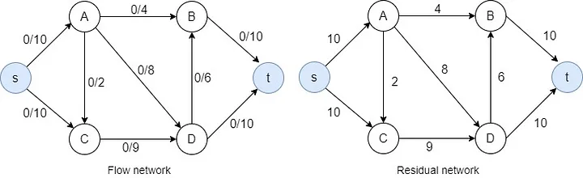

- Step 2- Find an augmenting path in the residual network. ( s→A→D→t)

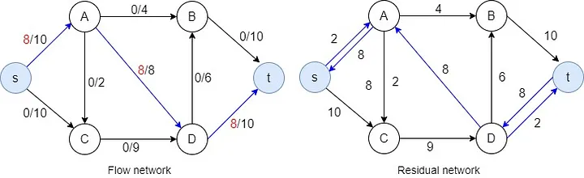

- Step 3- Selecting another augmenting path. (s→C→D→t)

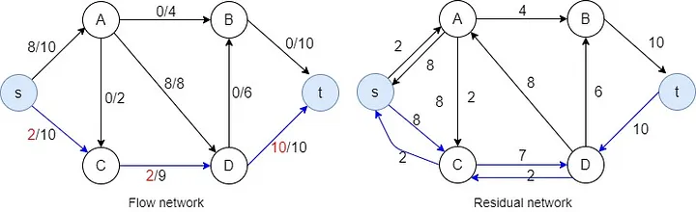

- Step 4- Selecting the augmenting path (s→A→B→t)
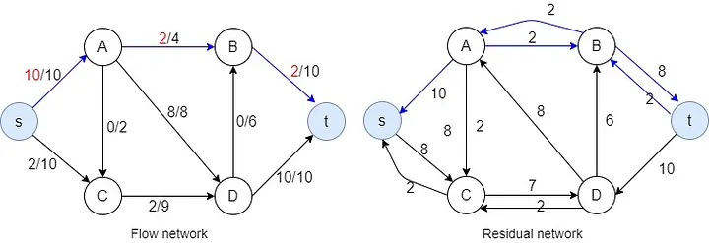

- Step 5- Selecting the augmenting path (s→C→D→B→t)
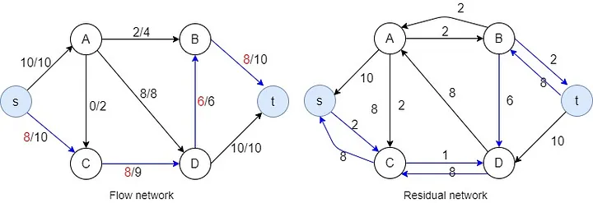

- Step 6- Selecting the augmenting path (s→C→D→A→B→t)

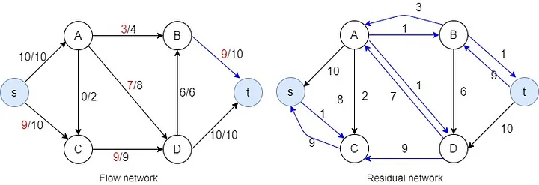

- After 6th step, there is no available capacity in s→A and although there is 1 available capacity in s→C there is no way from there to go to the sink node. Algorithm is now finished and maximum flow calculated as 19 in this case.

Summary:

We can summarize the maximum flow problem with a great real-life example. Let's consider the plumbing in our homes. It uses pipes of different sizes for various needs within a home. But the water needs of the whole house enter the house from a single point, and the wastewater leaving the house comes out from a single point in the same way. What the maximum flow problem asks in this regard is how much water can enter this house and how much water can leave this house without exceeding the capacity of the plumbing of this house. The point where the water inlet of our house is called our source, and the point where the wastewater comes out is called the sink. We can assume that the pipes of different sizes in our plumbing are edges, and the points where these pipes meet are nodes. In this case, our installation creates a directional and weighted network for us.

This network has some rules in the maximum flow problem:

First of all, the total flow coming to any node that is not a source or sink at the entrance or exit must be the same as the outgoing flow.

Secondly, a load below zero or above its capacity cannot pass through an edge, that is, a pipe.

Finally, the load coming out of our source and the load entering our sink must be the same. The more water enters your home, the more it comes out. If it is more or less, there is a problem somewhere.

To summarize the Ford-Fulkerson algorithm we need to know that this algorithm is working iteratively. To find the maximum flow, algorithm first finds a valid path from source node to the sink node while respecting the rules above. After the first path is found, in each iteration, algorithm tries to find an alternative path that increases the total flow. This path is called an Augmenting Path. Algorithm works until no paths are left, then the total flow is calculated.

Most important part of the algorithm:

We always need to check if an edge’s capacity while working with this algorithm, to make sure of it, we can use a Residual Network which is a network map that shows the current flow from that edge and its remaining capacity. It also helps with finding alternative routes due to its way of showing us the data it shows.

Real-World Applications:

Telecommunication Networks

Water/Electricity Networks

Logistics, Transportation

Exam Scheduling

Flight Scheduling

Homework:

A company has a factory located in Detroit, USA, producing electric golf carts. The carts will be exported to Asian countries, and are therefore stored in a warehouse in San Francisco. All carts are shipped from the company to San Francisco by train. The train company operates trains daily on the national rail network. The carts are packed in train compartments, called bogeys. There is a limit on how many compartments can be shipped across each link of the train network daily. The network below shows the carrying capacity. What is the maximum number of bogeys that can be shipped out of Detroit each day?

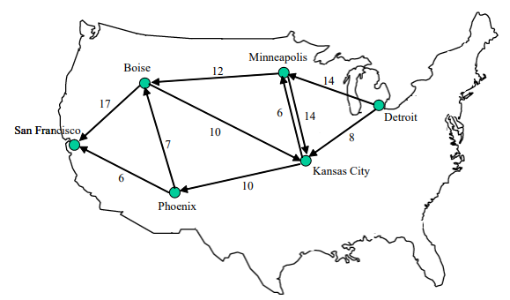

Resources:

Hackerearth.com

https://www.hackerearth.com/practice/algorithms/graphs/maximum-flow/tutorial/#:~:text=It%20is%20defined%20as%20the,Fulkerson%20algorithm%20and%20Dinic's%20Algorithm.

Stanford University

https://web.stanford.edu/class/archive/cs/cs161/cs161.1168/lecture16.pdf

Medium.com

https://medium.com/@jithmisha/solving-the-maximum-flow-problem-with-ford-fulkerson-method-3fccc2883dc7

Hong Kong University

https://ieda.ust.hk/dfaculty/ajay/courses/ieem101/lecs/graphs/graph-maxflow.pdf

Answer of the Homework : 22

