What is PageRank ?

PageRank (PR) is a mathematical formula that judges the “value of a page” by looking at the quantity and quality of other pages that link to it. Its purpose is to determine the relative importance of a given webpage in a network. The importance level of these links, and ranks your site by giving it a score from 0 to 10.

Calculating PageRank Using Formula

When Google calculates the PageRank of a web page, three factors are taken into account:

- The quantity and quality of inbound link pages;
- The number of outbound links on each link page;
- PageRank value of each link page.
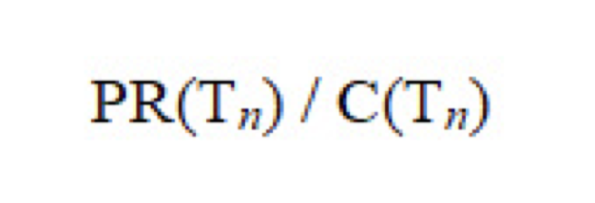
- PR (A), PageRank of Page A (the page where we want to find its PageRank);
- PR (Tn); PageRank Value of Tn Page;
- C (Tn); The number of links from the Tn page to other pages.

Pseudo Code

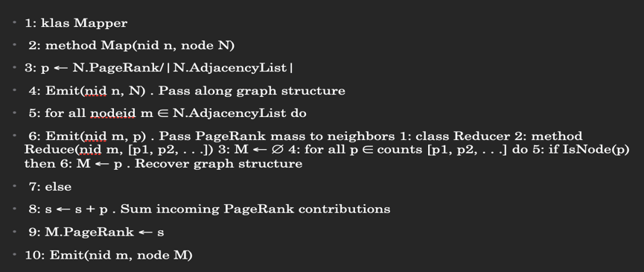

Advantages of PageRank

- PageRank algorithm make the webpage link analytic become more robust.
- PageRank is a global scale measurement.
- PageRank is query independent.

Disadvantages of PageRank

- Older pages may have higher rank. It is because a new page even have some very good contents but it may not have many links in the early state.
- PageRank can be easily increased by the "link-farms" .
- Rank can be raised by buying "links".

