Prim’s Algorithm for Minimum Spanning Tree (MST)

What is the Prim's Algorithm
Along with the algorithm, we will also see the working, example, pseudocode, complexity and applications of prim's algorithm. Before starting the main topic, we should discuss the basic and important terms such as spanning tree and minimum spanning tree.
- Spanning tree - A spanning tree is the subgraph of an undirected connected graph.
- Minimum Spanning tree - Minimum spanning tree can be defined as the spanning tree in which the sum of the weights of the edge is minimum. The weight of the spanning tree is the sum of the weights given to the edges of the spanning tree.
- Prim's Algorithm is a greedy algorithm that is used to find the minimum spanning tree from a graph. Prim's algorithm finds the subset of edges that includes every vertex of the graph such that the sum of the weights of the edges can be minimized. Prim's algorithm starts with the single node and explores all the adjacent nodes with all the connecting edges at every step.
Before we look at how the Prim’s algorithm works, we should discuss what the greedy algorithm is.
What is the Greedy Algorithm
In computer science, a greedy algorithm is an algorithm that finds a solution to problems in the shortest time possible. It picks the path that seems optimal at the moment without regard for the overall optimization of the solution that would be formed.
Edsger Dijkstra, a computer scientist and mathematician who wanted to calculate a minimum spanning tree, introduced the term "Greedy algorithm". Prim and Kruskal came up with optimization techniques for minimizing cost of graphs.
Many Greedy algorithms were developed to solve graph problems. A graph is a structure made up of edges and vertices.
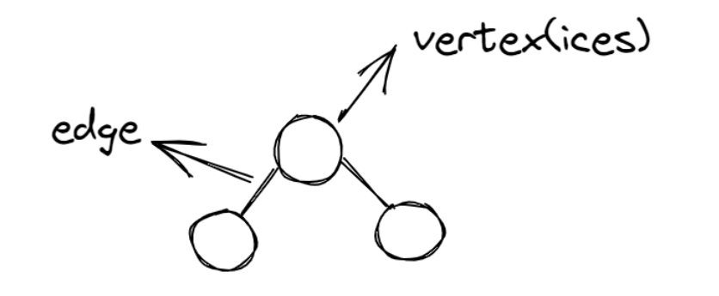
Diagram of a simple graph

Example: A graph has various weights and you are to determine the maximum value in the tree. You'd start by searching each node and checking its weight to see if it is the largest value.
There are two approaches to solving this problem: greedy approach or not greedy.
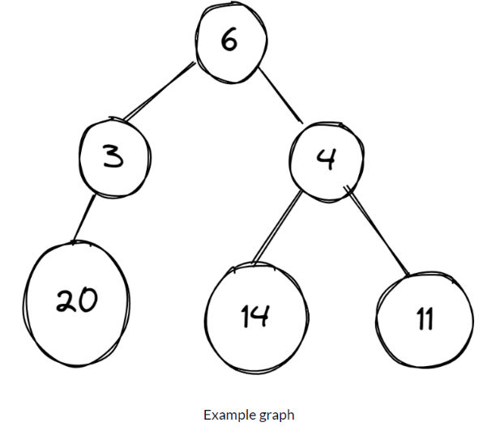

Greedy Approach :

In the images below, a graph has different numbers in its vertices and the algorithm is meant to select the vertex with the largest number.
Starting from vertex 6, then it's faced with two decisions – which is bigger, 3 or 4? The algorithm picks 4, and then is faced with another decision – which is bigger, 14 or 11. It selects 14, and the algorithm ends.
On the other hand, there is a vertex labeled 20, but this vertex has been added to 3, which the greedy does not consider to be the best choice because it chooses 14, which is the largest number in the graph.
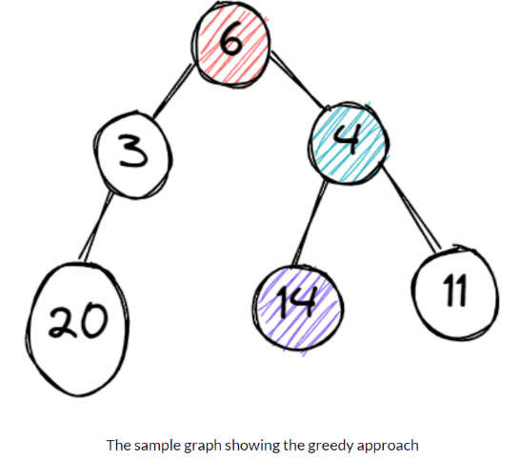

Not Greedy Approach :

The “not greedy” approach checks all options before arriving at a final solution, unlike the "greedy approach" which stops once it gets its results.
Starting from vertex 6, then it's faced with two decisions – which is bigger, 3 or 4? The algorithm picks 4, and then is faced with another decision – which is bigger, 14 or 11. It selects 14 and keeps it aside.
Then it runs the process again, starting from vertex 6. It selects the vertex with 3 and checks it. 20 is attached to the vertex 3 and the process stops. Now it compares the two results – 20 and 14. 20 is bigger, so it selects the vertex (3) that carries the largest number and the process ends.
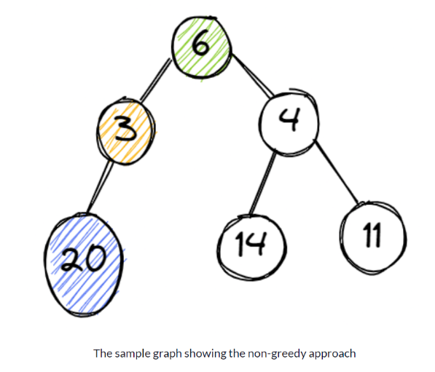

How to Use Greedy Algorithms
Before applying a greedy algorithm to a problem, you need to ask two questions:
- Do you need the best option at the moment for the problem?
- Do you need an optimal solution (either minimum or maximum value)?
If your answer to these questions is "Yes", then a greedy algorithm is a good choice to solve your problem.

How does the Prim's Algorithm work?
Prim's algorithm is a greedy algorithm that starts from one vertex and continues to add the edges with the smallest weight until the goal is reached. The steps to implement the prim's algorithm are given as follows -
- Step 1 - First, Initialize the minimum spanning tree with a vertex chosen at random.
- Step 2 - Find all the edges that connect the tree to new vertices, find the minimum edge and add it to the tree.
- Step 3 - Keep repeating step 2 until we get a minimum spanning tree.

Example of Prim's Algorithm

Consider the following graph as an example for which we need to find the Minimum Spanning Tree (MST).

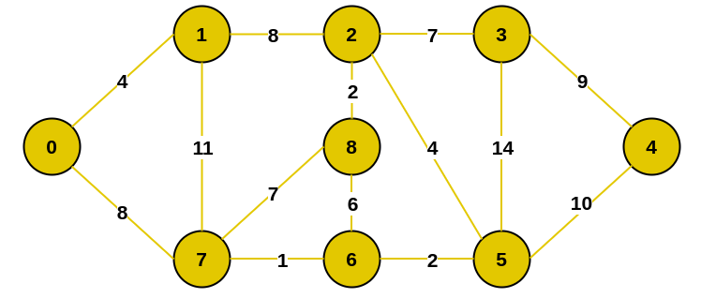

Solution:
Step 1 - Start by adding an arbitrary vertex to Vnew .
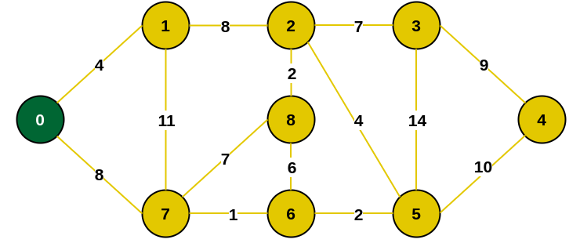

Step 1.1 - we have to find all the edges that connect the tree with the new vertices and mark the edges with blue paint.

8
4

8

Step 2 - From the edges found, select the minimum edge and mark the vertex with green paint to the tree.

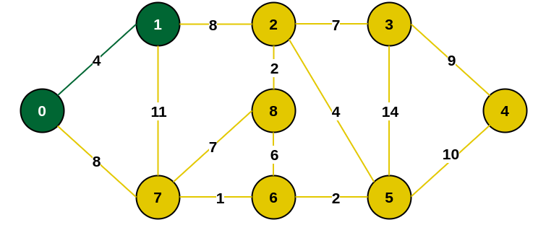

Step 2.1 - we have to find all the edges that connect the tree with the new vertices and mark the edges with blue paint.


8
11
8

Step 3 - From the edges found, select the minimum edge and mark the vertex with green paint to the tree. If two edges of the same size have the smallest value, it doesn't matter which edge we choose first.

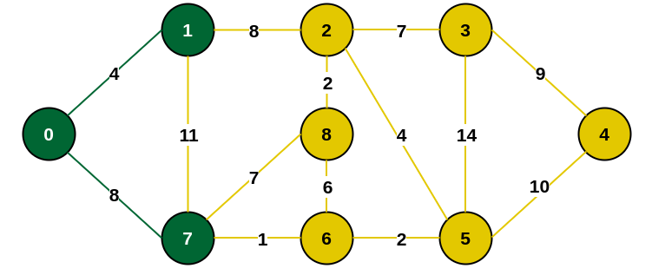

Step 3.1 - we have to find all the edges that connect the tree with the new vertices and mark the edges with blue paint.


1
7
8

Step 4 - From the edges found, select the minimum edge and mark the vertex with green paint to the tree.

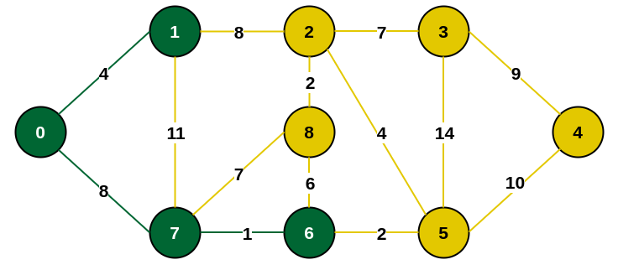

Step 4.1 - we have to find all the edges that connect the tree with the new vertices and mark the edges with blue paint.


2
6
7
8

Step 5 - From the edges found, select the minimum edge and mark the vertex with green paint to the tree.

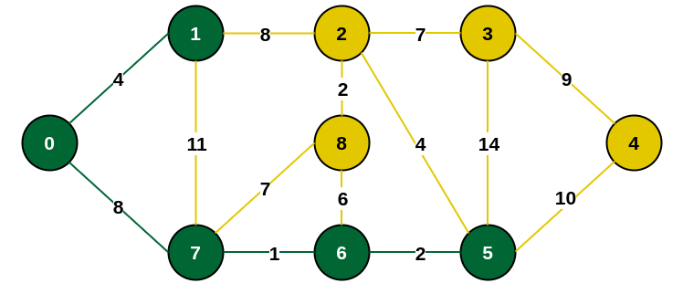

Step 5.1 - we have to find all the edges that connect the tree with the new vertices and mark the edges with blue paint.


10
14
4
6
7
8

Step 6 - From the edges found, select the minimum edge and mark the vertex with green paint to the tree.

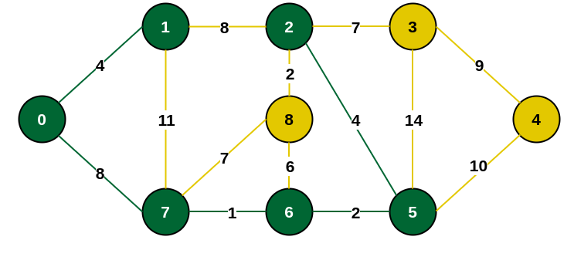

Step 6.1 - we have to find all the edges that connect the tree with the new vertices and mark the edges with blue paint.


14
6
7
10
7
2

Step 7 - From the edges found, select the minimum edge and mark the vertex with green paint to the tree.

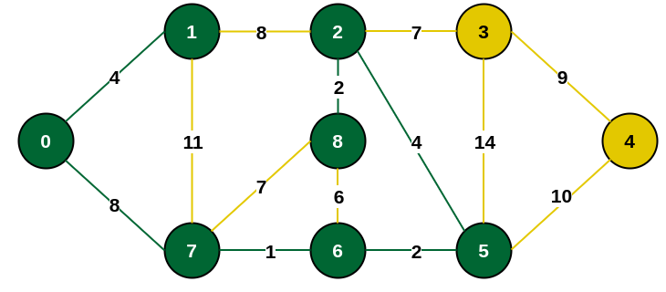

Step 7.1 - we have to find all the edges that connect the tree with the new vertices and mark the edges with blue paint.


10
14
7

Step 8 - From the edges found, select the minimum edge and mark the vertex with green paint to the tree.

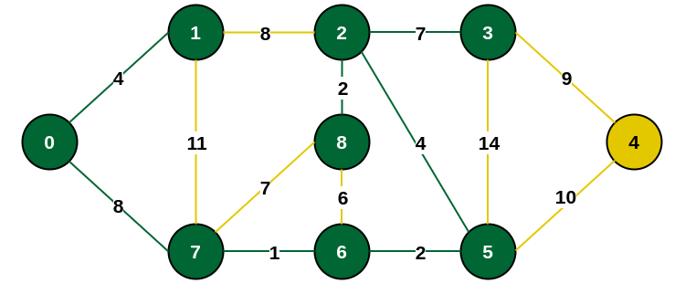

Step 8.1 - we have to find all the edges that connect the tree with the new vertices and mark the edges with blue paint.


10
9

Step 9 - From the edges found, select the minimum edge and mark the vertex with green paint to the tree.

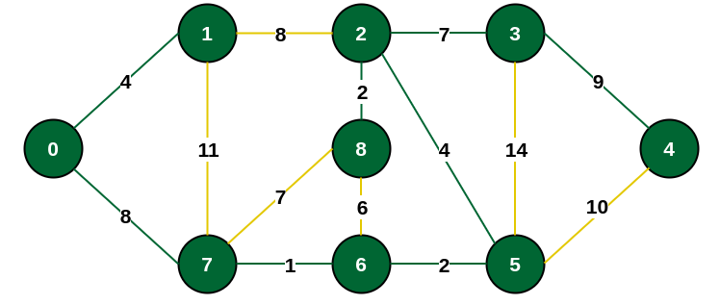

Final Step - Minimum Spanning Tree (MST)

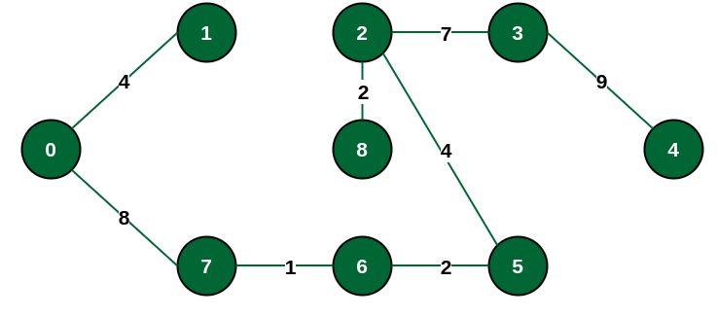
The final structure of the MST is as follows and the weight of the edges of the MST is
(4 + 8 + 1 + 2 + 4 + 2 + 7 + 9) = 37

Pseudocode of Prim's Algorithm

First, we create a null set A, where we will add all the edges of the minimum spanning tree. Then we create two sets of vertices U and V-U. V-U the list of vertices that haven’t been visited and U contains the list of vertices that have been visited. We move vertex by vertex, and move vertices from set V-U to set U by connecting the least weighted edge.

A = ∅;
U = {1};
while (U ≠ V)
let (u, v) be the least weighted edge such that
v ∈ V - U and u ∈ U;
A = A ∪ {(u, v)}
U = U ∪ {v}

Complexity of Prim's Algorithm

Data structure used for the minimum edge weights | Time Complexity
Adjacency matrix, linear searching |  | O(|V|²)
Adjacency list and binary heap |  | O(|E| log |V|)
Adjacency list and Fibonacci heap |  | O(|E|+ |V| log |V|)
Prim's algorithm can be simply implemented by using the adjacency matrix or adjacency list graph representation, and to add the edge with the minimum weight requires the linearly searching of an array of weights. It requires O(|V|²) running time. It can be improved further by using the implementation of heap to find the minimum weight edges in the inner loop of the algorithm.
The time complexity of the prim's algorithm is O(E logV) or O(V logV), where E is the number of edges, and V is the number of vertices.

Applications where Prim’s algorithm is generally used:
Prim’s Algorithm is used in various real-world applications where you need to find the Minimum Spanning Tree (MST) of a weighted graph. Here are some simple explanations of its uses:
Network Design: In telecommunications and computer networks, Prim’s Algorithm helps design efficient and cost-effective network layouts. It can be used to determine the optimal placement of communication cables or network connections while minimizing the total length or cost.
Circuit Board Design: When designing electronic circuit boards, you often want to minimize the length of connections between components to reduce interference and improve performance. Prim’s Algorithm can be employed to find the optimal arrangement of connections.
Transportation Planning: In transportation systems, such as road or railway networks, Prim’s Algorithm can help plan routes and connections. It ensures that you build new roads or railway tracks in a way that minimizes the total distance or cost.
Resource Management: When managing resources like pipelines for gas or water distribution, Prim’s Algorithm can determine the most efficient way to connect sources to destinations, minimizing the total length of pipelines while ensuring all areas are supplied.
Cluster Analysis: Prim’s Algorithm can be used in data analysis and clustering to find representative data points while minimizing the distance between them. This helps in identifying groups or clusters within datasets.
Image Processing: In image processing, it’s used for segmenting images into regions while minimizing the total “cut” cost. This can be applied in tasks like image segmentation and object recognition.
Robotics: In robotics, Prim’s Algorithm can be employed to plan paths for robots moving in a grid or on a map. It helps robots navigate efficiently while avoiding obstacles.
Spanning Tree Applications: Prim’s Algorithm, in general, is used in any application where you need to create a network or tree structure while minimizing some cost or distance measure. This could include tasks like designing electrical grids, connecting sensors in a sensor network, or creating a hierarchical structure in computer science.

Homework for Prim’s algorithm
Consider the following graph as an example for which we need to find the Minimum Spanning Tree (MST).
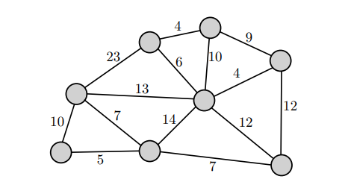

Solution of homework:
Step 1 - Start by adding an arbitrary vertex to Vnew .
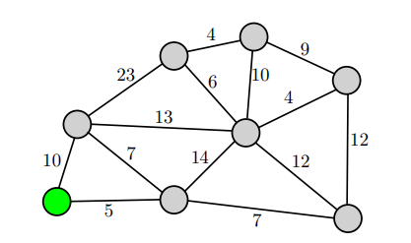
Step 1.1 - we have to find all the edges that connect the tree with the new vertices and mark the edges with blue paint.
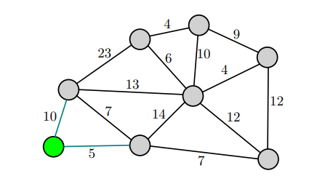

Step 2 - From the edges found, select the minimum edge and mark the vertex with green paint to the tree.
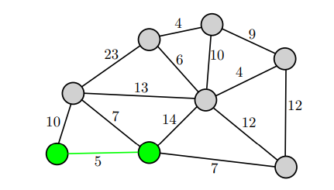

Step 2.1 - we have to find all the edges that connect the tree with the new vertices and mark the edges with blue paint.
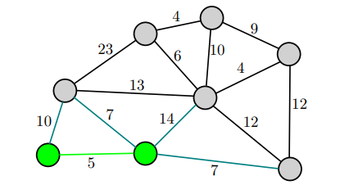

Step 3 - From the edges found, select the minimum edge and mark the vertex with green paint to the tree. If two edges of the same size have the smallest value, it doesn't matter which edge we choose first.(e.g. 7)
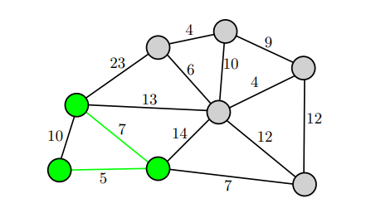

Step 3.1 - we have to find all the edges that connect the tree with the new vertices and mark the edges with blue paint.
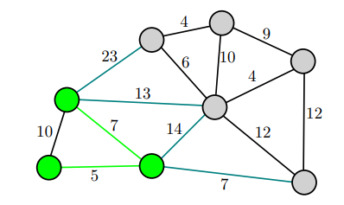

Step 4 - From the edges found, select the minimum edge and mark the vertex with green paint to the tree.
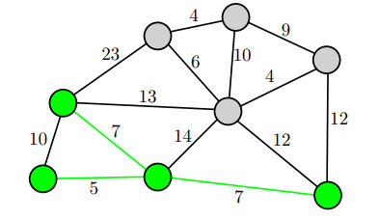

Step 4.1 - we have to find all the edges that connect the tree with the new vertices and mark the edges with blue paint.
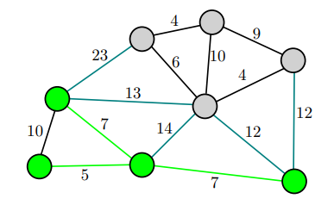

Step 5 - From the edges found, select the minimum edge and mark the vertex with green paint to the tree. If two edges of the same size have the smallest value, it doesn't matter which edge we choose first.(e.g. 12)
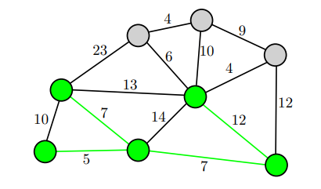

Step 5.1 - we have to find all the edges that connect the tree with the new vertices and mark the edges with blue paint.
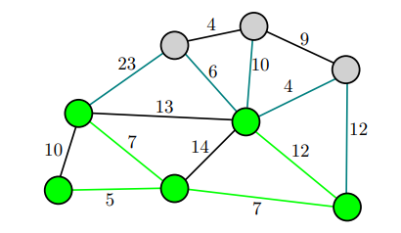

Step 6 - From the edges found, select the minimum edge and mark the vertex with green paint to the tree.
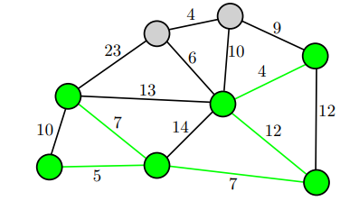

Step 6.1 - we have to find all the edges that connect the tree with the new vertices and mark the edges with blue paint.
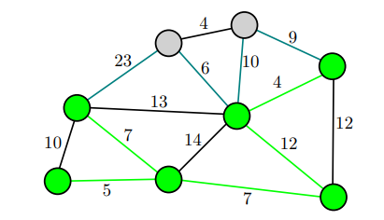

Step 7 - From the edges found, select the minimum edge and mark the vertex with green paint to the tree.
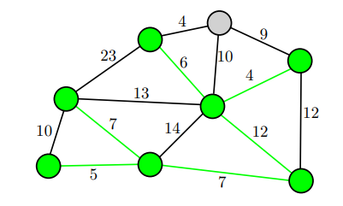

Step 7.1 - we have to find all the edges that connect the tree with the new vertices and mark the edges with blue paint.
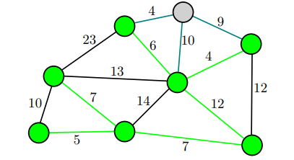

Step 8 - From the edges found, select the minimum edge and mark the vertex with green paint to the tree.
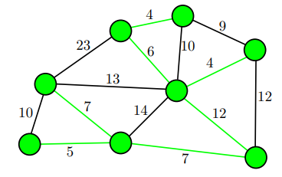

Final Step - Minimum Spanning Tree (MST)

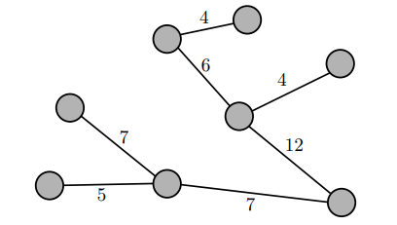

The final structure of the MST is as follows and the weight of the edges of the MST is
(5 + 7 + 7 + 12 + 4 + 6 + 4) = 45
Include vertex 4 in the MS

References
https://www.geeksforgeeks.org/prims-minimum-spanning-tree-mst-greedy-algo-5/
https://www.freecodecamp.org/news/greedy-algorithms/
https://user.it.uu.se/~filma606/ImageProcessingUsingGraphs/LectureNotes/Lecture3.pdf
https://medium.com/cracking-the-coding-interview-in-ruby-python-and/prims-algorithm-explained-with-examples-in-ruby-javascript-and-python-mastering-algorithms-cedc31f1d9c2
https://www.gatevidyalay.com/prims-algorithm-prim-algorithm-example/
https://www.javatpoint.com/prim-algorithm

