Home | E-learning | Discuss | Online Test |Online Video
- Index

- Chapter

- Content

- Slides

- Homework

- Lab

- Demo

- Video

- Resources

4.4.3.DATAGRAM FORMAT(TRANSLATE) BACK
The IPv4 datagram format is shown in Figure 4.4-8.

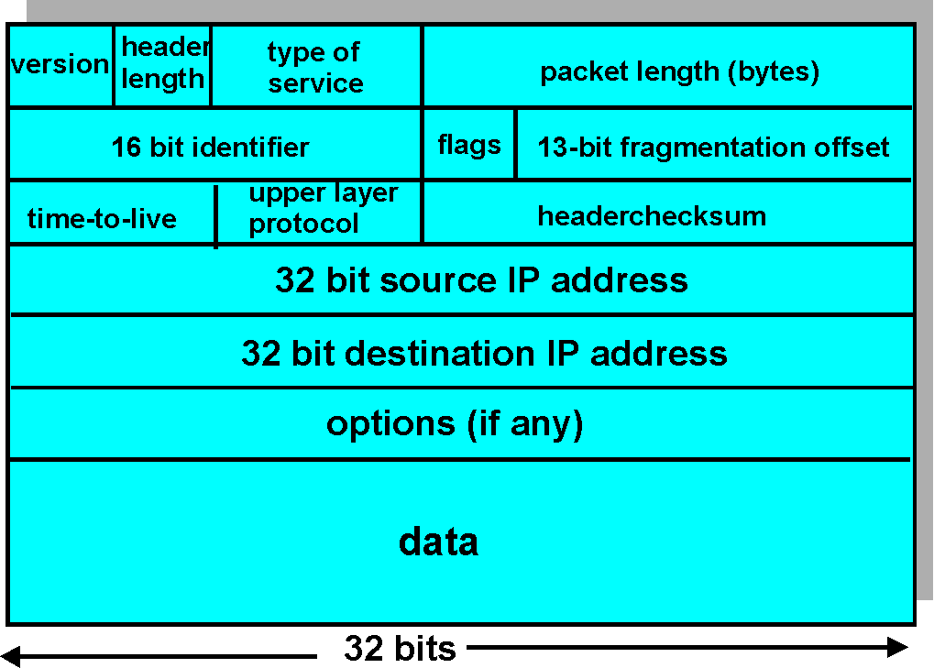
Figure 4.4-8: IPv4 datagram format
The key fields in the IPv4 datagram are the following:
- Version Number: These 4 bits specify the IP protocol version of the datagram. By looking at the version number, the router can then determine how to interpret the remainder of the IP datagram. Different versions of IP use different datagram formats. The datagram format for the "current" version of IP, IPv4, is shown in Figure 4..4-8. The datagram format for the "new" version of IP (IPv6) is discussed in Section 4.7.
- Header Length: Because an IPv4 datagram can contain a variable number of options (which are included in the IPv4 datagram header) these 4 bits are needed to determine where in the IP datagram the data actually begins. Most IP datagrams do not contain options so the typical IP datagram has a 20 byte header.
- TOS: The type of service (TOS) bits were included in the IPv4 header to allow different "types" of IP datagrams to be distinguished from each other, presumably so that they could be handled differently in times of overload. When the network is overloaded, for example, it would be useful to be able to distinguish network control datagrams (e.g., see the ICMP discussion in Section 4.4.5) from datagrams carrying data (e.g., HTTP messages). It would also be useful to distinguish real-time datagrams (e.g., used by an IP telephony application) from non-real-time traffic (e.g., FTP). More recently, one major routing vendor (Cisco) interprets the first three ToS bits as defining differential levels of service that can be provided by the router. The specific level of service to be provided is a policy issue determined by the router's administrator. We shall explore the topic of differentiated service in detail in Chapter 6.
- Datagram Length: This is the total length of the IP datagram (header plus data) measured in bytes. Since this field is 16 bits long, the theoretical maximum size of the IP datagram to 65,535 bytes. However, datagrams are rarely greater than 1500 bytes, and are often limited in size to 576 bytes.
- Identifier, Flags, Fragmentation Offset: These three fields have to do with so-called IP fragmentation, a topic we will consider in depth shortly. Interestingly, the new version of IP, IPv6, simply does not allow for fragmentation.
- Time-to-live: The time-to-live (TTL) field is included to insure that datagrams do not circulate forever (due to, for example, a long lived router loop) in the network. This field is decremented by one each time the datagram is processed by a router. If the TTL field reaches 0, the datagram must be dropped.
- Protocol: This field is only used when an IP datagram reaches its final destination. The value of this field indicates the transport-layer protocol at the destination to which the data portion of this IP datagram will be passed. For example, a value of 6 indicates that the data portion is passed to TCP, while a value of 17 indicates that the data is passed to UDP. For a listing of all possible numbers, see [RFC 1700]. Note that the the protocol number in the IP datagram has a role that is fully analogous to the role of the port number field in the transport-layer segment. The protocol number is the "glue" that holds the network and transport layers together, whereas port number is the "glue" that holds the transport and application layers together. We will see in Chapter 5 that the link layer frame also has a special field which glues the link layer to the network layer.
- Header Checksum: The header checksum aids a router in detecting bit errors in a received IP datagram. The header checksum is computed by treating each 2 bytes in the header as a number and summing these numbers using 1's complement arithmetic. As discussed in Section 3.3, the 1's complement of this sum, known as the Internet checksum, is stored in the checksum field. A router computes the Internet checksum for each received IP datagram and detects an error condition if the checksum carried in the datagram does not equal the computed checksum. Routers typically discard datagrams for which an error has been detected. Note that the checksum must be recomputed and restored at each router, as the TTL field, and possibly options fields as well, may change. An interesting discussion of fast algorithms for computing the Internet checksum is [1071]. A question often asked at this point is, why does TCP/IP perform error checking at both the transport and network layers? There are many reasons for this. First, routers are not required to perform error checking, so the transport layer cannot count on the network layer to do the job. Second, TCP/UDP and IP do not necessarily have to both belong to the same protocol stack. TCP can, in principle, run over a different protocol (e.g., ATM) and IP can carry data without passing through TCP/UDP (e.g., RIP data).
- Source and Destination IP Address: These fields carry the 32 bit IP address of the source and final destination for this IP datagram. The use and importance of the destination address is clear. The source IP address (along with the source and destination port numbers) is used at the destination host to direct the application data in the proper socket.
- Options: The optional options fields allows an IP header to be extended. Header options were meant to be used rarely -- hence the decision to save overhead by not including the information in options fields in every datagram header. However, the mere existence of options does complicate matters -- since datagram headers can be of variable length, one can not determine a priori where the data field will start. Also, since some datagrams may require options processing and others may not, the amount of time needed to process a IP datagram can vary greatly. These considerations become particularly important for IP processing in high performance routers and hosts. For these reasons and others, IP options were dropped in the IPv6 header.
- Data (payload): Finally, we come to the last, and most important field - the raison d'être for the datagram in the first place! In most circumstances, the data field of the IP datagram contains the transport-layer segment (TCP or UDP) to be delivered to the destination. However, the data field can carry other types of data, such ICMP messages (discusssed in Section 4.4.5) .
Note that IP datagram has a total of 20 bytes of header (assuming it has no options). If the IP datagram carries a TCP segment, then each (non-fragmented) datagram carries a total of 40 bytes of header (20 IP bytes and 20 TCP bytes) along with the application-layer data.
- ©2005 NCWU-METC
- Site Index
- Feedback
- About this site

- Contact Us
- Download

