CEN 216 OBJECT ORIENTED PROGRAMMING LAB
FINAL REPORT
(1. Education)
2020555041 Tolga Konat
Task 1
Write your answer below. If you rewrite the code wreite your code. You don’t need to explain your code.
1. …………… avoid multiple instance by adding virtual

2. …………… string to char
// 2020555041 Tolga Konat
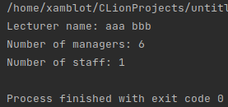
#include <iostream>
#include <cstring>
#include <cstdlib>
using namespace std;
class people
{
public:
char name[20];
};
class staff : virtual public people /////////////////// avoid multiple instance
{
public:
int i = 3;
};
class manager : virtual public people /////////////////// avoid multiple instance
{
public:
int j = 8;
};
class lecturer : public manager, public staff
{
public:
void set(const char *a) { strcpy(name, a); }
void get()
{
cout << "Lecturer name: " << name << endl
<< "Number of managers: " << j << endl
<< "Number of staff: " << i << endl;
}
};
int main()
{
lecturer ob;
ob.i = 1;
ob.j = 6;
ob.set(static_cast<const char *>("aaa bbb")); ///////// string to const char * for strcpy
ob.get();
return 0;
}

Task 2
Write your answers to the question given in Task 2 below.
function overloading is used to define multiple functions with the same name but different parameters
virtual functions are used to make polymorphism, it can be overridden by derived classes.
Task 3
Write your developed code below. You don’t need to explain your code.

// 2020555041 Tolga Konat
#include <iostream>
using namespace std;
template <typename T>
void qs(T arr[], int l, int r) {
int i = l, j = r;
T p = arr[(l + r) / 2];
while (i <= j) {
while (arr[i] < p)
i++;
while (arr[j] > p)
j--;
if (i <= j) {
swap(arr[i], arr[j]);
i++;
j--;
}
}
if (l < j)
qs(arr, l, j);
if (i < r)
qs(arr, i, r);
}
template <typename T>
void print(T arr[], int s) {
for (int i = 0; i < s; i++)
cout << arr[i] << " ";
cout << endl;
}
int main() {
int x[11] = {53, 5, 1, 12, 19, 46, 24, 34, 51, 9, 15};
char y[10] = {'y', 'i', 'f', 'c', 'o', 's', 't', 'k', 'a', 'h'};
int sx = sizeof(x) / sizeof(x[0]);
int sy = sizeof(y) / sizeof(y[0]);
qs(x, 0, sx - 1);
print(x, sx);
qs(y, 0, sy - 1);
print(y, sy);
return 0;
}

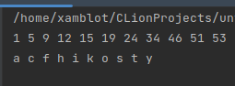

Task 4
Write your developed code below. You don’t need to explain your code.
// 2020555041 Tolga Konat
#include <iostream>
#include <string>
#include <cctype>
#include <algorithm>
#define ll long long
using namespace std;
bool checkNumber(const std::string& str) {
return std::any_of(str.begin(), str.end(), [](char ch) {
return std::isdigit(ch);
});
}
bool checkChar(const std::string& str) {
return std::any_of(str.begin(), str.end(), [](char ch) {
return std::isalpha(ch);
});
}
int main() {
std::string name,surname,number;
while (true)
{
try
{
std::cout << "Enter your name: ";
std::cin >> name;
unsigned long size = name.length();
if (checkNumber(name) || size < 2 || size > 20) {
if(size < 2)
throw std::runtime_error("Too short!");
if(size > 20)
throw std::runtime_error("Too long!");
throw std::runtime_error("Surname cannot contain numbers");
}
break;
}
catch (const std::exception& e) {
std::cout << "Exception caught: " << e.what() << "\n\n";
std::cin.clear();
std::cin.ignore(std::numeric_limits<std::streamsize>::max(), '\n');
}
}
while (true)
{
try
{
std::cout << "Enter your surname: ";
std::cin >> surname;
unsigned long size = surname.length();
if (checkNumber(surname) || size < 2 || size > 20) {
if(size < 2)
throw std::runtime_error("Too short!");
if(size > 20)
throw std::runtime_error("Too long!");
throw std::runtime_error("Surname cannot contain numbers");
}
break;
}
catch (const std::exception& e) {
std::cout << "Exception caught: " << e.what() << "\n\n";
std::cin.clear();
std::cin.ignore(std::numeric_limits<std::streamsize>::max(), '\n');
}
}
while (true)
{
try
{
std::cout << "Enter your number: ";
std::cin >> number;
if (checkChar(number)) {
throw std::runtime_error("Number cannot contain character");
}
if(number.length() != 10)
throw std::runtime_error("Must be 10 character!");
break;
}
catch (const std::exception& e) {
std::cout << "Exception caught: " << e.what() << "\n\n";
std::cin.clear();
std::cin.ignore(std::numeric_limits<std::streamsize>::max(), '\n');
}
}
cout << name << " " << surname << " " << number << endl;
return 0;
}

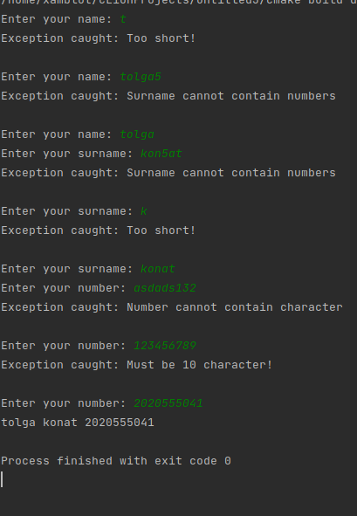

Task 5
Write your developed code below. You don’t need to explain your code.
// 2020555041 Tolga Konat
#include <iostream>
namespace MyNamespace
{
void cout(const std::string& in)
{
std::cout << "Your input is "<< in << std::endl;
}
}
int main(int argc, const char* argv[]) {
std::string in;
std::getline(std::cin, in);
MyNamespace::cout(in);
return argc;
}

