WHAT IS CIDR and SUPERNETTING?

CIDR, which stands for Classless Inter-Domain Routing, is an IP addressing scheme that improves the allocation of IP addresses. It replaces the old system based on classes A, B, and C. This scheme also helped greatly extend the life of IPv4 as well as slow the growth of routing tables.

How does CIDR work?
An IP address made it possible in the past to determine which class it belonged to. For example, the class C networks were located between the addresses 192.0.0.0 and 223.255.255.255. A subnet mask (e.g. 255.255.255.0) is like a mask on top of the IP address and specifies the hosts. In CIDR format, this information is stored as a suffix in the IP address itself. However, the basic principle remains the same: the suffix specifies which places (bits) of the IP address represent the network ID and therefore which bits automatically make up the range of the host ID.
255.255.255.0 ≙ 11111111 11111111 11111111 00000000
In CIDR notation, this (class C) subnet mask would be /24, since the first 24 bits determine the network component of the IP address. It’s possible to not only to fill octets completely with ones or zeros, but also to create more flexible subnets using VLSM. For example, the mask /25 corresponds to the binary value 11111111 11111111 11111111 10000000, which in turn (in dot-decimal notation) corresponds to 255.255.255.128.

Calculating CIDR
- Supernetting
Supernetting is the process of summarizing a bunch of contiguous Subnetted networks back in a single large network. Supernetting is also known as route summarization and route aggregation.
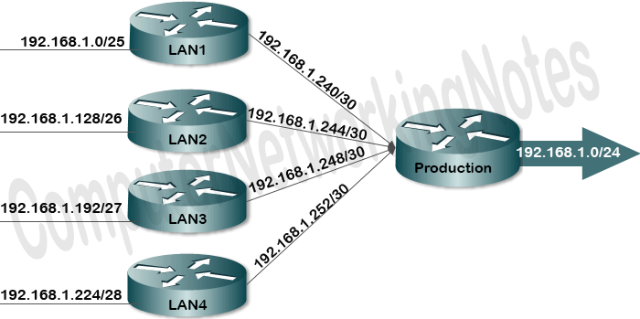
Example of Supernetting
Let’s assume that a company has three sites and three networks and their corresponding routers. It would make sense to turn it into a supernet. The three networks have the addresses 192.168.43.0, 192.168.44.0, and 192.168.45.0 (possible subnet masks next to the IP addresses of the networks are first relevant in this context). We first compare them in binary notation and only use the digits that all three addresses have in common – from left to right: From the first difference, all other digits are set to zero.
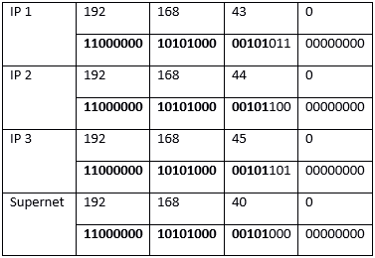
The network address of the supernet is therefore 192.168.40.0. To determine the corresponding subnet mask that belongs to this network, you count the places (bits) that led to the new IP address. In our example, these are 21 bits: 192.168.40.0/21.
- Subnetting
A subnet, or subnetwork, is a network inside a network. Subnets make networks more efficient. Through subnetting, network traffic can travel a shorter distance without passing through unnecessary routers to reach its destination.
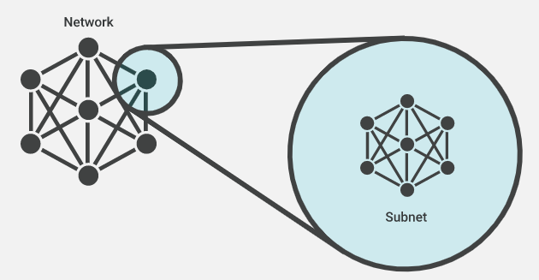

Example of Subnetting
In the first one of the Subnetting Examples, we will use, 192.168.5.85 /24 Address. Let’s determine the network and host part of this address. This is the first example, so we are starting with an easy example.
- IP Address : 192.168.5.85
- Subnet Mask : 255.255.255.0

For this example, firstly we will convert this decimal numbers to the binary equals. As you can see below, the 1s in the Subnet Mask will show the number of bits that network part has. And the 0s will show the host part bits.
- IP Address : 11000000. 10101000.00000101.01010101
- Subnet Mask : 11111111. 11111111. 11111111.00000000

So, here, the first 24 bits (First 3 octets) are network bits and the last 8 bits (Last octet) are the host bits. For this IP and Subnet Mask, to determine the Network Address of this IP address, we will use “AND” operation between IP Address and Subnet Mask in binary mode.

- IP Add: 11000000. 10101000.00000101.01010101
- SubM : 11111111. 11111111. 11111111.00000000

- AND : 11000000. 10101000.00000101.00000000

When we use AND operation with this binary numbers, the last octet will be multiple with zero (AND is Multiplication). So the result of this multiplication will be 192.168.5.0. Here, the first three octets will be same as IP address and the last octet will be full of 0s.
For this example the broadcast address will be 192.168.5.255. All the host bits are full of 1s for broadcast address. The other addresses in the middle through 192.168.5.1 to 192.168.5.254 are host addresses.

