# Mind Map: Healthy Lifestyle

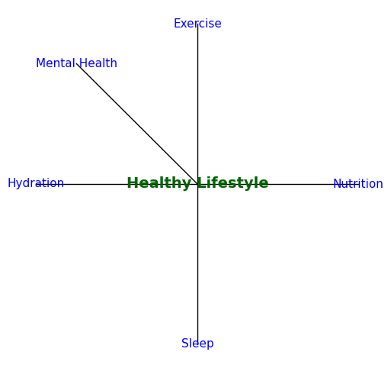

This mind map shows key aspects of maintaining a healthy lifestyle.