Task description
5. Black hole Black hole is a two-player game, played on a board consists of n x n fields, which has a black hole at its center. Each player has n-1 spaceships, which are placed initially in the lower (upper) diagonal of the board (so the same colored spaceships placed on the same side). The players take turns moving one of their own spaceships. The black hole interferes with the navigation system of the spaceships, so they cannot move only one place, but they move until they reach the edge of the board, the black hole, or an other spaceship. A spaceship cannot jump over an other one. A player wins, if he manages to move half of his spaceships into the black hole. Implement this game, and let the board size be selectable (5x5, 7x7, 9x9). The game should recognize if it is ended, and it has to show in a message box which player won. After this, a new game should be started automatically.

Class diagram

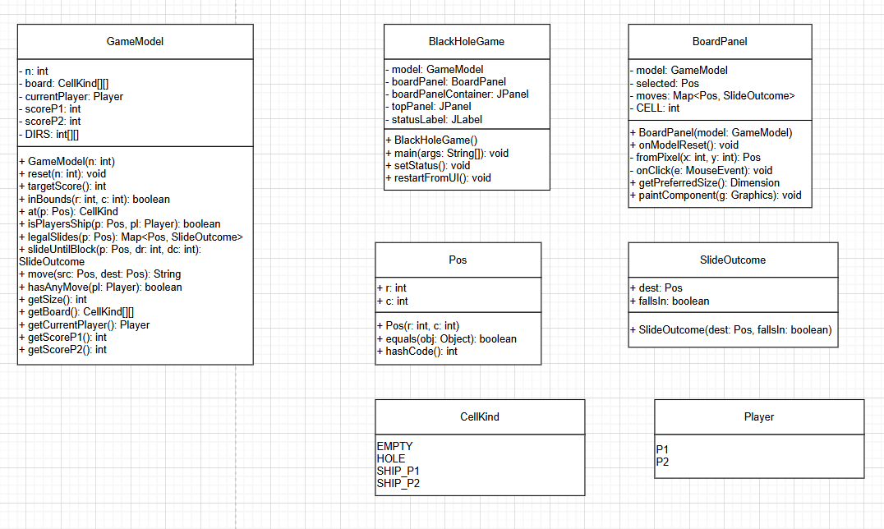
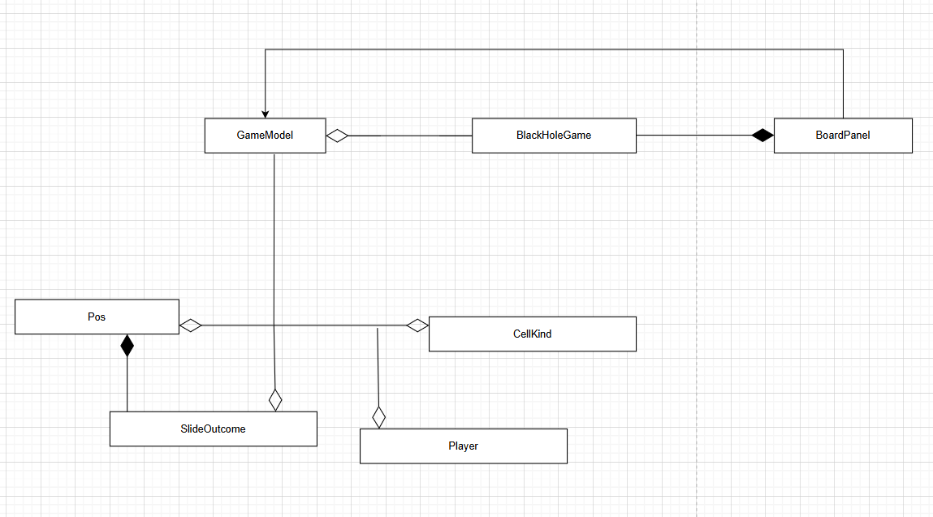

Task description
Class: BlackHoleGame
The constructor BlackHoleGame() initializes the main window and sets up the game interface.
The method main(String[] args) starts the program and opens the game window.
The method setStatus() updates the label that shows which player's turn it is.
The method restartFromUI() resets the entire game after it finishes or someone wins.
The menuLoginActionPerformed() opens a dialog for username and password input; confirms successful login.
The menuRestartActionPerformed() calls restartFromUI() to restart the current match.
The menuHowToPlayActionPerformed() displays a dialog window explaining how to play the Black Hole game.
The formWindowClosing() shows a confirmation dialog when attempting to exit; closes the program only if the user confirms.

Class: BoardPanel
The constructor BoardPanel(GameModel model) creates the visual game board and connects mouse actions to it.
The method onModelReset() clears any selected ship and redraws the board after restarting the game.
The private method fromPixel(int x, int y) converts mouse click positions on the panel into board coordinates.
The method onClick(MouseEvent e) handles what happens when a player clicks on the board, such as selecting or moving ships.
The method getPreferredSize() defines how large the panel should appear based on the board size.
The method paintComponent(Graphics g) draws the game grid, ships, black hole, and available moves on the screen.

Class: GameModel
The constructor GameModel(int n) creates a new logical game board of size n×n.
The method reset(int n) clears the board and places all ships and the black hole in their starting positions.
The method targetScore() calculates how many ships a player must move into the black hole to win.
The method inBounds(int r, int c) checks whether a given row and column are inside the board’s limits.
The method at(Pos p) returns what type of cell is at a given position (empty, hole, or ship).
The method isPlayersShip(Pos p, Player pl) checks if a position contains the ship of the given player.
The method legalSlides(Pos p) returns all valid moves for a ship from a given position.
The method slideUntilBlock(Pos p, int dr, int dc) simulates how far a ship can slide in one direction before it stops.
The method move(Pos src, Pos dest) performs a move, updates the board, scores, and checks if someone has won.
The method hasAnyMove(Player pl) checks whether a player has any possible moves left.
The method getSize() returns the board size.
The method getBoard() returns the current two-dimensional array that represents the board.
The method getCurrentPlayer() returns which player's turn it currently is.
The method getScoreP1() returns Player 1’s score.
The method getScoreP2() returns Player 2’s score.

Class: Pos
The constructor Pos(int r, int c) creates a new position on the board with the given row and column.
The method equals(Object obj) checks if another object represents the same position.
The method hashCode() returns a unique hash code for the position, useful for storing in collections.

Class: SlideOutcome
The constructor SlideOutcome(Pos dest, boolean fallsIn) creates a result that describes where a ship stops and whether it falls into the black hole.

Enum: CellKind
The enumeration CellKind defines the possible contents of a board cell:
EMPTY means no ship is there,
HOLE is the black hole,
SHIP_P1 belongs to Player 1,
and SHIP_P2 belongs to Player 2.

Enum: Player
The enumeration Player defines the two players in the game:
P1 for Player 1 (red) and P2 for Player 2 (blue).

Event Handlers
Event (User Action) | Event Source (Component) | Event Handler (Method) | Description of Action
User clicks “New Game” | newGameBtn | lambda → restartFromUI() | Resets the board to a new game with the selected size.
User changes board size in combo box | sizeCombo | lambda → restartFromUI() | Recreates the board using the chosen size (5×5, 7×7, or 9×9).
User clicks a board cell | boardPanel | onClick(MouseEvent e) | Moves the selected ship if the move is legal; updates game state.
User clicks “Login” menu item | menuLogin | menuLoginActionPerformed() | Displays a login dialog where the user can enter credentials.
User clicks “Restart Game” menu item | menuRestart | menuRestartActionPerformed() | Restarts the current game immediately.
User clicks “How to Play” menu item | menuHowToPlay | menuHowToPlayActionPerformed() | Opens a dialog showing the rules and instructions of the game.
User attempts to close the window | Main Frame (BlackHoleGame) | formWindowClosing() | Asks for confirmation before closing the application.

Test cases
Test Case 1: Initial Board Setup
Input: Board size = 5
Output:
Center cell = HOLE
Player 1 ships = 4
Player 2 ships = 4
✅ Result: Passed

Test Case 2: Legal Slide Movements
Input: Ship position (0, 0) on 5×5 board
Output:
Returned 3 valid slide positions
✅ Result: Passed

Test Case 3: Player Turn Switching
Input: Move a Player 1 ship from (0, 0) to a valid position
Output:
Turn changed from P1 to P2
✅ Result: Passed

Test Case 4: Player 1 Win Condition
Input: Player 1 score set to target, then moved into hole (2, 2)
Output:
Displayed message "Player 1 wins!"
✅ Result: Passed

Test Case 5: Out of Bounds Check
Input: Positions (-1, 0), (5, 5), (2, 2) on 5×5 board
Output:
(-1, 0) → false
(5, 5) → false
(2, 2) → true
✅ Result: Passed

