Programming
Name: Hasanli Toghrul
Neptun Code: MLMOPU
Task: Track Running
Specification
In: weeks ∈ N, laps ∈ N, lapTimes ∈ N[1..weeks,1..laps]
Out: isImproving ∈ L
Fn: isImprovingV: N x N x N[1..weeks,1..laps] -> L,
isImprovingV(weeks, laps, lapTimes) = ∀i ∈ [2..weeks]: (SUM(j=1..laps, lapTimes[i, j]) < SUM(j=1..laps, lapTimes[i-1, j]))
Pre: 1 ≤ weeks ≤ 10 and 1 ≤ laps ≤ 10 and ∀i ∈ [1..weeks]: (∀j ∈ [1..laps]: (30 ≤ lapTimes[i, j] ≤ 60))
Pattern | Task
weeks | Number of weeks provided as input to the algorithm.
laps | Number of laps per week provided as input to the algorithm.
lapTimes | 2D array storing lap times for each week and lap, provided as input.
currentTotal | Total lap time calculated for the current week in the loop.
previousTotal | Total lap time calculated for the previous week in the loop.
isImproving | Boolean variable in the main algorithm indicating whether all weeks satisfy the condition.
check | Boolean variable returned by isImprovingV to indicate if the current week satisfies the condition.
Post: isImproving = isImprovingV(weeks, laps, lapTimes)
Pattern: Decision All

Algorithm:
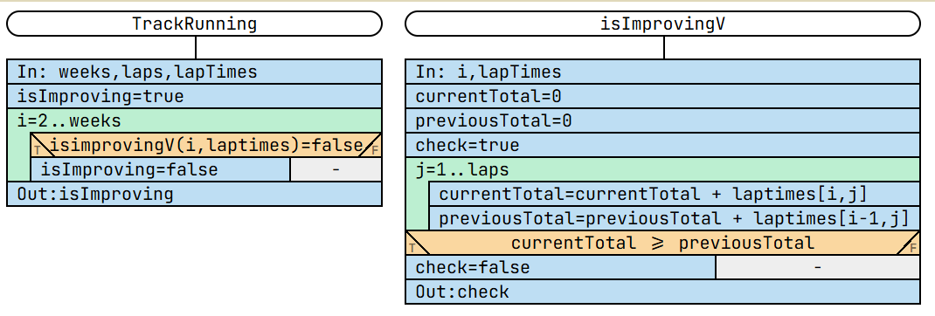

Test Cases:
- Input: weeks: 2; laps: 2; lapTimes: [[25, 20], [47, 43]]
Output: Invalid (lap times must be between 30 and 60).
- Input: weeks: 3; laps: 2; lapTimes: [[50, 45], [47, 43], [44, 42]]
Output: isImproving: true.
- Input: weeks: 3; laps: 2; lapTimes: [[50, 45], [47, 43], [47, 43]]
Output: isImproving: false.
- Input: weeks: 1; laps: 1; lapTimes: [[55]]
Output: isImproving: true.

