Programming
Name: Hasanli Toghrul
Neptun Code: MLMOPU

Task: Tram Service Company

Specification
In: stnum ∈ N,
geton ∈ N[1..stnum],
getoff ∈ N[1..stnum]
Out: sumpsngr ∈ N,
index ∈ N
Pre: 1 ≤ stnum ≤ 100 and
∀i ∈ [1..stnum]: (0 ≤ geton[i] ≤ 50 and 0 ≤ getoff[i] ≤ 50)
Post: sumpsngr = SUM(i=1..stnum, getoff[i]) and
index ∈ [1..stnum] and
∀i ∈ [1..stnum] : (geton[index] ≥ geton[i])

Pattern: Counting, Maximum selection

Algorithm
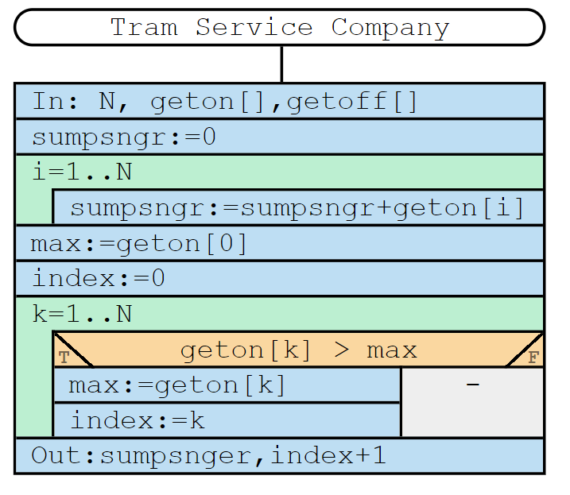
Pattern |  | Task
N | -> | Number of stations
geton | -> | Total passengers that got on
getoff | -> | Total passengers that got off
sumpsngr | -> | Total number of the passengers
max | -> | Maximum numbers of passengers that got on in one station
index | -> | Index of the maximum numbers of passengers that got on in one station

Test cases:
1) Input: stnum: 3; geton: [-3, 5, 6]; getoff: [3, 5, 7] Output: Invalid
2) Input: stnum: 3; geton: [4, 7, 5]; getoff: [6, 3, 7] Output: sumpsngr: 13, index: 2
3) Input: stnum: 1; geton: [8]; getoff: [8] Output: sumpsngr: 8, index: 1

