Repository URL
https://github.com/woodrow-snow/team17_handcrafted_haven

GitHub Projects URL
https://github.com/users/woodrow-snow/projects/1

Meeting Summary
- I had power outage, but I coordinated with the team as soon as the power went back.
- I was tasked with creating the homepage, and I submitted a skeleton for the team to check.
- My task for the upcoming week is to setup Vercel. I will also wait for the About Us page to be updated so I can fill in the homepage’s details.
- One challenge is that we have 2 new team members who were not around during the first few weeks of our meetings.
- One success is that inspite of having to adjust our plans since we have 2 additional members of the team, we still managed to give everyone tasks and successfully are moving the project forward.
- One insight I learned is that work becomes more efficient when there are many people working together.
- Attendees:
  - Woodrow John Snow
  - Andrea Carolina Ponton
  - Edwin Kambale
  - Rudy Pilande II

Summary

Meeting Summary
- Created landing page wireframe in Moqups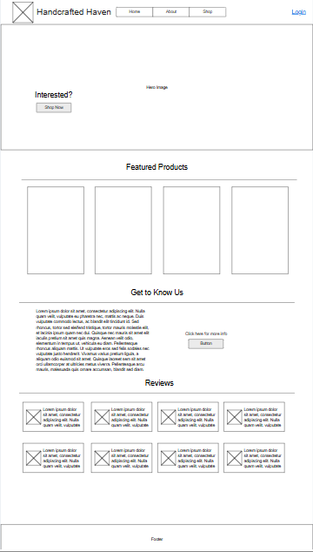
- Assigned tasks to be followed up throughout the week before next meeting
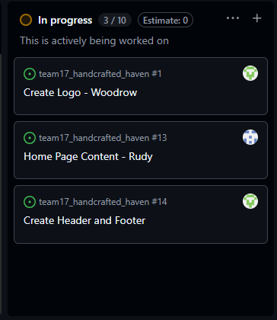

Challenges
- There are only 2 of us in the team. The other team members have not joined our meetings ever since the course started.

Successes
- Even though there are only two of us, we feel confident that we can get through this.

Insights
- Communication is key. What I love about my teammate is that we are open for feedback and suggestions from each other.

Participants
- Woodrow J. Snow
- Rudy F. Pilande II (Lead)

