Summary

Summary Meeting
- Discussed design and styling (fonts, colors, and graphical elements)
- Used Figma as inspiration for layout
- Brainstormed logo
- Created 10 user stories and work items

Participants
- Woodrow J. Snow (Lead)
- Rudy F. Pilande II

Repository URL
https://github.com/woodrow-snow/team17_handcrafted_haven

Local Repository Project
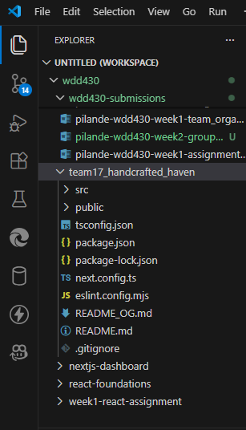

Design And Styling Identify

Colors / Themes
- Greens, browns, and an off-whites
- Considering using tailwind CSS framework for design
- All Colors: https://coolors.co/5a464c-ffd1ba-92ac86-1e3f20-345830

Fonts
- Poppins: https://fonts.google.com/specimen/Poppins?specimen.preview.text=Hello+World&preview.layout=grid
- Updock for heading font?? https://fonts.google.com/specimen/Updock?preview.layout=grid&categoryFilters=Feeling:%2FExpressive%2FArtistic

General Layout
- We are going to use what Figma's Ai provided as inspiration for our website. We will not copy what it has given.
https://www.figma.com/make/eHYFxwrGjufyap6C6RwiSp/Handcrafted-Haven?t=w2OHQ8sNLiF5bCLk-1

Other Graphical Elements
- Logo and companies name in the Upper left-hand side of the navigation.
- Right side of nav there will be a checkout button and a login button
- Middle of nav will have the navigation links
- We started brainstorming ideas for the Logo.
- Here is the link to the whiteboard: https://byupathwayworldwideprod-my.sharepoint.com/:wb:/g/personal/wsnow_byupathway_edu/IQCaSQeWlysURbCzyBz_1zMwAQTNA2t8DNAKYoZxMlV34w4?e=ccxjoq

User Stories and Work Items
Link to GitHub Projects: https://github.com/users/woodrow-snow/projects/
- Should be able to login
- Should be able to check out and purchase items
- Should be able to look at different products
- Should be able to give reviews to products and sellers
- Should be able to view posts created by seller accounts
- Sellers should be able to create profiles
- Users should be able to filter and sort the full catalog
- Users should be able to search for products
- Sellers should be able to create a new product listing
- Sellers should be able to add product description

