Repository URL
https://github.com/woodrow-snow/team17_handcrafted_haven

GitHub Projects URL
https://github.com/users/woodrow-snow/projects/1

Summary

Meeting Summary
- Created landing page wireframe in Moqups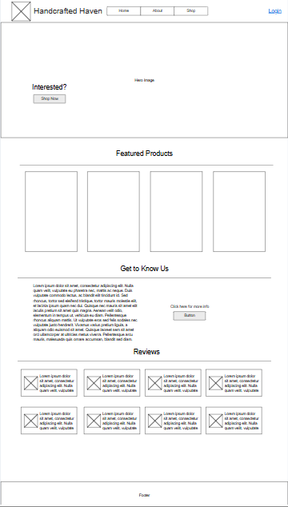
- Assigned tasks to be followed up throughout the week before next meeting
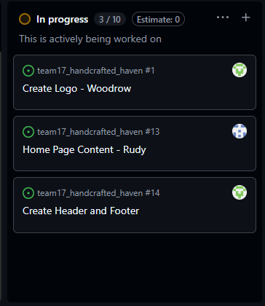

Challenges
- There are only 2 of us in the team. The other team members have not joined our meetings ever since the course started.

Successes
- Even though there are only two of us, we feel confident that we can get through this.

Insights
- Communication is key. What I love about my teammate is that we are open for feedback and suggestions from each other.

Participants
- Woodrow J. Snow
- Rudy F. Pilande II (Lead)

