Image processing: Exercise #1

Question 1
In this question we mess the 'bliss image' and then try to correct it using histogram equalization.
First, show a menu for the user with 4 options:
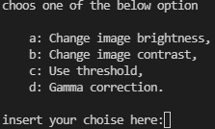
The user enters his choice for how to 'mess' the image, and then the value he wants to use (in the corresponding ranges).
The options are:
- Change the brightness of the image by adding permanent value to all pixels.
- Change contrast by multiply all images pixels with permanent value
- Use cv2 threshold
- Gamma correction equation
Then, by using histogram equalization (calculate CDF of the histogram), we fix the image.
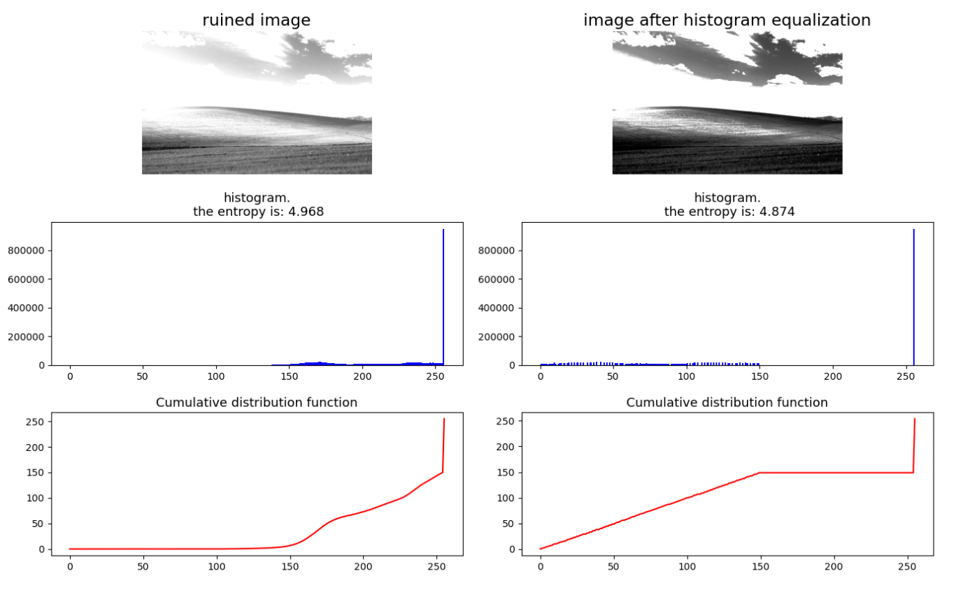
At the end the user can see the ruined image side by the fixed image, with their histogram, CDF, and entropy value.
An example: Ruined the image by changing the brightness, with added value = 100

Question 2
In this question, we tried to count the number of pixels in each area in the bliss image: clouds, sky, and grass.
First, we defined a threshold value for a white pixel (180) and counted all pixels in which all RGB values are bigger than the threshold, such as the clouds pixels.
For grass and sky we checked green and blue values for each pixel: if the B value is bigger than G value it’s a sky pixel, otherwise it’s a grass pixel.
The results are:

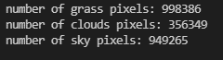

Question 3
In this question we draw a white rhombus with a black background and then try to find its outlines by using Sobel filters.
After creating the image of the rhombus, we create the Sobel filters like this:
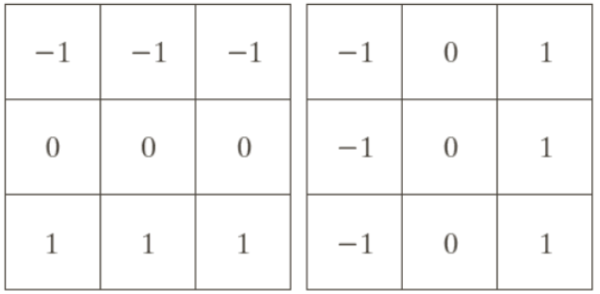
And then activate convolution using these filters, to find the derivative in the x and y axes.
Then we combine the results of the convolution to find the outlines.
The results are:
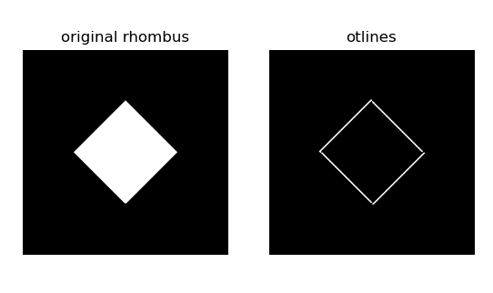
Question 4
This question is like the 3rd question with another step in the middle- adding noise to the image.
The noise is added to a random 5% of the pixels.
The noise value is also random with normal distribution when the mean is: 115 and the standard deviation is: 70
After we add the noise, once again we try to find the outlines.
The results are:
