Image processing: exercise 2

Question 1
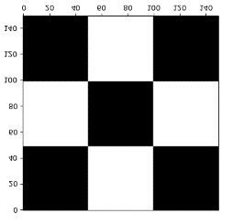
In this question we create a board of size 150X150 with black and white squares of size 50X50 each:

Our goal is to find the dots in which the squares connected. To do so, we use Laplacian of gaussian filter, which applies second division on the image with gaussian filter to cancel noise.
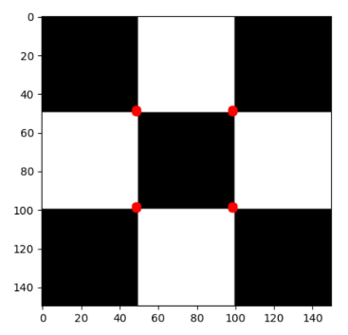
The LOG filter return a black image with white pixel in the connecting points. After finding the dots position by saving the white pixels place, we plot them on the original image.

The output:

Question 2
In this question we draw a white rhombus with a black background and then try to find its outlines by using canny edge detector.

Results:
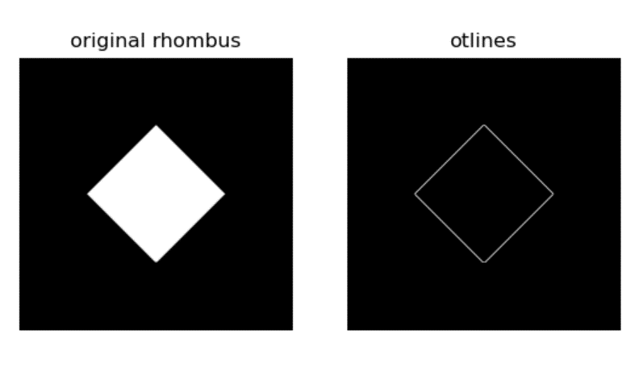

Question 3
In this question, like in the 3rd question we draw a white rhombus with a black background and then try to find its outlines, only this time we will add noise to the image and use Hough line algorithm.
After using Hough line to get accumulator of all the on pixels with the thetas and Rho's for each possible line, we need to find the 4 edges of the rhombus. To do so we use the information from theta and rho to decide which edge we found. For example: if theta < 0 it means the line is decreasing and its either the top-right edge or the bottom-left edge.
After finding the 4 edge we put them together and show the outlines of the rhombus.
The output:
