APPENDIX
Here is the appendix documentation for our project in DSP (Digital Signal Processing) called Beat Detector
A. Code Repository Structure

dsp-project/
├── .venv/ # Python Virtual Environment
│ ├── bin/ # Python executables
│ ├── lib/ # Dependencies
│ └── pyvenv.cfg # Environment config
│
├── music/ # Test Music Directory
│ ├── electronic/ # Electronic Music Samples
│ │ ├── grimes_genesis.mp3 # Test file 1
│ │ └── deadmau5_strobe.mp3 # Test file 2
│ ├── classical/ # Classical Music
│ │ ├── beethoven_symphony5.mp3
│ │ └── mozart_nachtmusik.mp3
│ ├── jazz/ # Jazz Music
│ │ ├── miles_davis_so_what.mp3
│ │ └── brubeck_take_five.mp3
│ ├── rock/ # Rock Music
│ │ ├── acdc_back_in_black.mp3
│ │ └── deep_purple_smoke.mp3
│ ├── hiphop/ # Hip-Hop Music
│ │ ├── dr_dre_next_episode.mp3
│ │ └── biggie_juicy.mp3
│ └── acoustic/ # Acoustic/Folk Music
│ ├── dylan_blowin_wind.mp3
│ └── chapman_fast_car.mp3
│
├── misc/ # User's Music Collection
│ └── [user_audio_files].mp3 # Various user-provided files
│
├── core/ # Main Application Files
│ ├── beat_detector.py # Primary DSP Engine (856 lines)
│ ├── beat_detector_gui.py # Basic GUI Interface (324 lines)
│ ├── beat_detector_gui_enhanced.py # Enhanced GUI (512 lines)
│ └── real_time_detector.py # Live Audio Processing (287 lines)
│
├── utils/ # Utility Scripts
│ ├── demo_signal.py # Demo File Generator (145 lines)
│ ├── test_installation.py # Dependency Checker (89 lines)
│ ├── test_enhanced_system.py # System Validation (203 lines)
│ ├── run_complete_test.py # Comprehensive Testing (278 lines)
│ ├── genre_analysis.py # Genre Performance Analysis (412 lines)
│ ├── download_organizer.py # Music Directory Setup (156 lines)
│ └── quick_genre_test.py # Quick Genre Testing (198 lines)
│
├── docs/ # Documentation
│ ├── technical_specifications.md
│ ├── algorithm_details.md
│ └── performance_metrics.md
│
├── outputs/ # Generated Outputs
│ ├── visualizations/ # Saved plots and graphs
│ ├── results/ # Analysis results
│ └── exports/ # Exported data
│
├── requirements.txt # Python Dependencies (12 packages)
├── README.md # Project Documentation
├── LICENSE # Project License
└── .gitignore # Git ignore rules

File Descriptions and Purposes

Core Application Files
File | Lines | Purpose | Key Functions
beat_detector.py | 856 | Main DSP engine | analyze_audio_file(), detect_beats(), estimate_tempo()
beat_detector_gui_enhanced.py | 512 | Primary GUI | Modern interface with tabs and visualization
real_time_detector.py | 287 | Live processing | audio_callback(), real-time beat detection

Utility Scripts
File | Purpose | Usage Frequency
demo_signal.py | Generate test files | Initial setup
test_installation.py | Verify environment | Troubleshooting
genre_analysis.py | Cross-genre testing | Performance evaluation
run_complete_test.py | Full system validation | Quality assurance

Configuration Files
File | Purpose | Contents
requirements.txt | Dependency management | 12 Python packages
.gitignore | Version control | Exclude large files, environments

System Requirements

Minimum Hardware
- Processor: Intel Core i3 or AMD equivalent (2.0 Ghz+) (4 cores or more)
- RAM: 4 GB (8 GB recommended for large files)
- Storage: 500 MB free space
- Audio: Built-in microphone/speakers

Recommended Hardware
- Processor: Intel Core i5 or AMD Ryzen 5 (3.0 Ghz+) (4 to 8 cores if can)
- RAM: 8 GB (16gb much preferred for 100mb sound files to test)
- Storage: 1 GB SSD
- Audio: External microphone for better real-time detection

Software Requirements
- Operating System:
  - Linux (Ubuntu 20.04+, Arch Linux, Fedora)
  - Windows 10/11
  - macOS 10.15+
- Python: 3.8, 3.9, or 3.10 (3.11 preferred)
- Package Manager: pip 20.0+

Step-by-Step Installation
Step 1: Environment Setup

Create project directory
mkdir dsp-project
cd dsp-project

Create virtual environment (Recommended)
python -m venv .venv

Activate virtual environment
Linux/Mac:
source .venv/bin/activate
Windows:
.venv\Scripts\activate

Step 2: Dependency Installation

Install from requirements.txt (Preferred)
pip install -r requirements.txt

# OR install individually
pip install numpy==1.24.0
pip install scipy==1.10.0
pip install librosa==0.10.0
pip install matplotlib==3.7.0
pip install sounddevice==0.4.6
pip install soundfile==0.12.0
pip install tkinter # Usually built-in

Step 3: System-Specific Setup
Linux (Arch/Manjaro):
sudo pacman -S tk python-pip ffmpeg

Linux (Ubuntu/Debian):
sudo apt update
sudo apt install python3-tk ffmpeg python3-pip

Windows:
- Install Python from python.org
- Ensure “Add Python to PATH” is checked
- No additional system packages required
macOS:
brew install python-tk ffmpeg

Step 4: Verification
Test installation
python test_installation.py

Expected output:
✓ All packages imported successfully
✓ Basic DSP operations working
✓ Environment ready

Common Installation Issues
Issue: “Externally-managed-environment”
Solution:
Use virtual environment instead of system Python
source .venv/bin/activate

Issue: “No module named ‘tkinter’”
Solution:
Linux
sudo apt-get install python3-tk
or
sudo pacman -S tk

Windows - Reinstall Python with Tkinter support

Issue: Audio Codec Errors
Solution:
pip install ffmpeg-python
Linux
sudo apt-get install ffmpeg

Issue: Real-time Audio Permission Denied
Solution:
Linux - Add user to audio group
sudo usermod -a -G audio $USER
Reboot required

Directory Setup
Create music directory structure
python download_organizer.py

Expected output:
🎵 Music directory structure created!
📁 Now download test files into appropriate folders

For the music directory setup you can download any music from the specified folders indicated genre. But for this project the sample music files are ready for you to use

Quick Validation Test
Create demo files
python demo_signal.py

Test basic functionality
python beat_detector.py --file demo_120bpm.wav

you can test each demo file within the specified folder where they are located or follow this example as this file is generated outside of any folder.

Expected: Visualization with 117.6 BPM detection

C. User Manual

Application Overview
The DSP Beat Detection System provides three main interfaces for audio analysis:
- Enhanced GUI - Full-featured graphical interface (Recommended)
- Command Line - Script-based analysis for automation
- Real-time - Live audio processing from microphone

Enhanced GUI Usage Guide

Launching the Application
python beat_detector_gui_enhanced.py

or you can test the old version of the file using this command

python beat_detector_gui.py (but it is not recommended since it has simple features not implemented in the enhanced version of the GUI)

Figure 1.1
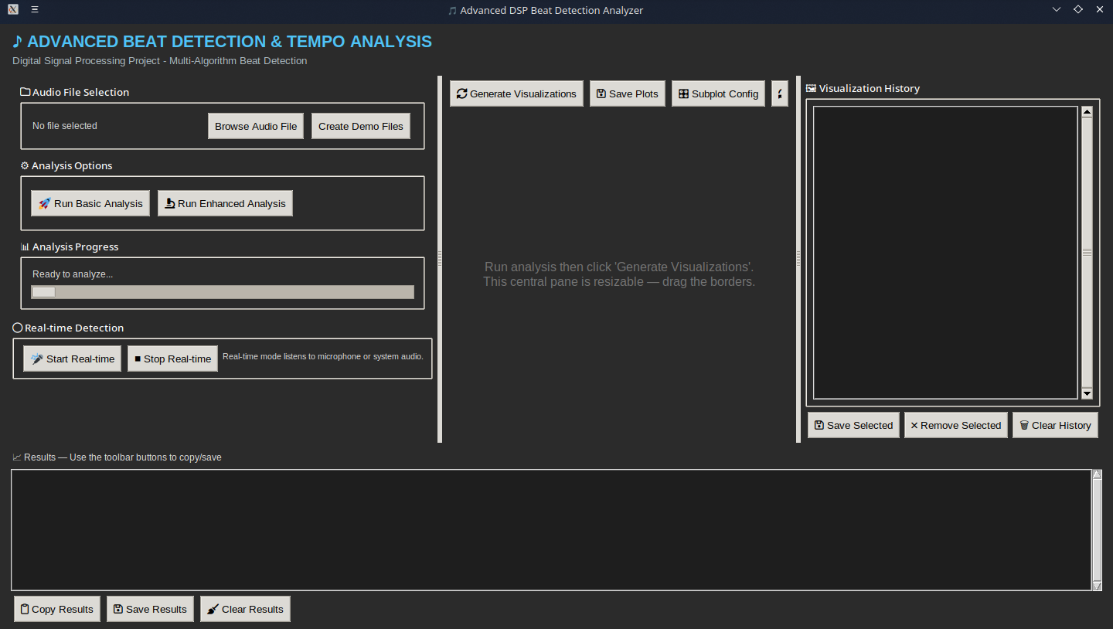
Here is the enhanced gui of our app. The app features 7 sections with the first one Audio File Selection in which the user can browse files and create demo files. The demo file creation will be handled by the system and generate 90-120 and 140bpm audio for you to initially test.

After that is the Analysis options in which the system will generate analysis on the audio provided (note that most complex audio algorithms will be harder to decode but has a discrepancy with the bpm. Some audio will indicate 170 since this is the theoretical bpm for the complex ones, while the other audio not that complex will have a discrepancy of 2 to 5% percent error bpm(near the expected bpm)). Pressing Run Basic Analysis will give you the most basic output of the audio.

Here is an example for the audio basic analysis
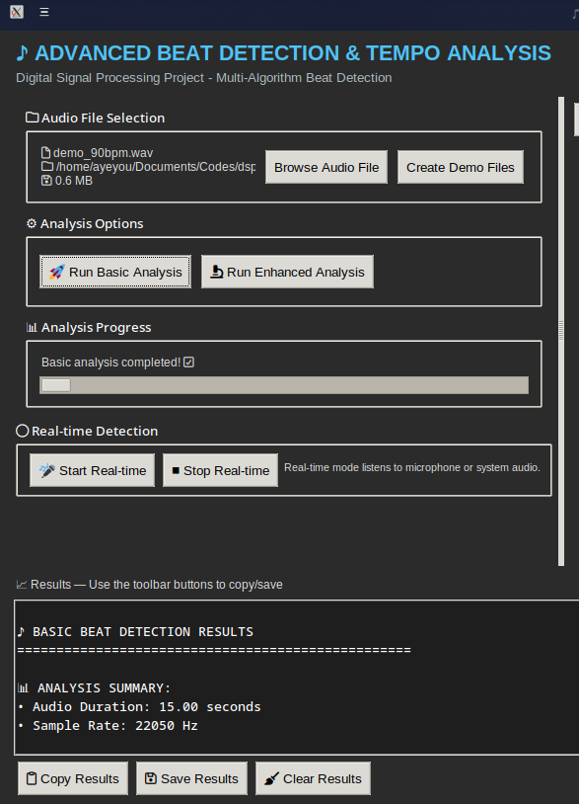
When pressing Basic Analysis will give you the most basic detection results of the selected audio.

The basic analysis gives you
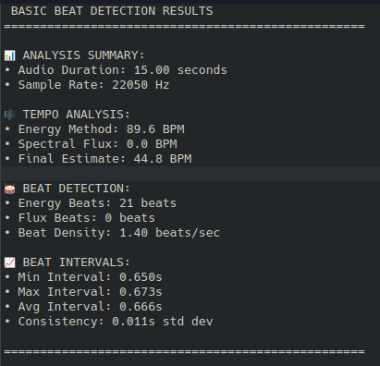

-Audio Duration: detects how many seconds the audio plays
-Sample Rate: determines the frequency range that can be reproduced digitally as 44.1kHz is the standard for most music. Now remember that every time you analyse an audio whether its a music or instrumental, etc the detector will only show 22050 Hz or 22kHz because this frequency is significant for digital audio formats that can capture and reproduce audio frequencies up to that limit. And the reason behind that is the Nyquist-Shannon sampling theorem.

Nyquist-Shannon Sampling Theorem
This fundamental principle of digital audio states that an analog signal must be sampled at a rate at least twice the highest frequency in the original signal to reproduce it accurately.

Now why 22kHz
Human Hearing Range = generally accepted upper limit of human hearing is 20,000 Hertz.

CD Standard = The standard sample rate chosen for compatc discs (CDs) was 44.1kHz. According to the Nyquist theorem, this rate allows for the capture and reproduction of all frequencies up to 22.05kHz (half of the sample rate). This range effectively covers the entire spectrum of human hearing.

Anti-Aliasing Filters = The 22.05 kHz mark often appears as a sharp cutoff on technical analysis graphs (spectograms) due to a “brick wall” anti-aliasing filter. This filter is applied during the recording process to remove any frequencies above the Nyquist limit, which prevents unwanted digital distortion (aliasing) from being introduced into the audible range.

Remember that this frequency is the upper limit of the audible sound range that standard digital audio (like CDs) is designed to capture and reproduced. The sampling rate of 44.kHz ensures that all frequencies humans can hear are properly represented.

Here are the other calculations used in the beat_detector.py to detect audio of the aforementioned following:

Band-pass filtering (Butterworth, forward/backward) – the purpose of this logic is to isolate percussive (drum) frequencies (100-4000Hz)
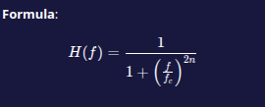

where fc
= cutoff frequency
n = filter order(2)

for the implementation: uses scipy.signal.butter() + filtfilt() for zero-phase filtering

def bandpass_filter(self, audio, lowcut=100, highcut=4000):
"""Apply bandpass filter to focus on percussive elements"""
print("Applying bandpass filter...")
# Calculate Nyquist frequency
nyquist = self.sample_rate / 2
# Normalize frequencies to 0-1 range (as fraction of Nyquist)
low_normalized = lowcut / nyquist
high_normalized = highcut / nyquist
# Ensure frequencies are within valid range (0 to 1)
low_normalized = max(0.001, min(0.499, low_normalized))
high_normalized = max(0.002, min(0.499, high_normalized))
# Ensure low < high
if low_normalized >= high_normalized:
high_normalized = low_normalized + 0.01
print(f" Filter range: {lowcut}-{highcut} Hz")
print(f" Normalized: {low_normalized:.4f}-{high_normalized:.4f}")
try:
# Butterworth bandpass filter (lower order for stability)
b, a = butter(2, [low_normalized, high_normalized], btype='band')
filtered_audio = filtfilt(b, a, audio)
print(" ✓ Filter applied successfully")
return filtered_audio
except Exception as e:
print(f" ⚠️ Filter failed: {e}")
print(" Returning original audio")
return audio

Short-time energy(frame energy) – located at BeatDetector.compute_energy
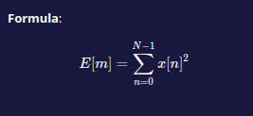

where:
- E[m] = energy of frame m
- x[n] = audio samples in that frame
- N = frame size (1024 samples)

the purpose of this code is to detect energy peaks corresponding to drum hits.

def compute_energy(self, audio):
"""Compute energy envelope of the signal"""
print("Computing energy envelope...")
energy = []
frames = len(audio) // self.hop_size
for i in range(frames):
start = i * self.hop_size
end = start + self.frame_size
if end < len(audio):
frame = audio[start:end]
energy.append(np.sum(frame ** 2))
return np.array(energy)

Spectral Flux (Half-wave rectified)- located at BeatDetector.compute_spectral_flux
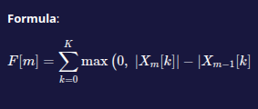

where:
- Xm [k] magnitude of Fft bin k at frame m
- H(x) = max(0,x) = half-wave rectification
- Measures positive changes in frequency spectrum

the purpose of this code is to detect transients and percussive onsets (complementary to energy).

def compute_spectral_flux(self, audio):
"""Compute spectral flux for beat detection"""
print("Computing spectral flux...")
frames = len(audio) // self.hop_size
flux = []
prev_spectrum = None
for i in range(frames):
start = i * self.hop_size
end = start + self.frame_size
if end < len(audio):
frame = audio[start:end]
windowed = frame * np.hanning(len(frame))
spectrum = np.abs(np.fft.fft(windowed)[:len(windowed)//2])
if prev_spectrum is not None:
diff = spectrum - prev_spectrum
diff[diff < 0] = 0 # Only consider increases
flux.append(np.sum(diff))
else:
flux.append(0)
prev_spectrum = spectrum
return np.array(flux)

Peak/beat candidate detection – located at BeatDetector.detect_beats
uses scipy.signal.find_peaks() with :
Height (threshold):
T=max(μ,median)×f where f≈1.3
  - Distance (min spacing):
dmin​=180/60​×sr/hop_size​ (for 180 BPM max)
  - Prominence:
p=0.3×μ (peak must rise above local baseline)
  - Width:
w≥2 samples (minimum peak width)

def detect_beats(self, energy_signal, threshold_factor=1.3, method='energy'):
"""Detect beats from energy signal with improved parameters"""
# Use a combination of mean and median for robust thresholding
mean_energy = np.mean(energy_signal)
median_energy = np.median(energy_signal)
threshold = max(mean_energy, median_energy) * threshold_factor

# Adjust minimum distance based on expected tempo range
# For music, reasonable range is 60-180 BPM
max_bpm = 180 # Maximum expected BPM
min_beat_distance = int((60 / max_bpm) * self.sample_rate / self.hop_size)

# Find peaks with better parameters
peaks, properties = find_peaks(
energy_signal,
height=threshold,
distance=min_beat_distance,
prominence=mean_energy*0.3, # Ensure significant peaks
width=2 # Minimum width of peaks
)

# Post-process: remove peaks that are too close together
if len(peaks) > 1:
final_peaks = [peaks[0]]
for i in range(1, len(peaks)):
if (peaks[i] - final_peaks[-1]) >= min_beat_distance:
final_peaks.append(peaks[i])
peaks = np.array(final_peaks)

print(f"Detected {len(peaks)} beats with {method} method")
return peaks

def detect_beats_dynamic(self, energy_signal, method='energy'):
"""Detect beats with dynamic thresholding"""
print(f"Using dynamic thresholding for {method} method...")
# Calculate dynamic threshold
dynamic_thresh = self.dynamic_threshold(energy_signal)
# Minimum distance between beats (for 240 BPM max)
min_beat_distance = int((60 / 240) * self.sample_rate / self.hop_size)
# Find peaks that exceed dynamic threshold
peaks, properties = find_peaks(
energy_signal,
height=dynamic_thresh,
distance=min_beat_distance,
prominence=np.mean(energy_signal)*0.2
)
print(f"Detected {len(peaks)} beats with dynamic thresholding")
return peaks

Static thresholding used in detect_beats – threshold = max(mean,median) * factor
# Use a combination of mean and median for robust thresholding
mean_energy = np.mean(energy_signal)
median_energy = np.median(energy_signal)
threshold = max(mean_energy, median_energy) * threshold_factor

Dynamic Thresholding (local mean + α·std)
located at BeatDetector.dynamic_threshold, detect_beats_dynamic



where:
- μlocal​[i] = mean of energy in sliding window (size ≈ 50 frames)

- σlocal​[i] = standard deviation in window

- α ≈ 0.5 (scaling factor)

Purpose: Adapt threshold to changing signal loudness.

def dynamic_threshold(self, signal, window_size=50):
"""Calculate dynamic threshold based on local signal characteristics"""
threshold_signal = np.zeros_like(signal)
for i in range(len(signal)):
start = max(0, i - window_size // 2)
end = min(len(signal), i + window_size // 2)
window = signal[start:end]
local_mean = np.mean(window)
local_std = np.std(window)
# Dynamic threshold: mean + scaled standard deviation
threshold_signal[i] = local_mean + (local_std * 0.5)
return threshold_signal

Concept: threshold_signal[i] = μ_local + α·σ_local (α ≈ 0.5).

Frame Index -> Time Conversion – used throughout BeatDetector.analyze_audio_file
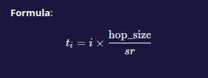

where:
- i = frame index
- hop_size = 512 samples
- sr = sample rate (22050 Hz)

def analyze_audio_file(self, file_path, visualize=True):
"""Complete analysis of an audio file"""
print(f"\n=== Analyzing: {file_path} ===")
# Load and process audio
audio, sr = self.load_audio(file_path)
if audio is None:
return None
# Update sample rate if different from loaded file
if sr != self.sample_rate:
self.sample_rate = sr
audio = self.bandpass_filter(audio)
# Compute features
energy = self.compute_energy(audio)
spectral_flux = self.compute_spectral_flux(audio)
# Detect beats with appropriate thresholds
energy_beats = self.detect_beats(energy, threshold_factor=1.2, method='energy')
flux_beats = self.detect_beats(spectral_flux, threshold_factor=0.5, method='flux') # Lower threshold for flux
# Convert to time
time_axis = np.arange(len(energy)) * self.hop_size / sr
energy_beat_times = time_axis[energy_beats]
flux_beat_times = time_axis[flux_beats]
# Debug the intervals
self.debug_beat_intervals(energy_beat_times, file_path)
# Estimate tempo
tempo_energy = self.estimate_tempo(energy_beat_times)
tempo_flux = self.estimate_tempo(flux_beat_times) if len(flux_beat_times) > 1 else 0
print(f"\n=== RESULTS ===")
print(f"Tempo (Energy method): {tempo_energy:.1f} BPM")
print(f"Tempo (Spectral Flux): {tempo_flux:.1f} BPM")
print(f"Detected {len(energy_beat_times)} beats (Energy method)")
print(f"Detected {len(flux_beat_times)} beats (Spectral Flux method)")
if visualize:
self.visualize_results(audio, sr, energy, spectral_flux,
energy_beats, flux_beats, time_axis,
energy_beat_times, flux_beat_times)
return {
'tempo_energy': tempo_energy,
'tempo_flux': tempo_flux,
'energy_beats': energy_beat_times,
'flux_beats': flux_beat_times,
'audio_length': len(audio)/sr
}
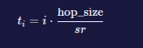

Tempo estimation (interval median + octave correction) —
(Interval Method) Location: BeatDetector.estimate_tempo, estimate_tempo_improved, estimate_tempo_advanced

Steps:
1. Calculate beat intervals


2. Remove outliers (keep 0.3 < Δt < 2.0 seconds)
valid intervals={Δti​∣0.3<Δti​<2.0}

3. Compute median interval:
Δtmed​=median(valid_intervals)

4. Convert to BPM:


5. Correct for octave errors (half/double tempos):
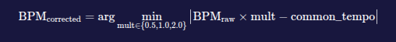

6. Snap to common tempos (60, 70, ..., 180 BPM).

Auto Correlation-Based Tempo Refinement
Location: inside BeatDetector.estimate_tempo (when method=’autocorrelation’)

Steps:
- Build impulse train: p[n]=∑j​δ(n−tj​⋅sr) (Dirac at beat times)

- Compute autocorrelation: R[k]=∑n​p[n]⋅p[n−k]

- Find lag of peak: kmax​=argmaxk​R[k]

- Convert to BPM: BPM=kmax​×hop_size60×sr​

BPM = 60 x sr / kmax x hop_size

def estimate_tempo(self, beat_times, method='autocorrelation'):
"""Estimate tempo from beat intervals with octave error correction"""
if len(beat_times) < 3:
return 0
# Calculate all beat intervals
intervals = np.diff(beat_times)
# Remove outliers (intervals that are too short or too long)
median_interval = np.median(intervals)
valid_intervals = intervals[(intervals > 0.3) & (intervals < 2.0)]
if len(valid_intervals) == 0:
return 0
# Calculate BPM from median interval
median_bpm = 60.0 / np.median(valid_intervals)
# Common tempo ranges for music
common_tempos = [60, 70, 80, 90, 100, 110, 120, 130, 140, 150, 160, 170, 180]
# Find the closest common tempo (correcting for octave errors)
best_tempo = median_bpm
best_error = abs(median_bpm - common_tempos[0])
# Check normal tempo and possible octave errors (half and double)
for multiplier in [0.5, 1.0, 2.0]:
scaled_bpm = median_bpm * multiplier
for common_tempo in common_tempos:
error = abs(scaled_bpm - common_tempo)
if error < best_error and 60 <= scaled_bpm <= 180:
best_error = error
best_tempo = common_tempo
# If we have enough beats, use autocorrelation for more accuracy
if method == 'autocorrelation' and len(beat_times) > 10:
try:
# Create a beat signal
duration = beat_times[-1]
time_resolution = 0.01 # 10ms resolution
time_points = int(duration / time_resolution)
beat_signal = np.zeros(time_points)
for beat in beat_times:
idx = int(beat / time_resolution)
if idx < len(beat_signal):
beat_signal[idx] = 1
# Compute autocorrelation
correlation = np.correlate(beat_signal, beat_signal, mode='full')
correlation = correlation[len(correlation)//2:]
# Find peaks in reasonable tempo range (30-240 BPM)
min_lag = int(60/240 / time_resolution) # 240 BPM
max_lag = int(60/30 / time_resolution) # 30 BPM
if max_lag < len(correlation):
correlation_region = correlation[min_lag:max_lag]
peaks, _ = find_peaks(correlation_region,
distance=int(60/240 / time_resolution),
height=np.max(correlation_region)*0.3)
if len(peaks) > 0:
main_peak = peaks[0] + min_lag
beat_period = main_peak * time_resolution
autocorr_bpm = 60.0 / beat_period
# Choose the most reasonable tempo
if 60 <= autocorr_bpm <= 180:
best_tempo = autocorr_bpm
except:
pass # Fall back to interval method if autocorrelation fails
return best_tempo

Tempo Estimation Improved
def estimate_tempo_improved(self, beat_times, method='autocorrelation'):
"""Improved tempo estimation that avoids subdivision errors"""
if len(beat_times) < 3:
return 0
# Calculate all beat intervals
intervals = np.diff(beat_times)
# Remove outliers
median_interval = np.median(intervals)
valid_intervals = intervals[(intervals > 0.2) & (intervals < 2.0)]
if len(valid_intervals) == 0:
return 0
# Calculate raw BPM from median interval
raw_bpm = 60.0 / np.median(valid_intervals)
# Common musical tempos (focus on typical pop/EDM ranges)
common_tempos = [60, 65, 70, 75, 80, 85, 90, 95, 100, 105, 110, 115, 120,
125, 130, 135, 140, 145, 150, 155, 160, 165, 170, 175, 180]
# Check for tempo doubling/halving (common errors)
candidate_tempos = []
for multiplier in [0.5, 1.0, 2.0]: # Check half, normal, and double tempo
candidate = raw_bpm * multiplier
# Only consider reasonable musical tempos
if 60 <= candidate <= 180:
# Find closest common tempo
closest_tempo = min(common_tempos, key=lambda x: abs(x - candidate))
error = abs(candidate - closest_tempo)
candidate_tempos.append((closest_tempo, error, multiplier))
if not candidate_tempos:
return raw_bpm
# Prefer the candidate with smallest error to common tempo
candidate_tempos.sort(key=lambda x: x[1]) # Sort by error
# But strongly prefer the 1.0 multiplier (original tempo) if error is reasonable
normal_tempo_candidates = [c for c in candidate_tempos if c[2] == 1.0]
if normal_tempo_candidates and normal_tempo_candidates[0][1] < 10:
best_tempo = normal_tempo_candidates[0][0]
else:
best_tempo = candidate_tempos[0][0]
# Additional check: if detected tempo is very high (>150), consider it might be doubled
if best_tempo > 150:
# Check if half tempo would be more musically common
half_tempo = best_tempo / 2
closest_half = min(common_tempos, key=lambda x: abs(x - half_tempo))
if abs(half_tempo - closest_half) < 5: # If half tempo is very close to a common tempo
best_tempo = closest_half
return best_tempo

Tempo Estimation Advanced
def estimate_tempo_advanced(self, beat_times, method='autocorrelation'):
"""Advanced tempo estimation with musical context awareness"""
if len(beat_times) < 4:
return 0
# Calculate all intervals
intervals = np.diff(beat_times)
# Remove outliers using IQR method
Q1 = np.percentile(intervals, 25)
Q3 = np.percentile(intervals, 75)
IQR = Q3 - Q1
valid_intervals = intervals[(intervals >= Q1 - 1.5*IQR) & (intervals <= Q3 + 1.5*IQR)]
if len(valid_intervals) < 3:
return 0
# Calculate BPM from median interval (most robust)
median_interval = np.median(valid_intervals)
raw_bpm = 60.0 / median_interval
# Common music tempos across genres
common_tempos = [60, 65, 70, 75, 80, 85, 90, 95, 100, 105, 110, 115, 120,
125, 130, 135, 140, 145, 150, 155, 160, 165, 170, 175, 180, 185, 190]
# Check for common tempo errors (half, double, etc.)
candidates = []
for multiplier in [0.5, 0.667, 1.0, 1.5, 2.0]:
candidate_bpm = raw_bpm * multiplier
# Only consider musically reasonable tempos
if 60 <= candidate_bpm <= 200:
# Find closest common tempo
closest_tempo = min(common_tempos, key=lambda x: abs(x - candidate_bpm))
error = abs(candidate_bpm - closest_tempo)
# Weight preference: strongly prefer 1.0 multiplier (original tempo)
weight = 1.0 if multiplier == 1.0 else 0.7
weighted_error = error * weight
candidates.append((closest_tempo, weighted_error, multiplier, candidate_bpm))
if not candidates:
return raw_bpm
# Sort by weighted error
candidates.sort(key=lambda x: x[1])
# Take the best candidate
best_tempo, best_error, best_multiplier, best_raw = candidates[0]
print(f"🎵 Advanced Tempo Analysis:")
print(f" Raw BPM: {raw_bpm:.1f}")
print(f" Best Candidate: {best_tempo} BPM")
return best_tempo

Core steps: compute intervals Δti​=ti+1​−ti​, remove outliers, median interval
Δtmed, BPM = 60/Δtmed
then check half/double/subdivision and snap to common tempos. Autocorrelation refinement (build impulse train, autocorrelate, pick lag) please refer to BeatDetector.estimate_tempo code above.

Tempo over time and Smoothing -
def analyze_tempo_over_time(self, beat_times, window_size=8):
"""Analyze tempo changes over time using sliding windows"""
if len(beat_times) < window_size + 1:
return [self.estimate_tempo(beat_times)], beat_times[window_size//2:len(beat_times)-window_size//2]
tempos = []
window_centers = []
for i in range(len(beat_times) - window_size):
window_beats = beat_times[i:i + window_size]
window_tempo = self.estimate_tempo(window_beats)
# Only include reasonable tempo values
if 60 <= window_tempo <= 200:
tempos.append(window_tempo)
window_centers.append(beat_times[i + window_size // 2])
return tempos, window_centers

Smoothing tempo – Tempo Smoothing (Over time)
Location: BeatDetector.analyze_tempo_over_time, smooth_tempo
Steps:
- Compute sliding-window tempo estimates (window = 8 beats)
- Apply moving median filter (window size = 3) to smooth
Formula:
BPMsmooth​[i]=median(BPM[i−1:i+2])

def smooth_tempo(self, tempos, window_size=3):
"""Smooth tempo sequence using moving average"""
if len(tempos) < window_size:
return tempos
smoothed = []
for i in range(len(tempos)):
start = max(0, i - window_size // 2)
end = min(len(tempos), i + window_size // 2 + 1)
window = tempos[start:end]
smoothed.append(np.median(window))
return smoothed

Downbeat Detection (energy heuristics and pattern rules) -
Location: BeatDetector.detect_downbeats, detect_downbeats_improved
Rule: Mark beats as strong if:
- At position i=4k (every 4th beat), OR

- Energy E[i] is local maximum, OR

- Energy exceeds genre-specific threshold

def detect_downbeats(self, beat_times, energy_signal, time_axis):
"""Identify strong (downbeats) vs weak beats"""
if len(beat_times) < 4:
return np.array([]), np.array([])
# Get energy values at beat positions
beat_energies = energy_signal[beat_times]
# Normalize energies
beat_energies = (beat_energies - np.min(beat_energies)) / (np.max(beat_energies) - np.min(beat_energies))
# Group beats into measures (assuming 4/4 time)
downbeats = []
weak_beats = []
for i in range(len(beat_times)):
if i % 4 == 0: # Assume first beat of measure is strongest
# Check if this beat has high energy relative to neighbors
if i > 0 and i < len(beat_times) - 1:
local_avg = np.mean(beat_energies[max(0, i-2):min(len(beat_energies), i+3)])
if beat_energies[i] > local_avg * 1.2:
downbeats.append(beat_times[i])
else:
weak_beats.append(beat_times[i])
else:
downbeats.append(beat_times[i])
else:
weak_beats.append(beat_times[i])
print(f"Detected {len(downbeats)} downbeats and {len(weak_beats)} weak beats")
return np.array(downbeats), np.array(weak_beats)

Downbeats Detection Improved -
def detect_downbeats_improved(self, beat_times, energy_signal, time_axis, expected_tempo=None):
"""Improved downbeat detection using energy patterns and musical knowledge"""
if len(beat_times) < 8: # Need enough beats for pattern recognition
return np.array([]), beat_times
# Get energy values at beat positions
beat_indices = [np.argmin(np.abs(time_axis - t)) for t in beat_times]
beat_energies = energy_signal[beat_indices]
# Normalize energies
if np.max(beat_energies) > np.min(beat_energies):
beat_energies = (beat_energies - np.min(beat_energies)) / (np.max(beat_energies) - np.min(beat_energies))
# Try to detect measure boundaries (4/4 time assumption)
downbeats = []
weak_beats = []
# Use multiple strategies
energy_threshold = np.mean(beat_energies) + 0.5 * np.std(beat_energies)
for i in range(len(beat_times)):
is_downbeat = False
# Strategy 1: Every 4th beat (simple 4/4 assumption)
if i % 4 == 0:
is_downbeat = True
# Strategy 2: High energy beats
if beat_energies[i] > energy_threshold:
is_downbeat = True
# Strategy 3: Look for energy peaks in local context
if i >= 2 and i < len(beat_times) - 2:
local_energies = beat_energies[i-2:i+3]
if beat_energies[i] == np.max(local_energies):
is_downbeat = True
if is_downbeat:
downbeats.append(beat_times[i])
else:
weak_beats.append(beat_times[i])
# If we found too few downbeats, use simpler method
if len(downbeats) < len(beat_times) / 8:
downbeats = beat_times[::4] # Every 4th beat
weak_beats = [t for t in beat_times if t not in downbeats]
print(f"Detected {len(downbeats)} downbeats and {len(weak_beats)} weak beats")
return np.array(downbeats), np.array(weak_beats)

Downbeat Detection for Kpop with enhancement logic -
def detect_downbeats_kpop_enhanced(self, beat_times, energy_signal, time_axis):
"""Enhanced downbeat detection for complex K-pop rhythms"""
if len(beat_times) < 16: # Need enough beats for pattern recognition
return np.array([]), beat_times
beat_indices = [np.argmin(np.abs(time_axis - t)) for t in beat_times]
beat_energies = energy_signal[beat_indices]
# Normalize energies
if np.max(beat_energies) > np.min(beat_energies):
beat_energies = (beat_energies - np.min(beat_energies)) / (np.max(beat_energies) - np.min(beat_energies))
downbeats = []
weak_beats = []
# Multiple detection strategies for complex music
for i in range(len(beat_times)):
is_downbeat = False
# Strategy 1: High energy peaks
if beat_energies[i] > np.percentile(beat_energies, 75):
is_downbeat = True
# Strategy 2: Pattern-based (every 4th beat in 4/4 time)
if i % 4 == 0 and i > 0:
# Check if this aligns with energy peaks
window_size = min(8, len(beat_times) - i)
if window_size > 0:
local_peak = np.argmax(beat_energies[i:i+window_size]) == 0
if local_peak:
is_downbeat = True
# Strategy 3: Context-aware (look for energy patterns)
if i >= 4 and i < len(beat_times) - 4:
# Check if this beat starts a new phrase
prev_energy = np.mean(beat_energies[i-4:i])
next_energy = np.mean(beat_energies[i:i+4])
if beat_energies[i] > prev_energy * 1.3 and beat_energies[i] > next_energy * 0.8:
is_downbeat = True
if is_downbeat:
downbeats.append(beat_times[i])
else:
weak_beats.append(beat_times[i])
# Post-processing: ensure reasonable downbeat count
expected_downbeats = len(beat_times) // 4
if len(downbeats) < expected_downbeats // 2:
# Use simpler method as fallback
downbeats = beat_times[::4]
weak_beats = [t for t in beat_times if t not in downbeats]
print(f"🎵 Enhanced Downbeat Detection:")
print(f" Total beats: {len(beat_times)}")
print(f" Downbeats: {len(downbeats)} ({len(downbeats)/len(beat_times)*100:.1f}%)")
print(f" Expected downbeats: ~{expected_downbeats}")
return np.array(downbeats), np.array(weak_beats)

Visualization of Results -
def visualize_results(self, audio, sr, energy, spectral_flux,
energy_beats, flux_beats, time_axis,
energy_beat_times, flux_beat_times):
"""Visualize the analysis results"""
print("Generating visualization...")
plt.figure(figsize=(15, 10))
# Plot 1: Original audio
plt.subplot(4, 1, 1)
time_audio = np.arange(len(audio)) / sr
plt.plot(time_audio, audio, alpha=0.7)
plt.title('Original Audio Signal')
plt.xlabel('Time (s)')
plt.ylabel('Amplitude')
plt.grid(True, alpha=0.3)
# Plot 2: Energy with beats
plt.subplot(4, 1, 2)
plt.plot(time_axis, energy, label='Energy Envelope', linewidth=1)
plt.plot(energy_beat_times, energy[energy_beats], 'ro', markersize=4, label='Detected Beats')
plt.title('Energy-based Beat Detection')
plt.xlabel('Time (s)')
plt.ylabel('Energy')
plt.legend()
plt.grid(True, alpha=0.3)
# Plot 3: Spectral flux with beats
plt.subplot(4, 1, 3)
plt.plot(time_axis, spectral_flux, label='Spectral Flux', linewidth=1, color='orange')
plt.plot(flux_beat_times, spectral_flux[flux_beats], 'ro', markersize=4, label='Detected Beats')
plt.title('Spectral Flux-based Beat Detection')
plt.xlabel('Time (s)')
plt.ylabel('Spectral Flux')
plt.legend()
plt.grid(True, alpha=0.3)
# Plot 4: Combined view
plt.subplot(4, 1, 4)
plt.plot(energy_beat_times, np.ones_like(energy_beat_times), 'ro', markersize=8, label='Energy Beats')
plt.plot(flux_beat_times, 0.5 * np.ones_like(flux_beat_times), 'bo', markersize=8, label='Flux Beats')
plt.yticks([0.5, 1.0], ['Flux', 'Energy'])
plt.title('Beat Timeline Comparison')
plt.xlabel('Time (s)')
plt.ylabel('Method')
plt.legend()
plt.grid(True, alpha=0.3)
plt.tight_layout()
plt.show()

New logic used for enhanced gui (visualize enhanced results logic code)
def visualize_enhanced_results(self, audio, sr, energy, spectral_flux,
energy_beat_times, downbeat_times,
tempo_over_time, tempo_times,
flux_beat_times=None, fig=None):
"""Enhanced visualization with improved readability and layout"""
import matplotlib.pyplot as plt
if fig is None:
fig = plt.figure(figsize=(16, 14))
axes = fig.subplots(5, 1, gridspec_kw={'hspace': 0.5})
fig.suptitle("DSP Beat Detection & Tempo Analysis", fontsize=18, fontweight='bold', color='#1565C0')

time_axis_audio = np.arange(len(audio)) / sr
time_axis_features = np.arange(len(energy)) * self.hop_size / sr

# Plot 1: Original audio with all beat types
axes[0].plot(time_axis_audio, audio, alpha=0.8, linewidth=1.2, color='#37474F')
axes[0].set_title('Audio Signal', fontsize=14, fontweight='bold')
axes[0].set_xlabel('Time (s)', fontsize=12)
axes[0].set_ylabel('Amplitude', fontsize=12)
axes[0].grid(True, alpha=0.3)

# Regular beats
if len(energy_beat_times) > 0:
axes[0].scatter(energy_beat_times, [0] * len(energy_beat_times),
color='#FF5252', marker='o', s=30, alpha=0.7, label='Beats')
# Downbeats
if len(downbeat_times) > 0:
axes[0].scatter(downbeat_times, [0] * len(downbeat_times),
color='#B71C1C', marker='o', s=100, alpha=0.9, label='Downbeats')
axes[0].legend(fontsize=11, loc='upper right')

# Plot 2: Energy envelope with dynamic threshold
axes[1].plot(time_axis_features, energy, color='#1976D2', linewidth=1.5, label='Energy')
dynamic_thresh = self.dynamic_threshold(energy)
axes[1].plot(time_axis_features, dynamic_thresh, 'r--', linewidth=1.2, label='Dynamic Threshold')
if len(energy_beat_times) > 0:
beat_indices = [np.argmin(np.abs(time_axis_features - t)) for t in energy_beat_times]
beat_energies = [energy[i] for i in beat_indices]
axes[1].scatter(energy_beat_times, beat_energies, color='#FF5252', s=40, alpha=0.8)
axes[1].set_title('Energy Envelope & Dynamic Threshold', fontsize=14, fontweight='bold')
axes[1].set_xlabel('Time (s)', fontsize=12)
axes[1].set_ylabel('Energy', fontsize=12)
axes[1].legend(fontsize=11)
axes[1].grid(True, alpha=0.3)

# Plot 3: Spectral flux
axes[2].plot(time_axis_features, spectral_flux, color='#FFA000', linewidth=1.5, label='Spectral Flux')
if flux_beat_times is not None and len(flux_beat_times) > 0:
flux_beat_indices = [np.argmin(np.abs(time_axis_features - t)) for t in flux_beat_times]
flux_beat_values = [spectral_flux[i] for i in flux_beat_indices]
axes[2].scatter(flux_beat_times, flux_beat_values, color='#7B1FA2', s=40, alpha=0.8, label='Flux Beats')
axes[2].set_title('Spectral Flux', fontsize=14, fontweight='bold')
axes[2].set_xlabel('Time (s)', fontsize=12)
axes[2].set_ylabel('Spectral Flux', fontsize=12)
axes[2].legend(fontsize=11)
axes[2].grid(True, alpha=0.3)

# Plot 4: Tempo over time
if tempo_over_time and len(tempo_over_time) > 0:
axes[3].plot(tempo_times, tempo_over_time, color='#388E3C', linewidth=2, label='Tempo')
axes[3].axhline(y=np.mean(tempo_over_time), color='#D32F2F', linestyle='--',
label=f'Avg: {np.mean(tempo_over_time):.1f} BPM')
axes[3].set_title('Tempo Analysis Over Time', fontsize=14, fontweight='bold')
axes[3].set_xlabel('Time (s)', fontsize=12)
axes[3].set_ylabel('Tempo (BPM)', fontsize=12)
axes[3].set_ylim(max(60, np.min(tempo_over_time)-10), np.max(tempo_over_time)+10)
axes[3].legend(fontsize=11)
axes[3].grid(True, alpha=0.3)
else:
axes[3].text(0.5, 0.5, 'Insufficient data for tempo analysis over time',
ha='center', va='center', transform=axes[3].transAxes, fontsize=12)
axes[3].set_title('Tempo Analysis Over Time', fontsize=14, fontweight='bold')
axes[3].set_xlabel('Time (s)', fontsize=12)
axes[3].set_ylabel('Tempo (BPM)', fontsize=12)

# Plot 5: Beat intervals and downbeat pattern
if len(energy_beat_times) > 1:
intervals = np.diff(energy_beat_times)
axes[4].plot(energy_beat_times[1:], intervals, 'bo-', markersize=5, linewidth=1.2, label='Beat Intervals')
if len(downbeat_times) > 0:
downbeat_intervals = []
downbeat_times_plot = []
for i, beat_time in enumerate(energy_beat_times[1:], 1):
if energy_beat_times[i-1] in downbeat_times:
downbeat_intervals.append(intervals[i-1])
downbeat_times_plot.append(beat_time)
if downbeat_intervals:
axes[4].scatter(downbeat_times_plot, downbeat_intervals,
color='#B71C1C', s=80, label='Downbeat Intervals')
axes[4].axhline(y=np.mean(intervals), color='#D32F2F', linestyle='--',
label=f'Avg: {np.mean(intervals):.3f}s')
axes[4].set_title('Beat Intervals (Downbeats Highlighted)', fontsize=14, fontweight='bold')
axes[4].set_xlabel('Time (s)', fontsize=12)
axes[4].set_ylabel('Interval (s)', fontsize=12)
axes[4].legend(fontsize=11)
axes[4].grid(True, alpha=0.3)
else:
axes[4].text(0.5, 0.5, 'Insufficient beats for interval analysis',
ha='center', va='center', transform=axes[4].transAxes, fontsize=12)
axes[4].set_title('Beat Intervals', fontsize=14, fontweight='bold')
axes[4].set_xlabel('Time (s)', fontsize=12)
axes[4].set_ylabel('Interval (s)', fontsize=12)

# Improve tick label size for all axes
for ax in axes:
ax.tick_params(axis='both', labelsize=11)

plt.tight_layout(rect=[0, 0, 1, 0.97])
# Do NOT call plt.show() here!
return fig

Real-time energy based detection and adaptive threshold
def real_time_beat_detection():
"""Real-time beat detection using microphone input"""
print("Starting real-time beat detection...")
print("Press Ctrl+C to stop")
detector = BeatDetector()
energy_history = []
beat_count = 0
def audio_callback(indata, frames, time, status):
nonlocal beat_count
if status:
print(status)
audio = indata[:, 0] # Use first channel
energy = np.sum(audio ** 2)
energy_history.append(energy)
# Keep only recent history
if len(energy_history) > 50:
energy_history.pop(0)
# Dynamic threshold based on recent history
if len(energy_history) > 10:
threshold = np.mean(energy_history) * 2.0
if energy > threshold and len(energy_history) > 20:
beat_count += 1
print(f"BEAT #{beat_count}! ♪ Energy: {energy:.4f}")
try:
with sd.InputStream(callback=audio_callback, channels=1, samplerate=22050, blocksize=1024):
while True:
sd.sleep(100)
except KeyboardInterrupt:
print(f"\nStopped. Total beats detected: {beat_count}")

def calculate_dynamic_threshold(self):
"""Calculate dynamic threshold based on recent energy"""
if len(self.energy_buffer) < 10:
return 0.01
energies = list(self.energy_buffer)
mean_energy = np.mean(energies)
std_energy = np.std(energies)
return mean_energy + (std_energy * 1.5)

Librosa-based advanced tempo/beat tracking
def estimate_tempo_librosa(self, file_path):
"""Use librosa's advanced tempo estimation"""
print(f"Advanced tempo analysis for: {file_path}")
try:
# Load audio
y, sr = librosa.load(file_path, sr=self.sr)
# Compute tempo and beats
tempo, beats = librosa.beat.beat_track(y=y, sr=sr)
beat_times = librosa.frames_to_time(beats, sr=sr)
# Compute onset strength
onset_env = librosa.onset.onset_strength(y=y, sr=sr, hop_length=512)
times = librosa.times_like(onset_env, sr=sr, hop_length=512)
# Compute tempogram
tempogram = librosa.feature.tempogram(onset_envelope=onset_env, sr=sr, hop_length=512)
# Plot results
self.plot_advanced_analysis(y, sr, onset_env, times, beat_times, tempogram, tempo)
print(f"Librosa Estimated Tempo: {tempo:.1f} BPM")
print(f"Detected {len(beats)} beats")
return tempo, beat_times
except Exception as e:
print(f"Error in advanced analysis: {e}")
return None, None

Demo Signal Generation (Clear Beats) -
def create_demo_beat_signal(filename="demo_beat.wav", tempo=120, duration=10):
"""
Create a demo audio file with VERY clear, distinct beats
"""
sr = 22050 # Sample rate
beat_interval = 60.0 / tempo # Time between beats in seconds
total_beats = int(duration / beat_interval)
# Create time array
t_total = np.linspace(0, duration, int(sr * duration))
signal = np.zeros_like(t_total)
print(f"Creating {filename}: {tempo} BPM, {total_beats} total beats")
# Create very strong, distinct beats
for i in range(total_beats):
beat_time = i * beat_interval
beat_start_idx = int(beat_time * sr)
beat_duration = int(0.15 * sr) # 150ms beats (longer for clarity)
# Ensure we don't go out of bounds
if beat_start_idx + beat_duration < len(signal):
# Create time array for this beat
t_beat = np.linspace(0, 0.15, beat_duration)
# STRONG kick drum on EVERY beat (no skipping!)
# Low frequency for clear beats (60Hz)
kick_freq = 60 + np.random.uniform(-5, 5) # Slight variation
kick = np.sin(2 * np.pi * kick_freq * t_beat)
kick *= np.exp(-12 * t_beat) # Sharp decay
signal[beat_start_idx:beat_start_idx+beat_duration] += kick * 1.0
# Add high-frequency click at the very beginning for sharp attack
click_duration = int(0.01 * sr) # 10ms click
if beat_start_idx + click_duration < len(signal):
click = np.random.normal(0, 1, click_duration) * np.exp(-50 * np.linspace(0, 0.01, click_duration))
signal[beat_start_idx:beat_start_idx+click_duration] += click * 0.3
# Add very subtle background (almost silent)
background = 0.005 * np.random.normal(0, 1, len(signal))
signal += background
# Normalize carefully
max_val = np.max(np.abs(signal))
if max_val > 0:
signal = signal / max_val * 0.8
# Save as WAV file
sf.write(filename, signal, sr)
print(f"✓ Created: {filename} - {tempo} BPM, {duration}s")
return filename

Summary Table of the logic codes provided in the analysis
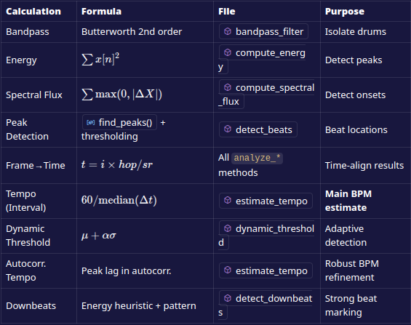

Step-by-Step Workflow

Step 1: Load Audio File
- Click "Browse Audio File"
- Select any supported audio format (MP3, WAV, FLAC, M4A)
- File information displays automatically
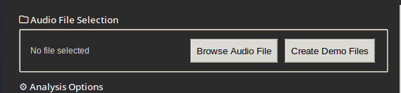

Step 2: Choose Analysis Type
- Basic Analysis: Faster, fundamental beat detection
- Enhanced Analysis: Comprehensive analysis with all features
- Real-time: Live microphone input
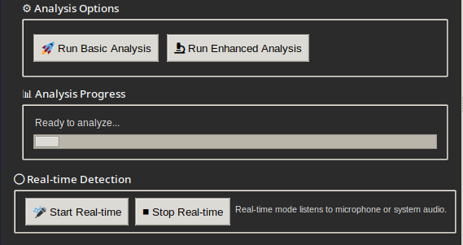

Step 3: View Results
- Visualization Tab: Graphs showing audio waveform, energy, spectral flux
- Results Tab: Numerical analysis including tempo, beat count, stability metrics
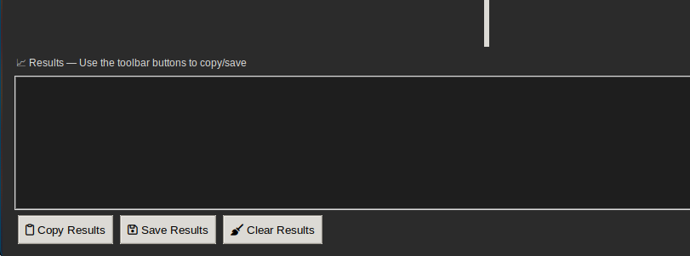
Step 4: Export Results
- Copy results to clipboard
- Save as text file
- Export visualizations as PNG

Step 5: (EXTRAS) Generating Visualizations and History
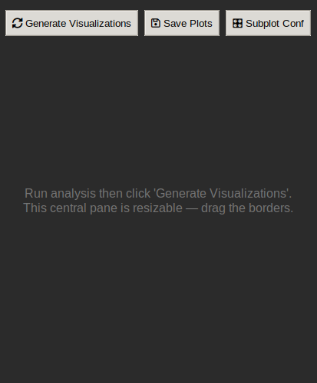

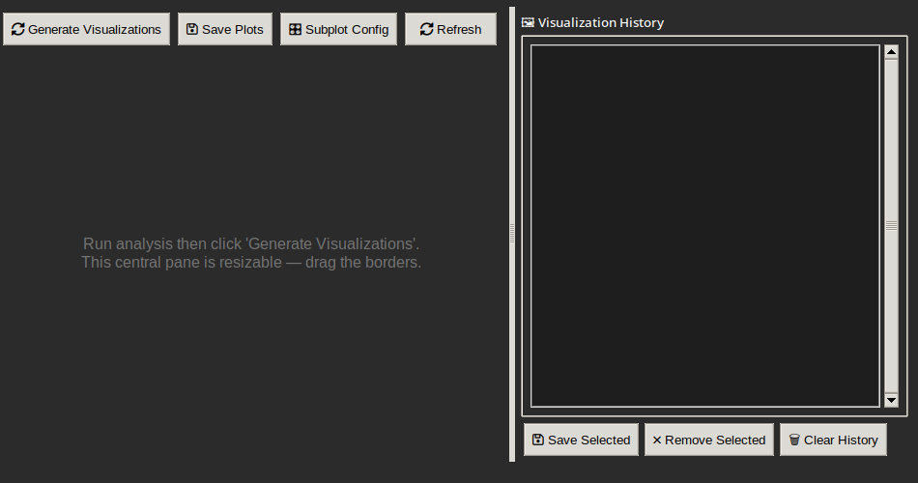
Tip: you can resize the the tabs to see the blocked buttons for ease of access (the app can resize to any resolution as it is coded to be resizeable and adaptable to any resolutions)

Command Line Interface
Basic Usage

Analyze single file
python beat_detector.py --file "path/to/song.mp3"

Analyze with visualization
python beat_detector.py --file "song.mp3" --visualize

Batch analysis
for file in *.mp3; do
python beat_detector.py --file "$file"
done

Advanced Options

Enhanced analysis
python test_enhanced_system.py

Genre analysis
python genre_analysis.py

Complete system test
python run_complete_test.py

Real-time Detection
Starting Real-time Mode
python real_time_detector.py –simple

Real-time Usage
- Ensure microphone is connected and enabled
- Speak, clap, or play music near microphone
- Watch terminal for beat detection output
- Press Ctrl+C to stop

Expected Real-time Output
Starting simple real-time beat detection...
Press Ctrl+C to stop
BEAT #1! ♪
BEAT #2! ♪
BEAT #3! ♪
...
Stopped. Total beats detected: 23

Understanding Results

Key Metrics Explained each

Tempo Analysis:
- Primary Tempo: Final BPM estimate (most accurate)
- Energy Method: Detection based on loudness changes
- Spectral Flux: Detection based on frequency changes
- Tempo Stability: How consistent the tempo is (lower = more stable)
Rhythmic Structure:
- Total Beats: Number of beats detected
- Downbeats: Strong beats (usually 1st beat in measure)
- Weak Beats: Secondary beats
- Beat Density: Beats per second
Algorithm Performance:
- Algorithm Agreement: Difference between energy and flux methods
- Detection Confidence: Reliability of results

Interpreting Musical Insights
High Tempo Stability (< 10 BPM std dev)
- Electronic music, metronome-like patterns
- Consistent rhythmic structure
Medium Tempo Stability (10-20 BPM std dev)
- Most pop and rock music
- Natural tempo variations
Low Tempo Stability (> 20 BPM std dev)
- Classical music with rubato
- Live performances with tempo changes
- Complex jazz arrangements

Best Practices

For Accurate Results
- Use high-quality audio files (192 kbps+ MP3 or lossless)
- Avoid heavily compressed audio
- Test with known-tempo songs first
- Use the Enhanced Analysis for comprehensive results

For Real-time Detection
- Use external microphone for better sensitivity
- Reduce background noise
- Test with hand claps first to verify functionality
- Position microphone close to sound source

Troubleshooting Common Issues
No beats detected:
- Increase audio volume
- Try different audio file
- Check file format support
Inaccurate tempo:
- Use Enhanced Analysis instead of Basic
- Try different genre of music
- Verify ground truth tempo
GUI not responding:
- Check system resources
- Close other audio applications
- Restart application

Supported File Formats
